UNITED STATES
SECURITIES AND EXCHANGE COMMISSION
Washington, D.C. 20549

FORM 8-K
CURRENT REPORT
Pursuant to Section 13 or 15(d) of the
Securities Exchange Act of 1934
Date of Report (Date of earliest event reported): September 11, 2013

SAIC, INC.
SCIENCE APPLICATIONS INTERNATIONAL CORPORATION
(Exact names of registrants as specified in their charters)

DELAWARE |  | 001-33072  000-12771 |  | 20-3562868  95-3630868
(State or other Jurisdiction of  Incorporation) |  | (Commission File Numbers) |  | (IRS Employer Identification Nos.)
1710 SAIC Drive, McLean, Virginia |  |  |  | 22102
(Address of Principal Executive Offices) |  |  |  | (Zip Code)
Registrants telephone number, including area code: (703) 676-4300
N/A
(Former name or former address if changed since last report.)
Check the appropriate box below if the Form 8-K filing is intended to simultaneously satisfy the filing obligation of the registrant under any of the following provisions:

☐ | Written communications pursuant to Rule 425 under the Securities Act (17 CFR 230.425)

☐ | Soliciting material pursuant to Rule 14a-12 under the Exchange Act (17 CFR 240.14a-12)

☐ | Pre-commencement communications pursuant to Rule 14d-2(b) under the Exchange Act (17 CFR 240.14d-2(b))

☐ | Pre-commencement communications pursuant to Rule 13e-4(c) under the Exchange Act (17 CFR 240.13e-4(c))

Item 7.01. | Other Events.
Management of SAIC, Inc. (to be renamed Leidos Holdings, Inc. (Leidos)) and SAIC Gemini, Inc. (New SAIC) will hold a joint Investor Day at the Waldorf Astoria Hotel in New York City on September 11, 2013, beginning at approximately 8:25 a.m. Eastern to discuss the upcoming separation of Leidos and New SAIC. A live video broadcast of the event along with presentation materials will be available to the public through links on the Investor Relations section of the SAIC website at http://Investors.SAIC.com.
A copy of the investor presentation materials relating to Leidos is furnished as Exhibit 99.1 to this report and a copy of the investor presentation materials relating to New SAIC is furnished as Exhibit 99.2 to this report.
The information contained in this report, including Exhibits 99.1 and 99.2, shall not be deemed to be filed for purposes of Section 18 of the Securities Exchange Act of 1934, as amended (Exchange Act), or otherwise subject to the liabilities of that section, and shall not be incorporated by reference into any registration statement or other document filed under the Securities Act of 1933, as amended, or the Exchange Act, except as shall be expressly set forth by specific reference in such filing.
Section 9  Financial Statements and Exhibits

Item 9.01. | Financial Statements and Exhibits.
(d) EXHIBITS

Exhibit  Number |  | Title
99.1 |  | Investor Presentation Materials (Leidos).
99.2 |  | Investor Presentation Materials (New SAIC).

SIGNATURES
Pursuant to the requirements of the Securities Exchange Act of 1934, the registrants have duly caused this report to be signed on their behalf by the undersigned hereunto duly authorized.

SAIC, INC.
By: |  | /s/ Raymond L. Veldman
Name: Raymond L. Veldman
Title: Secretary and Assistant General Counsel

SCIENCE APPLICATIONS INTERNATIONAL CORPORATION
By: |  | /s/ Raymond L. Veldman
Name: Raymond L. Veldman
Title: Secretary and Assistant General Counsel
Dated: September 11, 2013


Waldorf Astoria Hotel 
New York, NY
Leidos Investor Day
September 11, 2013

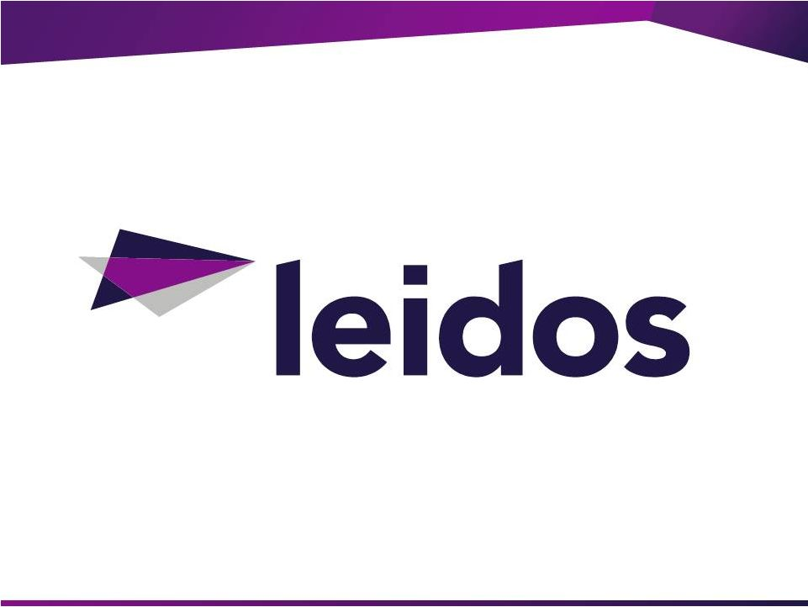


Forward-Looking Statements
Certain statements in this presentation contain or are based on "forward-looking" information within the meaning of the Private Litigation Reform Act of
1995. In some cases, you can identify forward-looking statements by words such as "expects," "intends," "plans," "anticipates," "believes," "estimates
and similar words or phrases. Forward-looking statements in this presentation include, among others: our intent to separate into two independent
publicly
traded
companies
as
a
result
of
the
proposed
spin-off
and
the
timing
of
the
proposed
transaction;
revenue,
growth,
profitability
and
cost-
efficiency expectations for the company following the spin-off; the expectation that the spin-off will be tax-free; statements regarding the resources,
potential, priorities, competitive positioning, opportunities and addressable markets for the company following the spin-off; expectations about future
regular
or
special
dividends,
stock
repurchases
and
other
anticipated
uses
of
capital.
These
statements
reflect
our
belief
and
assumptions
as
to
future
events that may not prove to be accurate.
Actual performance and results may differ materially from the forward-looking statements made in these slides depending on a variety of factors,
including: developments in the U.S. Government defense budget, including budget reductions, implementation of spending cuts (sequestration) or
changes
in
budgetary
priorities;
delays
in
the
U.S.
Government
budget
process
or
approval
to
raise
the
U.S.
debt
ceiling;
delays
in
the
U.S.
Government
contract
procurement
process
or
the
award
of
contracts;
delays
or
loss
of
contracts
as
result
of
competitor
protests;
changes
in
U.S.
Government
procurement
rules,
regulations
and
practices;
our
compliance
with
various
U.S.
Government
and
other
government
procurement
rules
and
regulations;
governmental reviews, audits and investigations of our company; our ability to effectively compete and win contracts with the U.S. Government and other
customers; our ability to attract, train and retain skilled employees, including our management team, and to obtain security clearances for our
employees; our ability to accurately estimate costs associated with our firm-fixed-price and other contracts; our ability to comply with certain agreements
entered
into
in
connection
with
the
CityTime
matter;
cybersecurity,
data
security
or
other
security
threats,
systems
failures
or
other
disruptions
of
our
business; resolution of legal and other disputes with our customers and others or legal or regulatory compliance issues; our ability to effectively acquire
businesses and make investments; our ability to maintain relationships with prime contractors, subcontractors and joint venture partners; our ability to
manage performance and other risks related to customer contracts, including complex engineering or design build projects; the failure of our inspection
or detection systems to detect threats; the adequacy of our insurance programs designed to protect us from significant product or other liability claims;
our ability to manage risks associated with our international business; our ability to declare future dividends based on our earnings, financial condition,
capital requirements and other factors, including compliance with applicable laws and contractual agreements; risks associated with the proposed spin-
off of our technical, engineering and enterprise information technology services business, such as disruption to business operations, unanticipated
expenses, significant transaction costs and/or liabilities, the timing of the spin-off or a failure to complete the proposed spin-off or realize the expected
benefits of the proposed spin-off; and our ability to execute our business plan and long-term management initiatives effectively and to overcome these
and other known and unknown risks that we face. These are only some of the factors that may affect the forward-looking statements contained in these
slides. For further information concerning risks and uncertainties associated with our business, please refer to the filings we make from time to time with
the U.S. Securities and Exchange Commission.
All information in this presentation is as of September 11, 2013. The Company expressly disclaims any duty to update the forward-looking statement
provided
in
this
presentation
to
reflect
subsequent
events,
actual
results
or
changes
in
the
Company's
expectations.
The
Company
also
disclaims
any
duty to comment upon or correct information that may be contained in reports published by investment analysts or others.


START
STOP
DURATION (mins)
TOPIC
7:30
8:25
55
Registration and Continental Breakfast
8:25
8:30
5
Opening Remarks and Introductions: John Sweeney, Investor
Relations
8:30
8:50
20
Introduction and Company Overview: John Jumper, CEO
8:50
9:20
30
Strategy and Operations: Stu Shea, President & Chief Operating
Officer
9:20
9:40
20
CEO and COO Q&A
9:40
10:10
30
National Security: Lou Von Thaer, Sector President
10:10
10:30
20
National Security: Q&A
10:30
10:45
15
Break
10:45
11:15
30
Health and Engineering: Joe Craver, Sector President
11:15
11:35
20
Health and Engineering: Q&A
11:35
11:40
15
Financial: Mark Sopp, Chief Financial Officer
11:40
12:00
20
Financial: Q&A
12:00
12:15
15
Closing Remarks: John Jumper, CEO
4
Investor DayWednesday, September 11
©2013 LEIDOS. ALL RIGHTS RESERVED.
th


Introduction and Company
Overview
John Jumper
CEO


7
$200M+ cost savings with more to come in FY15
Emphasize profit growth over top line revenue

Target 10.0% EPS annual growth

Continuous improvement driving lower rates & higher margin
Strong cash generation: priority return to shareholders

$400M annual operating cash flow
Stable business base: doing the important things

Intelligence, Health, Energy, Environment
Technology leverage: deep analytics, cybersecurity
Remove Organizational Conflict of Interest
©2013 LEIDOS. ALL RIGHTS RESERVED.
Unlocking The Value of Leidos

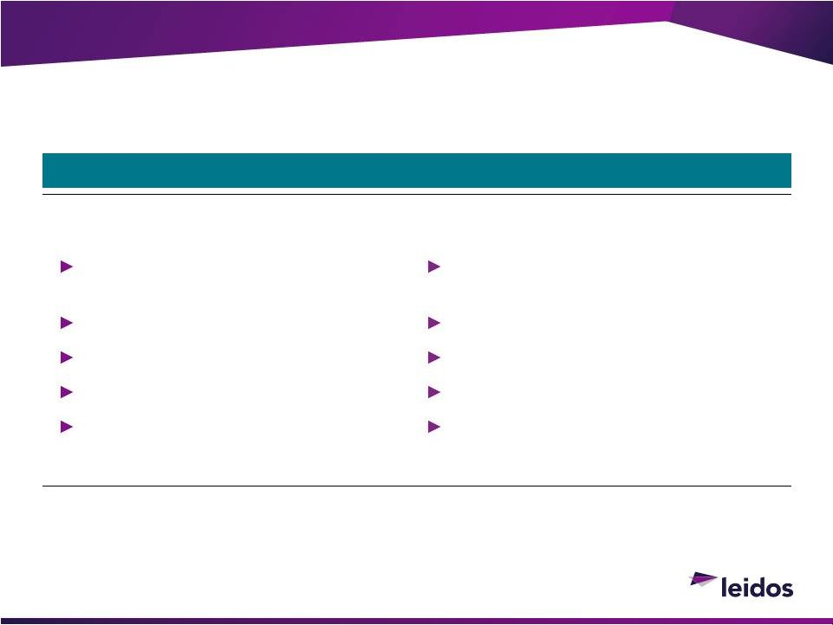
8
©2013 LEIDOS. ALL RIGHTS RESERVED.
What Has Changed
Old SAIC
Leidos
1,000 flowers blooming and internal
competition
Organizational Conflicts of Interest
Higher cost structure
M&A-focused capital deployment
Cash on the balance sheet
Optimized portfolios, shared resources
and leveraged technology
Free to pursue more business
Designed to cost
Return-focused capital deployment
Cash returned to shareholders
Our Transformation

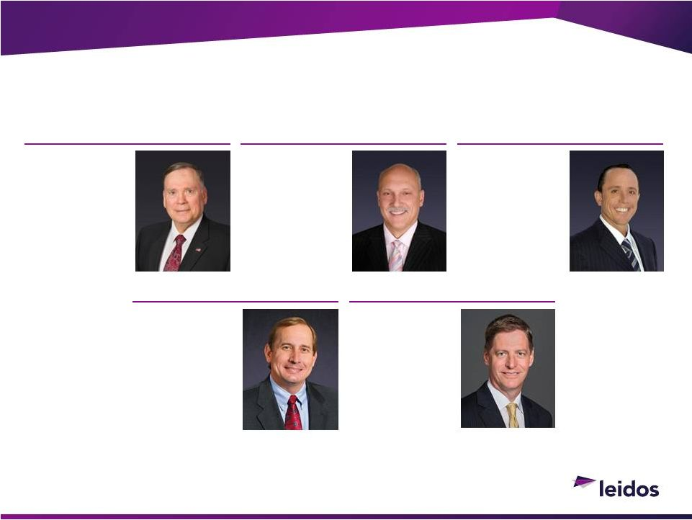
9
©2013 LEIDOS. ALL RIGHTS RESERVED.
Our Key Leaders With You Today
JOHN JUMPER
Chairman and Chief
Executive Officer
STU SHEA
President and Chief
Operating Officer
MARK SOPP
Chief Financial
Officer
JOE
CRAVER
President,
Health and
Engineering Sector
LOU VON THAER
President,
National Security
Sector
Aligned in Their Vision for the Company

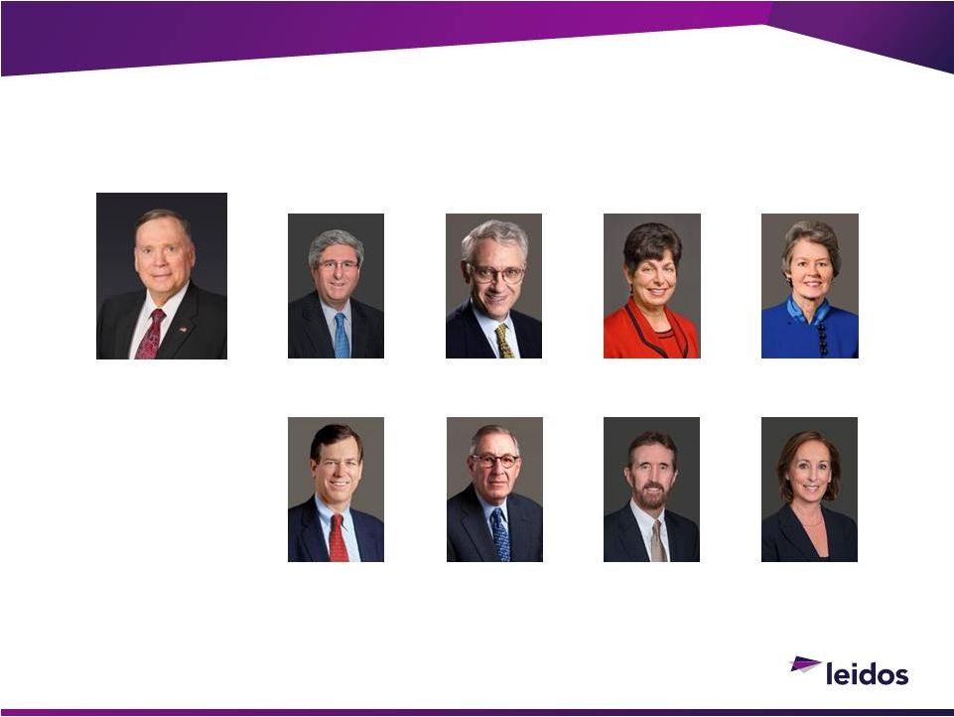
10
©2013 LEIDOS. ALL RIGHTS RESERVED.
Our Board of Directors
JOHN P. JUMPER
Chairman & Chief
Executive Officer
DAVID G. FUBINI
Director
JOHN J. HAMRE
Director
MIRIAM E. JOHN
Director
ANITA K. JONES
Director
HARRY M. J. KRAEMER, JR.
Director
LAWRENCE C. NUSSDORF
Director
ROBERT S. SHAPARD
Director
NOEL B. WILLIAMS
Director


11
Stable National Security Sector revenues combined with growth
opportunities in Health and Engineering
Removal of organizational conflicts of interest
Continuous improvement to drive down costs
Target operating margin of 8.0%+
Low Cap Ex requirements
Strong operating cash generation: Target $400M
operating cash
flow in FY15
Return Value to Shareholder

Attractive dividend yield

Priority on returning cash to shareholders

Higher threshold for acquisitions
©2013 LEIDOS. ALL RIGHTS RESERVED.
Investment Rational
+

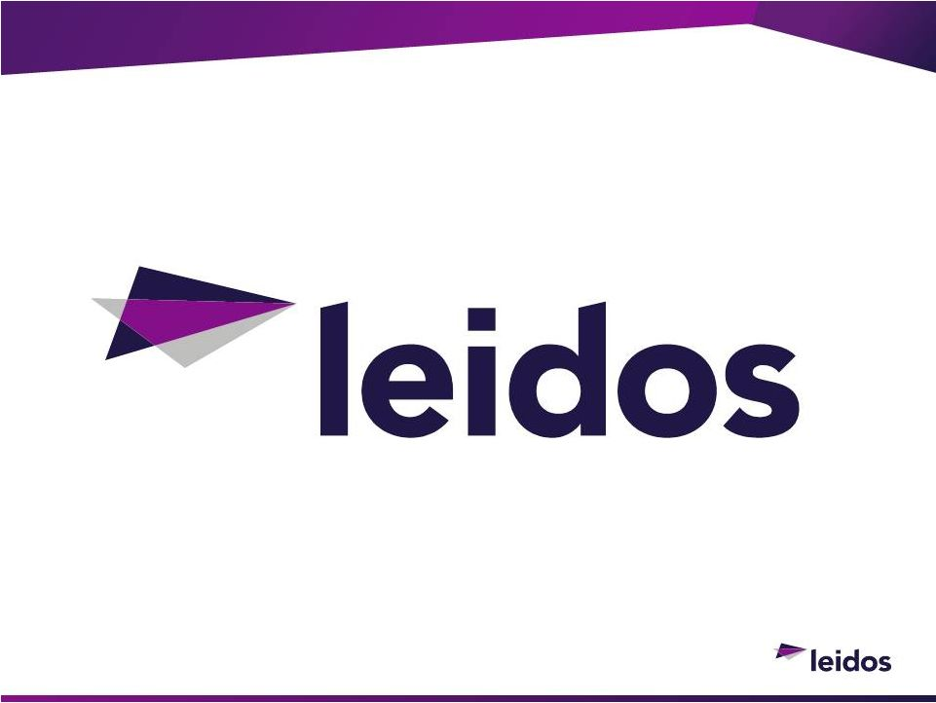


Strategy and Operations
Stu Shea
PRESIDENT AND CHIEF OPERATING OFFICER


©2013 LEIDOS. ALL RIGHTS RESERVED.
Executing on Our Vision
Why Leidos Matters
Who We Are
What Makes Us Distinctive
What is Our Value Proposition
What You Should Expect From Us
We Have a Roadmap for Delivering Value to our Shareholders
14

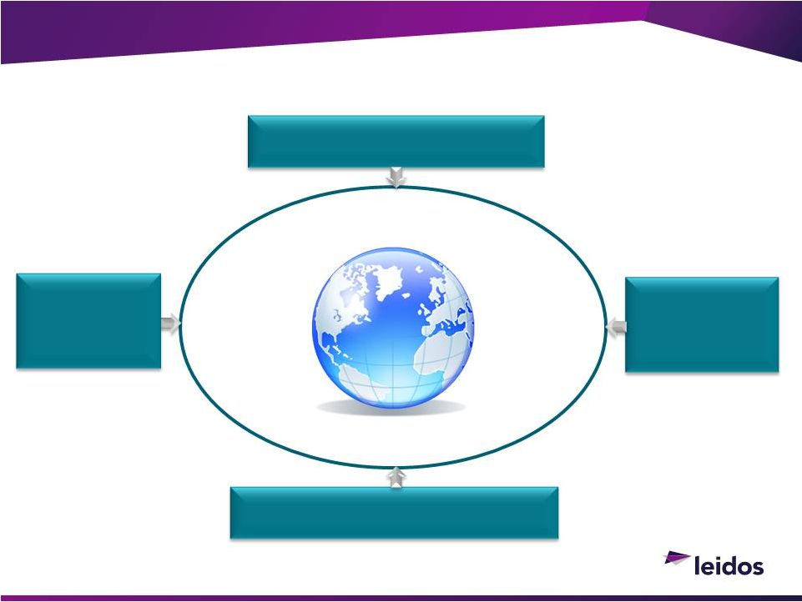
Why Leidos Matters: Convergence of Megatrends
Giving Rise to Opportunities in Enduring Markets That Matter
15
Increasingly
Impactful
Cybersecurity
Threats
National
Security Threats
Protected
Environment
Clean
Water
Aging Critical
Infrastructure
Border
Protection
Cyber
Threats
Global
Pandemics
Clean
Energy
Preserve
Natural
Resources
Affordable
Healthcare
Increasingly Challenging Economics,
Geopolitics, and Urbanization
Increasingly
Global,
Interconnected
Markets
Increasingly Complex,
Data Rich Environments
©2013 LEIDOS. ALL RIGHTS RESERVED.

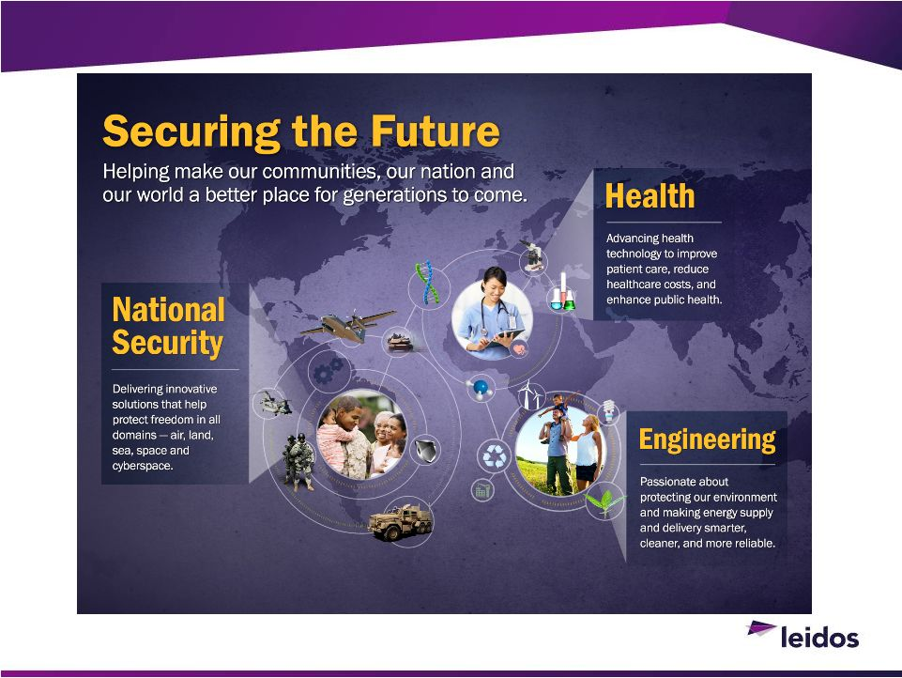
16
©2013 LEIDOS. ALL RIGHTS RESERVED.

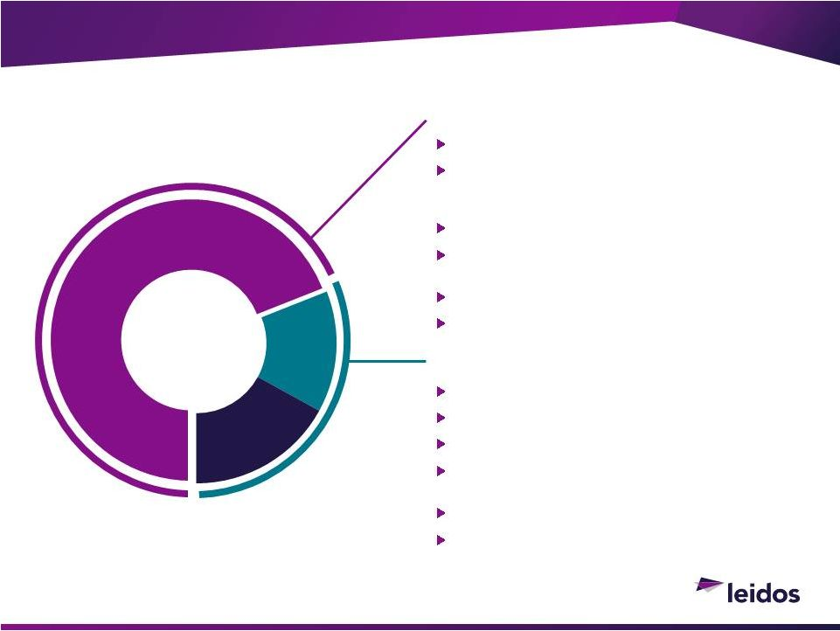
©2013 LEIDOS. ALL RIGHTS RESERVED.
Who We Are
Solutions That Secure Our Future and Our Way of Life
17
FY2014 revenues: ~$6B
National
Security
68%
Health
14%
Engineering
17%
National Security Sector
~$4B revenue
13,500 employees with >10,500 possessing
DoD, TS/SCI, SAP/SAR, and DoE security
clearances
99% government, <1% commercial
Critical mission support for intelligence
community
C4ISR R&D and solutions for DoD
Industry-leading cybersecurity capabilities
Health & Engineering Sector
~$2B revenue
9,500 employees
63% commercial, 37% government
Healthcare information technology, electronic
health records, and advanced data analytics
Health and life science / clinical research
Energy grid and critical infrastructure design
and integration

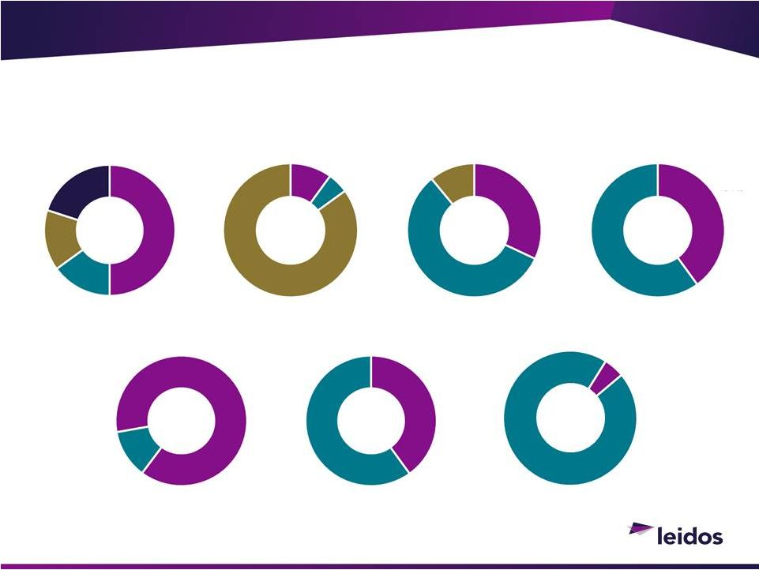
Revenue Composition
Diversified and Stable Revenue Base, Low Concentration Risk
18
Contract Type
Prime vs. Subcontract
Contract Concentration
IDIQ v. Non-IDIQ
Employee Location
Customers
OCO Exposure
Intelligence /
Cyber
Other
Commercial
Federal
Gov
Defense
Top 5
Top
6-10
Subcontract
T&M
Fixed Price
Cost Plus
Customer
Site
Non
IDIQ
Prime
OCO
Non OCO
Leidos
Site
IDIQ
©2013 LEIDOS. ALL RIGHTS RESERVED.

©2013 LEIDOS. ALL RIGHTS RESERVED.
We Have the Right Team
A Balanced, Well-Educated Workforce Capable of Creating the Right Solutions
19
United States
Top Operating Locations
International
Years of Service
Degrees
Veterans
Concentration
Washington, DC (26%)
Baltimore, MD (16%)
San Diego, CA (6%)
Boston, MA (3%)
Orlando, FL (3%)
Dayton, OH (2%)
St. Louis, MO (2%)
Pensacola, FL (2%)
Knoxville, TN (1%)
Oklahoma City, OK (1%)
Afghanistan
Kuwait
Germany
Canada
Japan
Korea
Australia
United Kingdom
Italy
Iraq
Social
Sciences
Sciences
Engineering
Veterans
Non Veterans
Masters
Bachelors
Others
Doctorate
<2 years
2-5
years
5-10
years
>10
years
Business,
Law,
Economics


©2013 LEIDOS. ALL RIGHTS RESERVED.
Health ($43B)

National Security ($94B)


Evolve value-based
healthcare through data
analytics

Embed cybersecurity for
privacy protection

Focus on agile, mission-
critical integration

Exploit & leverage
technology for mission
advantage

Build on IT, analytics and
engineering capabilities

Bring science &
technology solutions
Engineering ($80B)

What Makes Us Distinctive: Rich Markets
Leveraging Technical Capabilities and Innovate Across Markets
20
One company in three opportunity rich markets of global importance
Drive leading C4ISR
solutions in challenging
mission environments
across all operational
regimes
Improve access and quality
of healthcare by driving
digitization, interoperability
and personalized medicine
Expand commercially and
internationally to meet
global infrastructure and
natural resource needs

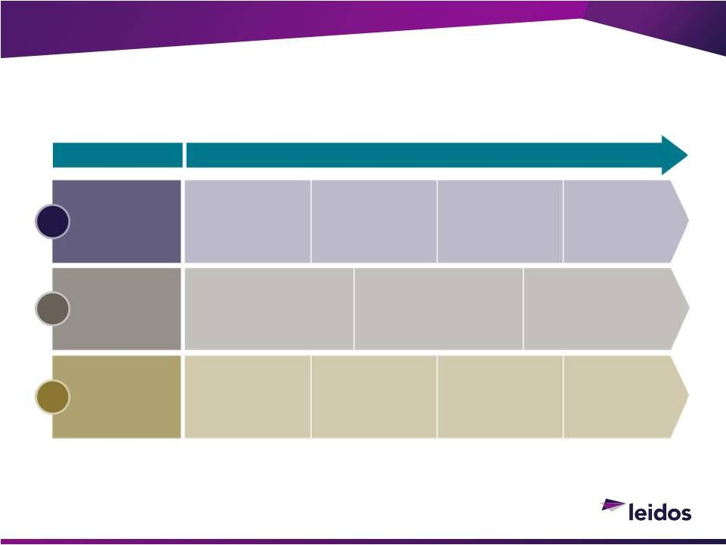
©2013 LEIDOS. ALL RIGHTS RESERVED.
What Makes Us Distinctive: Competitive Levers
Leidos
3 Competitive Levers are Unique, Complete, and Proven
21
Deep
Customer
Domain
Knowledge
Deep scientific,
technology, and
subject matter
expertise
Complex
data and
analytic
insight
Relevant
customer
operational
expertise
Community
thought
leadership
1
People,
Process,
and Tools
Highly educated
workforce
ISO, CMMI
certifications
Physics-based
modeling and
simulation
2
Scalable
Capabilities
Applied
research and
development
Pilot
engagements
and system
prototypes
Component,
systems, and
subsystems
Agile, quick
reaction/
delivery
solutions
3
3 Key Levers
The Leidos Performance Value Chain

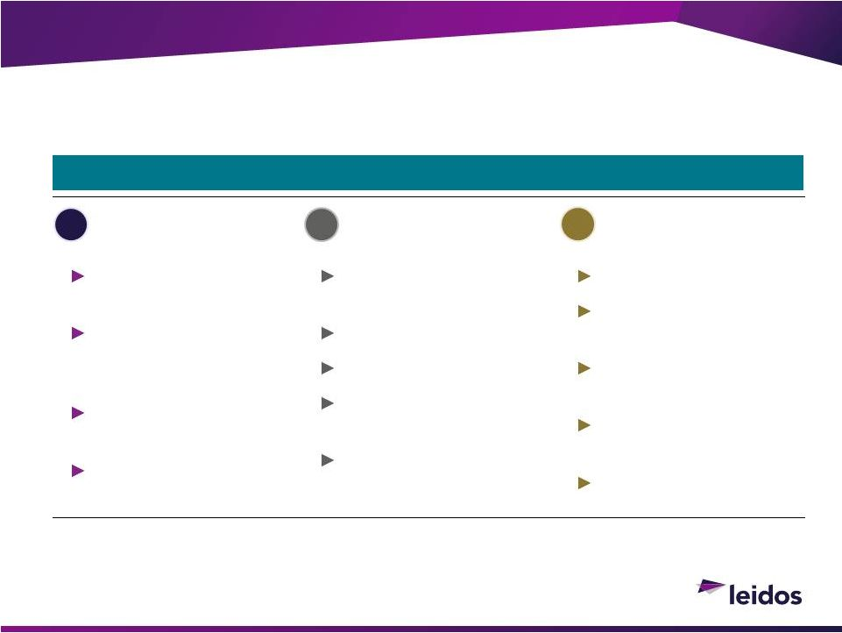
©2013 LEIDOS. ALL RIGHTS RESERVED.
What Makes Us Distinctive: Solutions That Work
Our Strategy Gives Us a Roadmap for Meeting Our Objectives
22
People, Processes,
and Tools
Deep Customer
Domain Knowledge
Agile development
processes
Repeatable processes
Reliable integrators
Physics-based modeling
and simulation
Science and technology
heritage
Practical operational
knowledge
Embedded with our
customer
community
Critical to mission
success
Respected community
thought leadership
Concept to creation
Information-enabled
engineering
Advanced data
analytics
Full range of
CyberSecurity
Appropriate solutions
Scalable
Capabilities
1
2
3
One company with Three Unique Levers

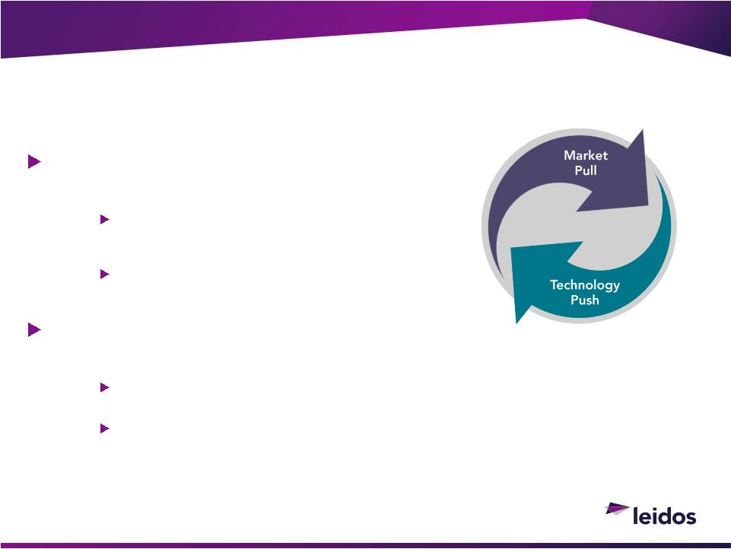
©2013 LEIDOS. ALL RIGHTS RESERVED.
What Makes Us Distinctive: Information-Driven
Capabilities
Achieving technology leverage

Market
pull
is
enabled
by
technology
Provides channel access to customers

Technology
push
is
informed
by
the
market
Retains the imperative of innovation
Opportunity to scale

Diverse markets share common technical challenges
Health market drowning in data and need to offset demanding regulatory
challenges
Future of a highly-interconnected infrastructure (energy sensors)

Additional investments key capabilities
Enterprise Strategy, Focused Leadership, and Repeatable Solutions
23


©2013 LEIDOS. ALL RIGHTS RESERVED.
Leidos Investment Thesis
Compelling vision and performance objectives
Balanced financial strategy
Repeatable operating model
Aggressive portfolio management
Common core of information-driven capabilities
Proximity and criticality to operators & customers
Continually optimized cost structure
24


©2013 LEIDOS. ALL RIGHTS RESERVED.
What You Should Expect From Us: Performance
Maintain discipline

Laser-focused on core markets

Controlled adjacencies
Expanding commercial
portfolio
Technology sharing

Increased, shared investment
Economic profit improvement

Quality revenues

Educated workforce

Higher margin expectations
We Will Drive Profit Growth While Earning a Competitive Return on Capital
25
Perform on current contracts

Early contract reviews

Integrated early warning system
Divestitures and monetization

Portfolio shaping
Better return of capital
to shareholders
Continuous attention to cost
efficiencies

Improved business ecosystems


©2013 LEIDOS. ALL RIGHTS RESERVED.
26
National Security
Engineering
Health
Cybersecurity

National Security
Lou Von Thaer
SECTOR PRESIDENT


28
~$4B in revenues
NSS capabilities aligned to address our Nations vast Intelligence &
Defense requirements
Intelligence collection, analysis and exploitation of data expertise are
indispensable in todays world

Comprises 80% of NSS revenues
New multibillion dollar OCI-deconflicted markets available to pursue
Forty-four year track record of winning competitively and executing
Highly regarded industry reputation

Adept at rapidly developing and producing cost-effective solutions
©2013 LEIDOS. ALL RIGHTS RESERVED.
National Security Sector -
Positioned for
Success

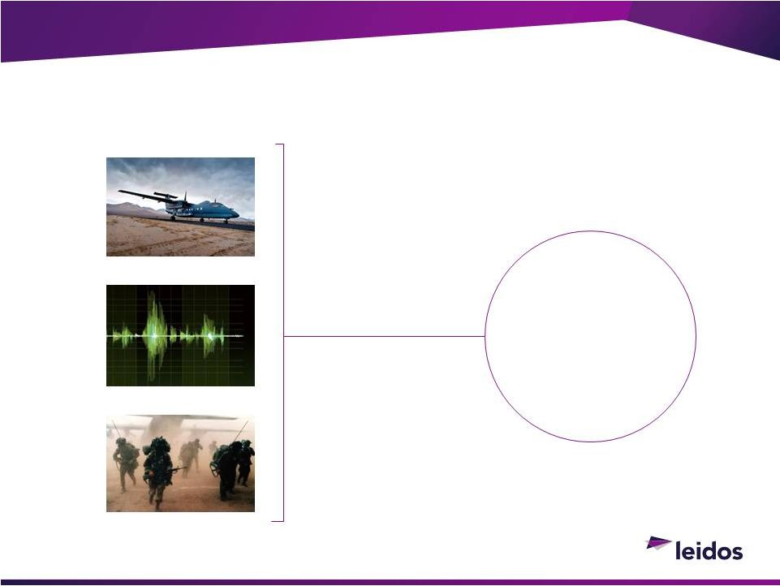
Leidos
Information
Enabled
Solutions
29
©2013 LEIDOS. ALL RIGHTS RESERVED.
Market Shift Plays to Leidos
Advantage
CONVERGENCE
In the future, those that control the
information will control greater
portions of the budget
PHYSICAL REALM
DIGITAL REALM
OPERATIONAL REALM


30
©2013 LEIDOS. ALL RIGHTS RESERVED.
Disclosed US Government Intelligence Budget
Intelligence Spending
CURRENT DOLLARS $B
Key contributors to U.S. intelligence for four decades
Sources:
DNI
disclosure
of
National
Intelligence
Budget
&
DoD
Green
Book;
USD
not
adjusted
for
inflation.
80%
of our current revenue
National Security
Sector Revenue
2006
2007
2008
2009
2010
2011
2012
2013
MIP Budget
NIP Budget
$10
$20
$30
$40
$50
$60
$70
$80
$90
80%
INTELLIGENCE
15%
DEFENSE
5%
DHS &
COMMERCIAL
$0

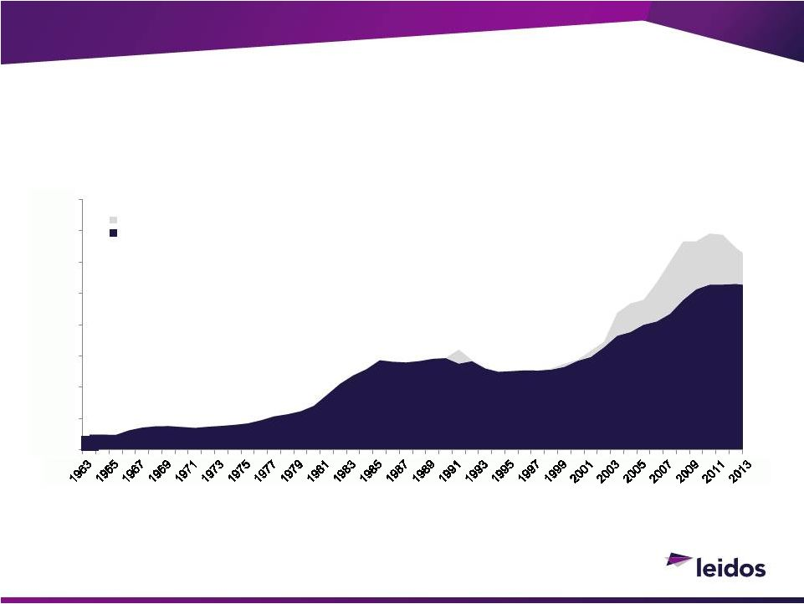
31
©2013 LEIDOS. ALL RIGHTS RESERVED.
Expanding Growth Into Defense Market
Reagan Era
Vietnam Era
Iraq/Afghanistan
Source: DoD Green Book, USD not adjusted for inflation
Long-term growing market
DoD Spending
CURRENT DOLLARS $B
War Funding
Current Year
$0
$100
$200
$300
$400
$500
$600
$700
$800

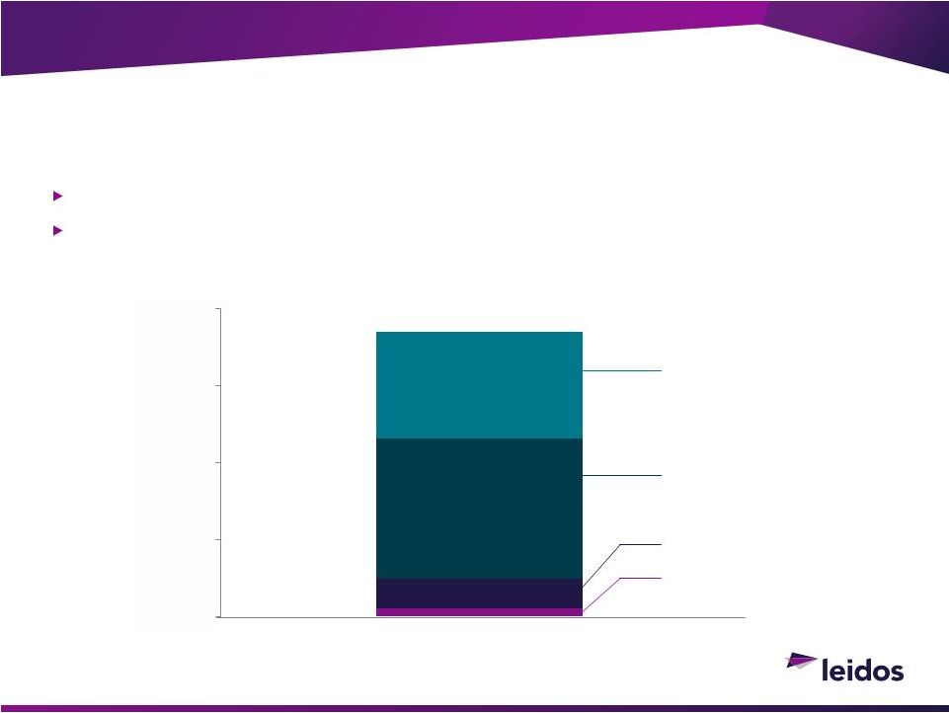
32
Addressable market increases dramatically upon separation
Significant opportunity space in long term Defense budgets
©2013 LEIDOS. ALL RIGHTS RESERVED.
National Security Sector Unconstrained
Markets
$37B
AIR FORCE
NAVY
ARMY
SOCOM & UNIFIED
COMMANDS
$0
$10
$20
$30
$40

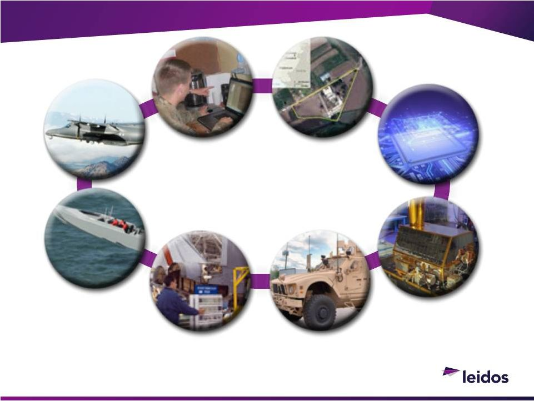
33
©2013 LEIDOS. ALL RIGHTS RESERVED.
National Security
Maritime
Systems
Space
Systems
Airborne
Systems
Ground
Systems
Readiness &
Sustainment
Cybersecurity
Intelligence Analysis &
Production
Intelligence
Systems
Critical Mission Support in all Operational Domains:
Air, Land, Sea, Space and Cyberspace

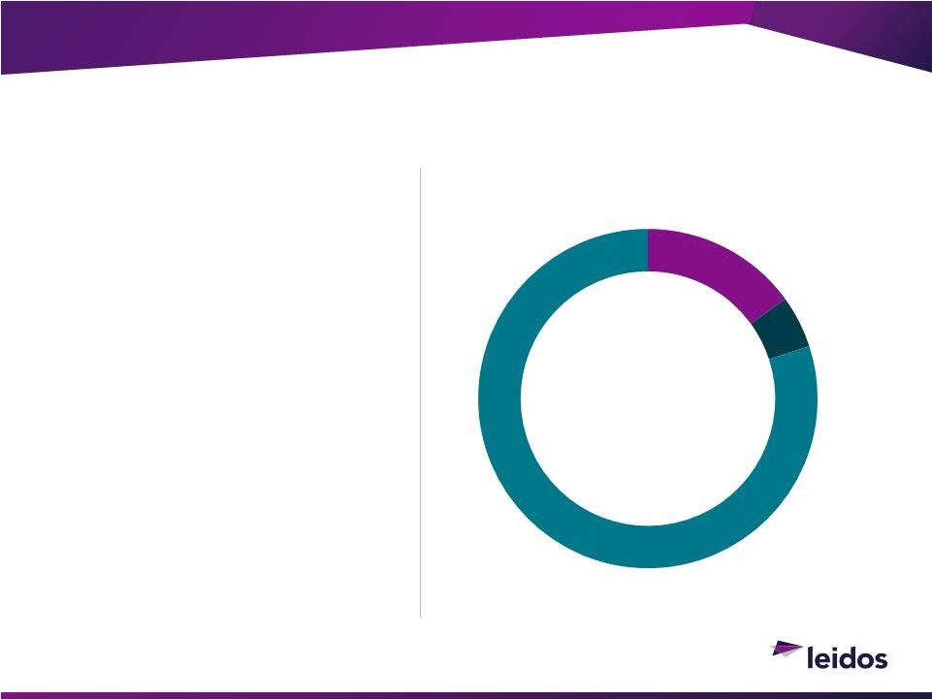
34
©2013 LEIDOS. ALL RIGHTS RESERVED.
National Security at a Glance
13,500
PROFESSIONALS
10,500
WITH SECURITY CLEARANCES
Broad technology,
development and
integration capabilities
CONTRIBUTE TO OUR CUSTOMER MISSIONS
OUR CORE RESOURCES
5%
DHS AND COMMERCIAL
15%
DEFENSE
80%
INTELLIGENCE


35
©2013 LEIDOS. ALL RIGHTS RESERVED.
National Security at a Glance
Increase of $37 Billion in Addressable Market
BUSINESS
SEGMENT
REVENUE
PERCENTAGE
ADDRESSABLE
MARKET
Technology
25%
$47B
Intelligence
60%
$23B
Cybersecurity
15%
$24B
$94B


36
Diversified contract base
Top 10 contracts < 25%
of total revenues
9 of Top 10 contracts in
stable intelligence market
©2013 LEIDOS. ALL RIGHTS RESERVED.
National Security at a Glance
FY14 Top Contracts
PROGRAM
REVENUE
BUSINESS
SEGMENT
Classified
$154M
Intelligence
Saturn Arch
$140M
Technology
GGI
$102M
Intelligence
MRAP JLI
$ 99M
Intelligence
Classified
$ 97M
Cyber
Classified
$ 86M
Cyber
Classified
$ 85M
Cyber
Buckeye
$ 79M
Technology
Blue Devil
$ 72M
Technology
Joint Intel Ops Center
$ 70M
Intelligence

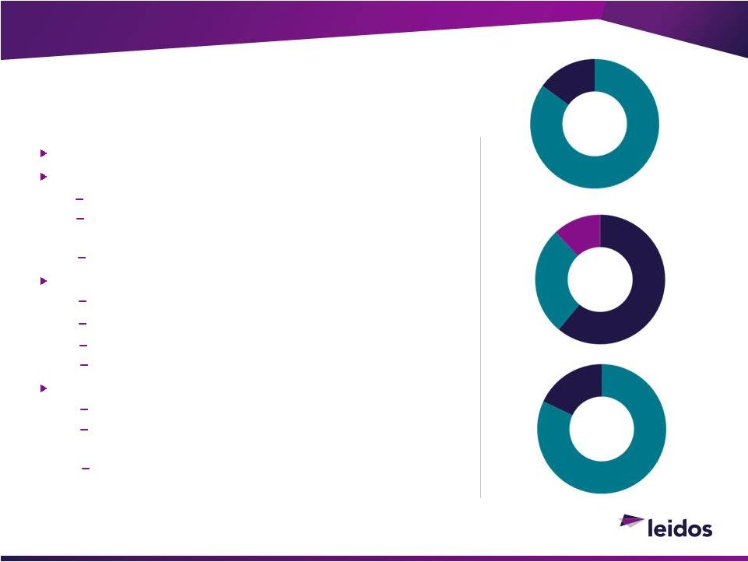
27%
Fixed
Price
37
Proximity to operators & deep domain expertise
Capabilities address emerging market needs
Rapidly deploy cost-effective technical solutions
Advanced analytics to solve complex information
problems
Cybersecurity to defend critical missions and systems
Well positioned in market for revenue & profit growth
Market leader with prime contracts
Broad and established base
Positioned for OCI deconflicted defense market
Streamlined infrastructure with costs reduced 15%
Prolific business development engine
60% increase in proposal submissions
$7B of bids pending award

Additional $7B of IDIQ bids submitted
Competitive
win
rate
(50

65%)
©2013 LEIDOS. ALL RIGHTS RESERVED.
History as a Fierce Competitor
88%
PRIME
82%
Base Funding
61%
Cost Plus
12%
T&M
27%
Fixed
Price
88%
PRIME
12%
SUB
82%
Base Funding
18%
OCO

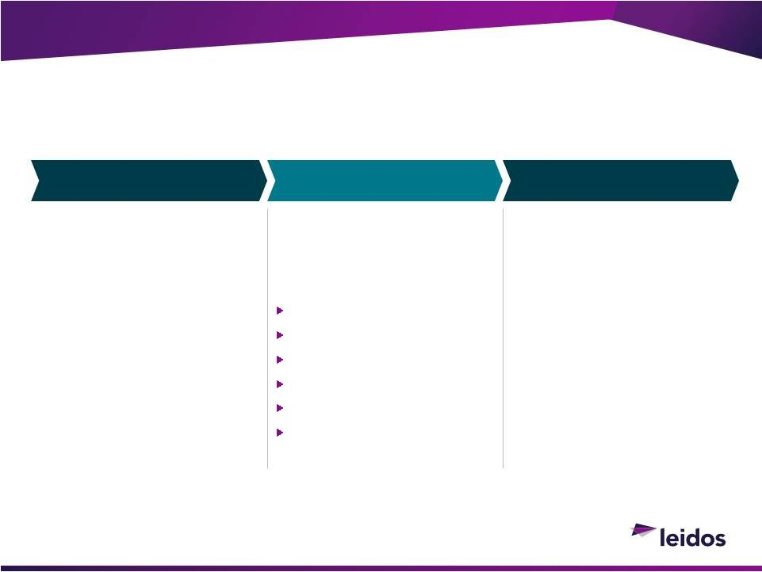
38
Horizontally Integrated
Solutions into New
Markets
©2013 LEIDOS. ALL RIGHTS RESERVED.
Leidos National Security Strategy
Consistent,
Reliable,
Secure
Technology
and
Information
Globally
for
all
Customers
Technology
Intelligence
Cybersecurity
Intelligence
Defense
Homeland Security
Healthcare
Engineering
Utilities
BUSINESS SEGMENTS
DELIVERY FOCUS
MARKETS
Quick to Market
Tailored to Need
Predictive Analytics
Full Life Cycle Support
Affordable
Global Operations

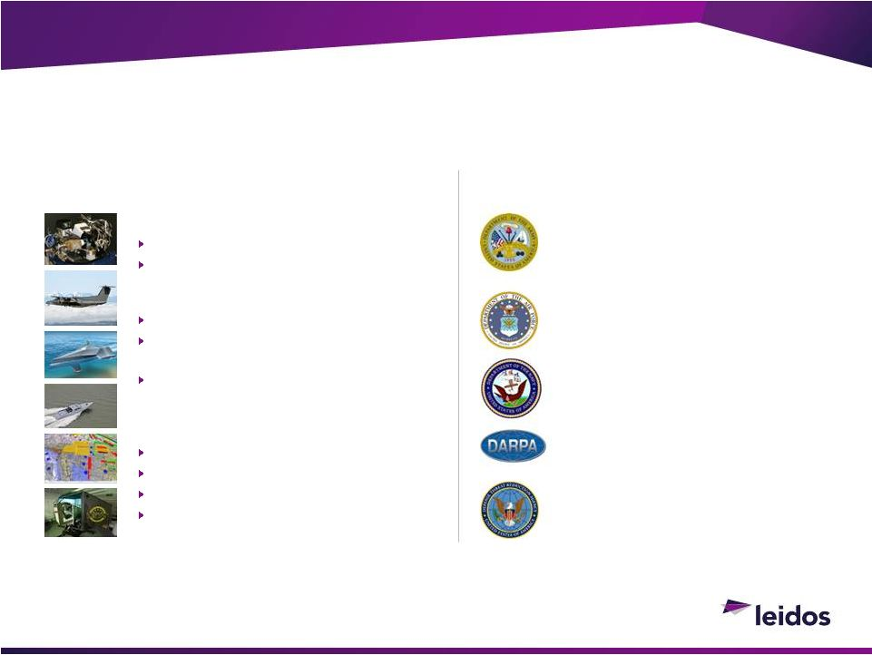
39
©2013 LEIDOS. ALL RIGHTS RESERVED.
Technology Business Segment
Technology-driven end-to-end integrated solutions operating in the air, land, sea & space
Advanced Technology Solutions to Differentiate Leidos Offerings
R&D in air, sea, ground & space
Autonomous and distributed solutions
Modeling, simulation and training
Wide range of technical solutions
First full-spectrum ISR in theater
Leading Navys diesel submarine tracking
prototype
Developing one of two high-speed
prototype crafts for USSOCOM
Transitioning to new markets
Unmanned, autonomous naval systems
Advanced electronic warfare
Border Security missions
Classified next generation sensors
Saturn Arch
Buckeye
Desert Owl
Blue Devil ISR
Target Recognition
Tactical Sonar
Naval Warfare Engineering
MOJAVE
ACTUV
Integrated WMD
Targeting & Intelligence Support
CAPABILITIES
PRIMARY CUSTOMERS
Research organizations across DoD

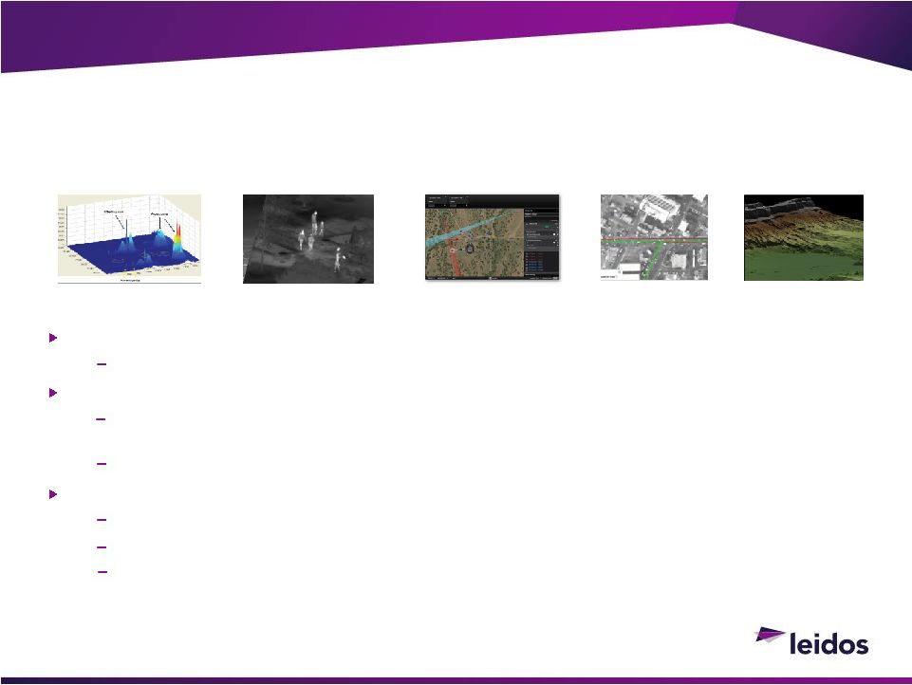
40
©2013 LEIDOS. ALL RIGHTS RESERVED.
Success Story: Distributed Airborne Information
Solutions
Deployed technologies on Blue Devil, Buckeye, Desert Owl, Radiant Falcon, Saturn Arch
Catching Bad Guys and Protecting our Troops
Mission Needs
Customer needed to integrate sensor operations to identify and address threats
Leidos Response
Leidos combined our expertise, experience, and technologies to develop solutions quickly to
match the need
Idea to deployment in less than10 months
Result
Delivered
rapid
persistent,
multisource,
integrated
intelligence
capability
Identified multiple high-value targets
Protected U.S. and coalition troops operating in high-threat areas
Day & Night
3-D Geospatial
Multiple Sources
Full Motion Video
Wide Area Imagery
Technology Business Segment

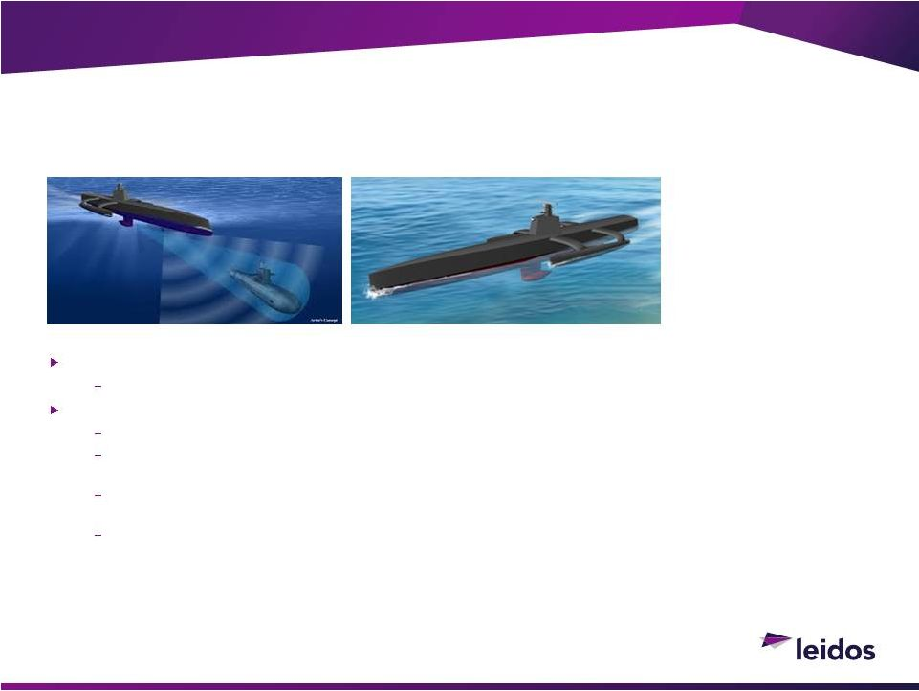
41
Expanding market for Navy autonomous solutions to address expanding threats
Navy developing solution to counter diesel submarines
Leidos ability to meet Navys need
Leading
prototype
design
to
track
diesel
electric
submarines
for
months
at
a
fraction
of
their
size
and
cost
Leveraging integration capabilities in ocean modeling, systems engineering and integration, and software
development
Enabled by experience in design and build of maritime sensors, communications systems, autonomous
controls, and propulsion systems
Positions Leidos for expanded Navy business over the coming decade
©2013 LEIDOS. ALL RIGHTS RESERVED.
Growth Opportunity: Naval Autonomous Technology
Design and integrate unmanned, autonomous solutions for intelligence and defense needs
Advanced Platform Development to Meet Demanding New Mission Needs
ACTUV: Anti-Submarine
Warfare (ASW) Continuous
Trail Unmanned Vessel
130
40
80
FEET LONG
FEET WIDE
TONS
Technology Business Segment

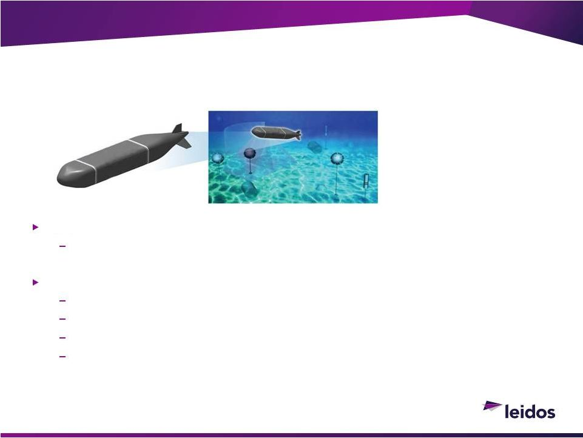
42
Growing market for multiple mission autonomous systems
Navy
developing
affordable,
versatile
systems
for
deploying
and
retrieving
equipment
Leidos ability to meet Navys need
Leveraging ACTUV prototype design experience
Knowledge in underwater operations, propulsion, and controls
Broad experience in intelligence, surveillance, and reconnaissance
Expanding Leidos offering for next-generation Navy systems
©2013 LEIDOS. ALL RIGHTS RESERVED.
Growth Opportunity: Naval Autonomous Technology
Design and integrate unmanned, autonomous solutions for intelligence and defense needs
Leveraging
Technology
and
Experience
into
Affordable
Future
Navy
Workhorse
25
5
5
FEET LONG
FOOT DIAMETER
TONS
UUV:
Unmanned
Underwater
Vehicle
Technology Business Segment

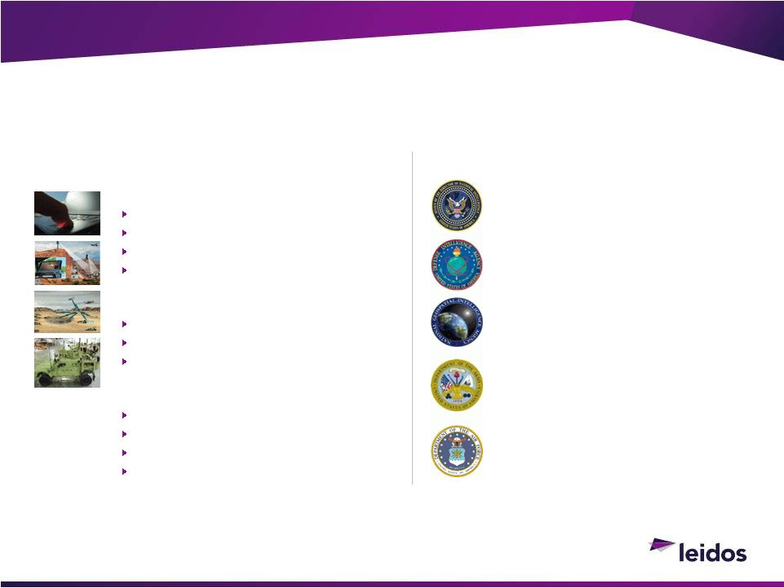
43
©2013 LEIDOS. ALL RIGHTS RESERVED.
Intelligence Business Segment
Building wide range of information processing systems solving toughest challenges today
Delivering Glue-ware
to Create Integrated Systems for Decision Makers
PRIMARY CUSTOMERS
System Engineering & Integration
Delivering across Intelligence & Defense
Pursuing adjacent markets in Defense
Classified
Intelligence Communications
Army Military Intel Enterprise
Joint Intelligence Ops Center
Geospatial Production
iSTORE Content Management
MRAP JLI
Distributed Common Ground
System
GPS System Engineering
TACAN Replacement
CAPABILITIES
Advanced analytics
Software development
Intelligence analysis & operations
Integrated logistics solutions
Top geospatial products producer for IC
Leading NSA & Army data analytics
First Intel & Defense Cloud architectures
Bid Data & Cloud solutions
Integrated intelligence systems
Infrastructure protection
Modernization, readiness & sustainment

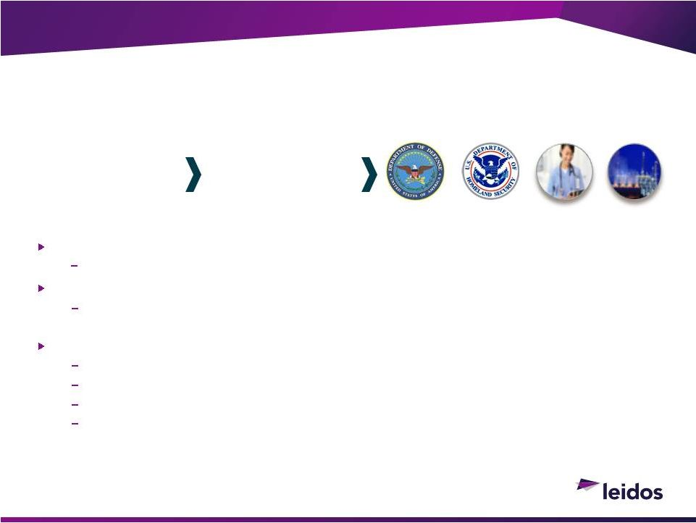
44
Mission Need
Intelligence community must review massive amounts of data to make accurate decisions
Leidos Response
Leidos leveraged our domain knowledge, data analytics and software development
capabilities to deliver the leading data analytics platform
Result
Leidos solution transformed tactical intelligence
Leidos implemented a 40x improvement in throughput following year
The most significant SIGINT system in aiding the Warfighter in the past 10 years
In 2013, Leidos developed a commercial platform operating at a 200x improvement
©2013 LEIDOS. ALL RIGHTS RESERVED.
Success Story: Big Data Analytic Solution
Leverage leading data analytics successes in Intelligence into broader markets
ENERGY
HEALTH
DEFENSE
DHS
CRITICAL INSIGHT
Intelligence Data
Analytics Tools
Commercial Data
Analytics Tool
Intelligence Business Segment

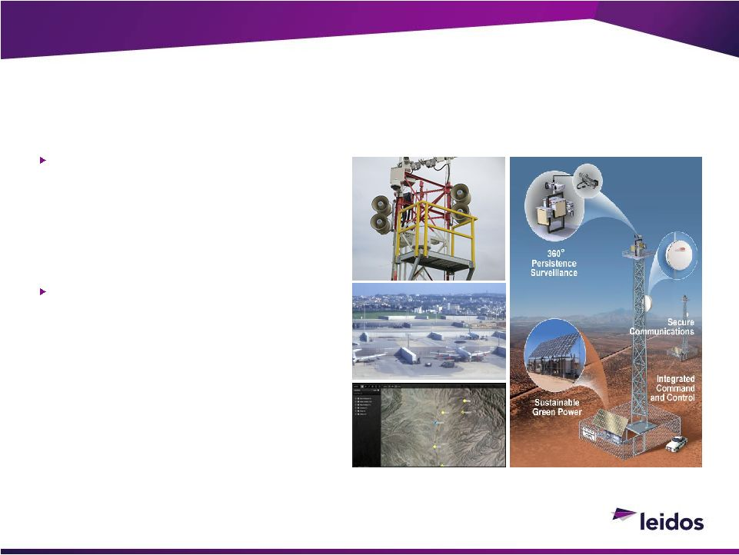
45
DHS seeking low-risk near-term
solution for U.S. border security

Failed Secure Border Initiative program
delayed border security implementation

Seeking proven system to detect and
track items of interest along nation's
borders
Leidos ability to meet DHS
need

Leverage security and force protection

Integrated solution with proven systems
and operations experience

Automated solution flexible and easy to
operate

Positioned for growth in U.S. and global
markets
©2013 LEIDOS. ALL RIGHTS RESERVED.
Growth Opportunity: Border Security
Surveillance
Rapid solution deployment for high confidence border security
Proven, affordable and flexible solutions for border security
Intelligence Business Segment

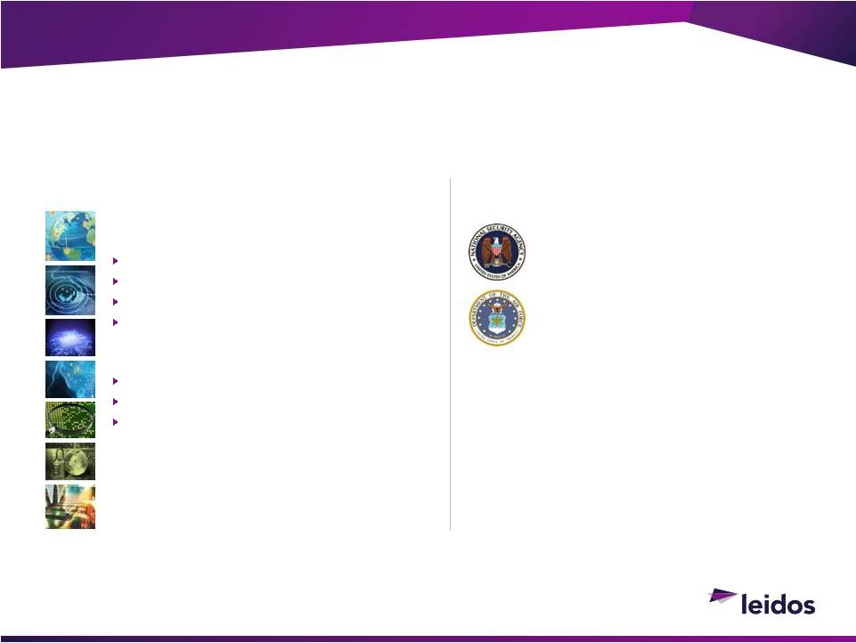
46
©2013 LEIDOS. ALL RIGHTS RESERVED.
Cybersecurity Business Segment
Delivering over $700M of Cybersecurity to the Intelligence Community to constantly defend critical
infrastructure against the most sophisticated adversaries
Leveraging Cyber leadership in Intelligence to address increasing commercial demands
Leading Cyber Provider in Intelligence
Community
Computer Defense, Exploitation, & Ops
Predictive Cyber analytics
Largest forensics malware in IC
Large-scale systems design and integration
Delivering Broad Cyber Solutions
Cryptographic algorithms, key management
Cyber software development
Navy 2013 Tech Award: Cyber Domain Services
Expanding Cyber beyond Intelligence
Community
Federal Government
Classified (Multiple)
Key Management
U.S. National Data Center
Key Management
Commercial & Critical
Infrastructure
Health
Critical Infrastructure
Commercial Providers
CAPABILITIES
PRIMARY CUSTOMERS

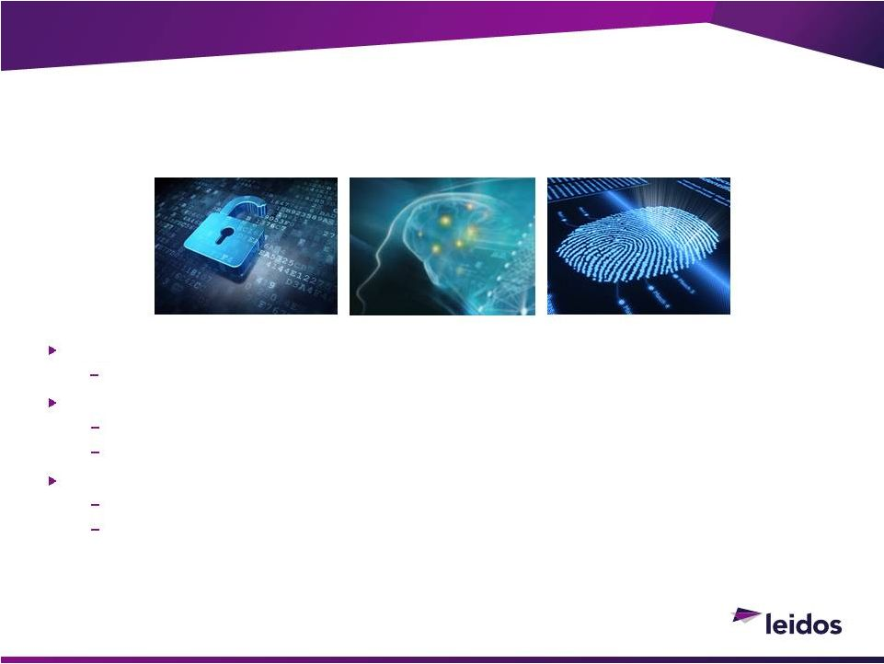
47
Mission Needs
Intelligence community faced with constant, sophisticated cyber attacks
Leidos Response
Developed solution to identify and defend against new cyber threats
Delivers software to defend against new attacks, and protect networks across IC
Result
Enterprisewide protection from new and emerging cyber threats
Well positioned to leverage capabilities across defense and commercial markets
©2013 LEIDOS. ALL RIGHTS RESERVED.
Success
Story: Cyber Signature Management
Delivering cyber signatures to protect critical Intelligence Community infrastructure
Cybersecurity Business Segment

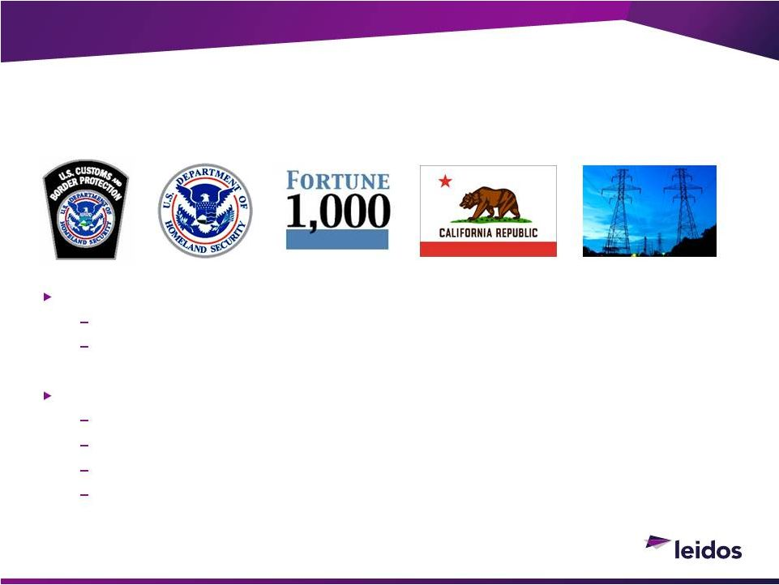
48
DHS and commercial companies seeking secure network solutions
Cyber threats continue to expand in numbers and sophistication
Need for reliable cyber protection expanding
Leidos has the ability to meet emerging needs
Deliver differentiated solutions to protect networks and information
Provide cybersecurity defense and incident response
Highest margins, fastest growing market
Solutions in development
©2013 LEIDOS. ALL RIGHTS RESERVED.
Growth Opportunity: Cyber Threat Operations
Using
intelligence-based
capabilities,
deliver
cybersecurity
to
protect
federal
and
commercial
entities
Cybersecurity Business Segment

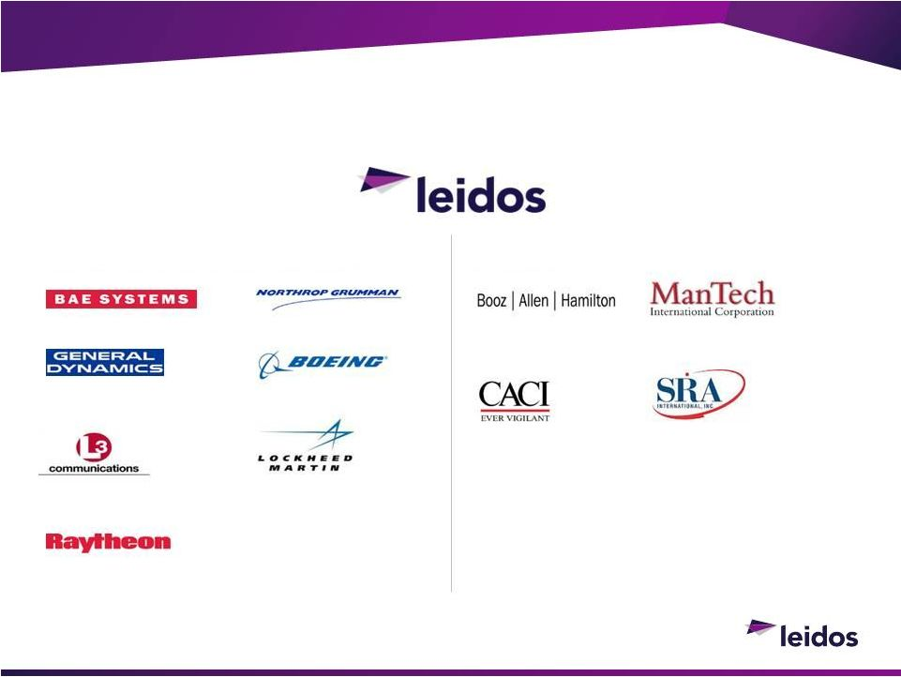
49
©2013 LEIDOS. ALL RIGHTS RESERVED.
Competition
Intelligence & Security
Information Systems
& Technology
Information Systems &
Global Solutions
National Security
Solutions
Intelligence, Information
& Services
Information Systems
Defense, Space & Security
SERVICES
Mission, Cyber &
Intelligence Solutions
SYSTEM INTEGRATORS & SOLUTIONS


50
NSS brings a 44 year history of performance in good markets and bad

Leidos design drives horizontal technology collaboration in expanded markets

Continual focus on streamlined operations at reduced cost

Expanded focus on increasing earnings to drive shareholder value
Continued need for intelligence and market shift plays to Leidos
advantage
Nimble and affordable
Uniquely positioned to compete
©2013 LEIDOS. ALL RIGHTS RESERVED.
Summary
Leidos 
Missions that Matter

Health & Engineering
Joe Craver
SECTOR PRESIDENT

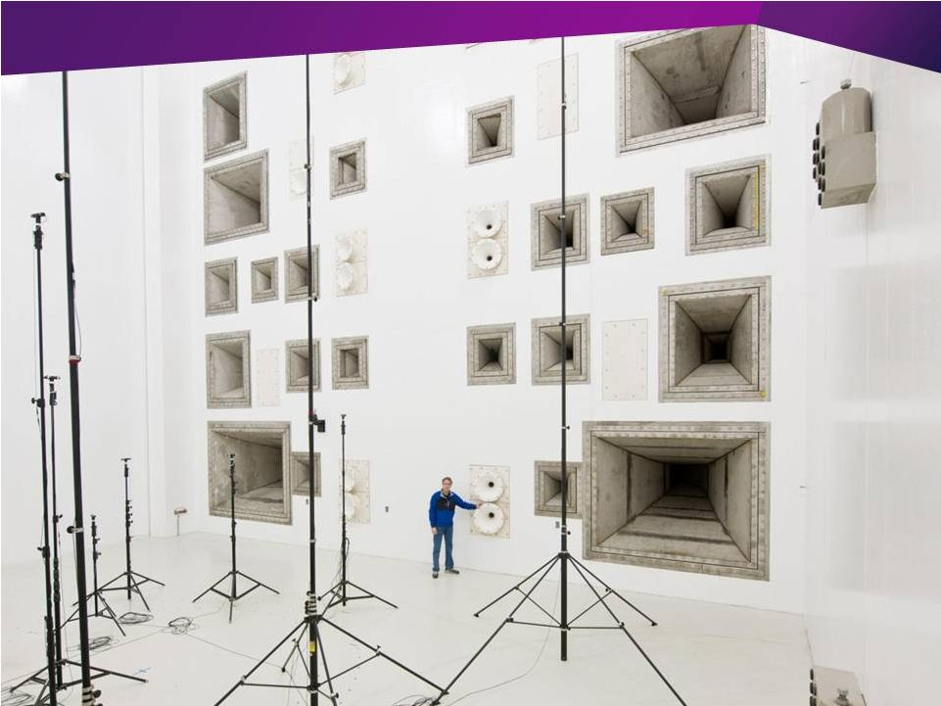

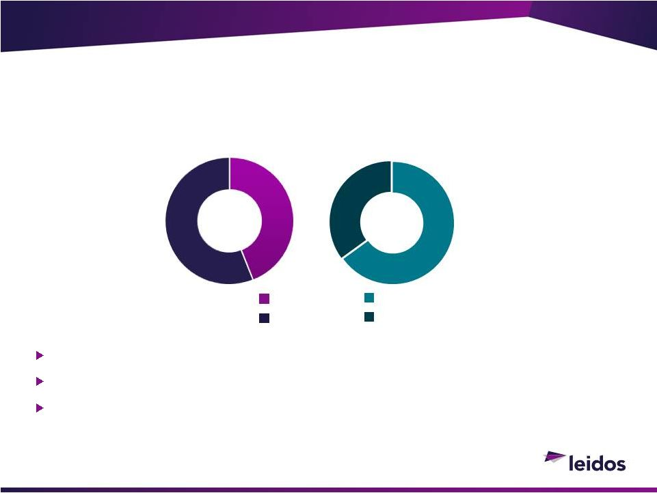
53
Long-term market presence with solution and service delivery at scale
Applied solutions focused on large, receptive commercial markets
Core capability leverage with broad impact across multiple market
segments
©2013 LEIDOS. ALL RIGHTS RESERVED.
Health & Engineering Sector
Healthcare
Engineering
~$2B Revenues
Commercial
Federal
63%
37%
43%
57%

Leidos Health


55
Material presence and scale in more than $35B healthcare IT market
Market drivers and business imperatives creating need for health
organizations to seek applied solutions
Extensive
client
list,
reputation
for
quality
and
partnered
with
all
the
industry leading software vendors
Uniquely positioned with expertise in IT, clinical transformation,
behavioral health, life sciences and data analytics
Positioned to grow in both Commercial and Federal markets
©2013 LEIDOS. ALL RIGHTS RESERVED.
Leidos
Health

Positioned
for
Long-Term
Success

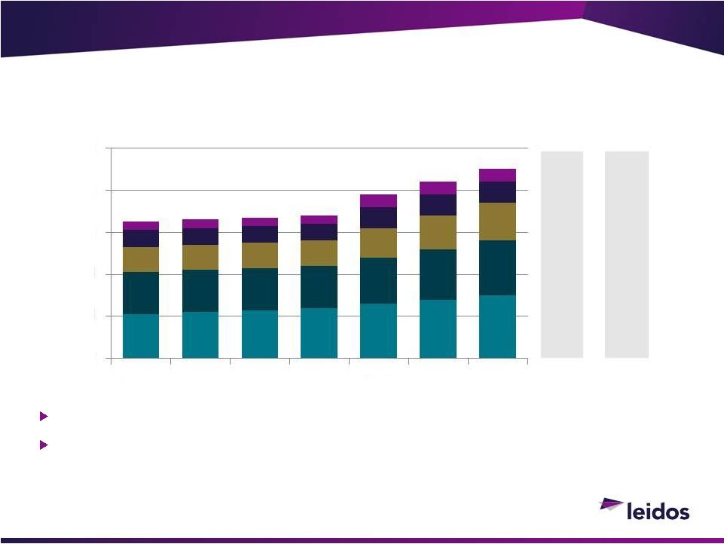
34
35
36
39
41
43
45
Hardware
Telecom
Software
Internal
Services
IT
Services
56
International Health IT market is more than $90B
Total addressable market is much bigger than just Health IT
©2013 LEIDOS. ALL RIGHTS RESERVED.
U.S. Healthcare Provider IT Market
Source: Gartner Enterprise IT spending by verticals forecast, 2013Q1
CAGR
1113F
4%
4%
2%
6%
7%
0%
CAGR
13F17F
5%
3%
3%
7%
7%
4%
0
10
20
30
40
50
2011
2012
2013
2014F
2015F
2016F
2017F

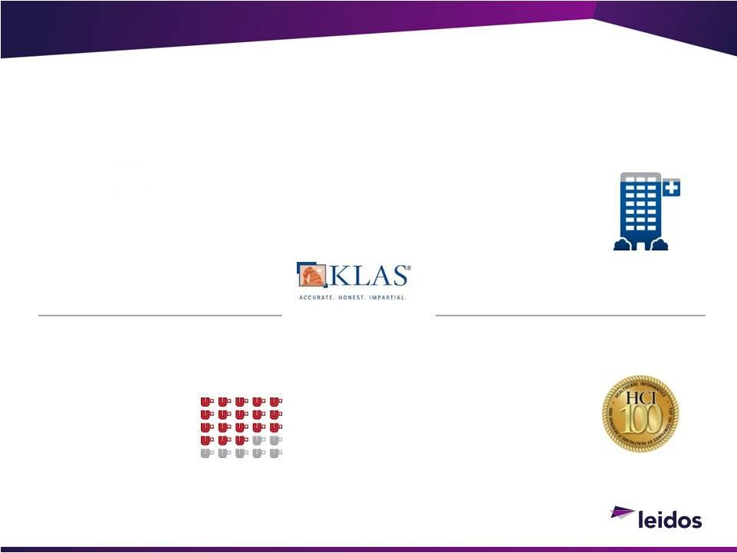
57
©2013 LEIDOS. ALL RIGHTS RESERVED.
Leidos Health in the Marketplace
#9
Modern Healthcare's
2013 Management
Consulting Firms
Engaged by
18 of 25
largest Academic
Medical Centers as
listed by Modern
Healthcare 2012
Worked with
15 of 18
U.S. News and
World Reports
2012-13 Best
Hospitals Honor Roll
#4
KLAS Ranking of Overall
Health Services Firms
#18
Healthcare
Informatics Top 100


58
Major Shift as Healthcare Becomes More Data-Enabled
©2013 LEIDOS. ALL RIGHTS RESERVED.
A New Era in Healthcare Is Emerging
Leidos
Analytical Capabilities and Domain Knowledge
Allow Us To Excel In Data-Enabled Environments
Tomorrow
Today
Digitization
Integration and
Interoperability
Data
Leverage
Precision Medicine
& Personalization

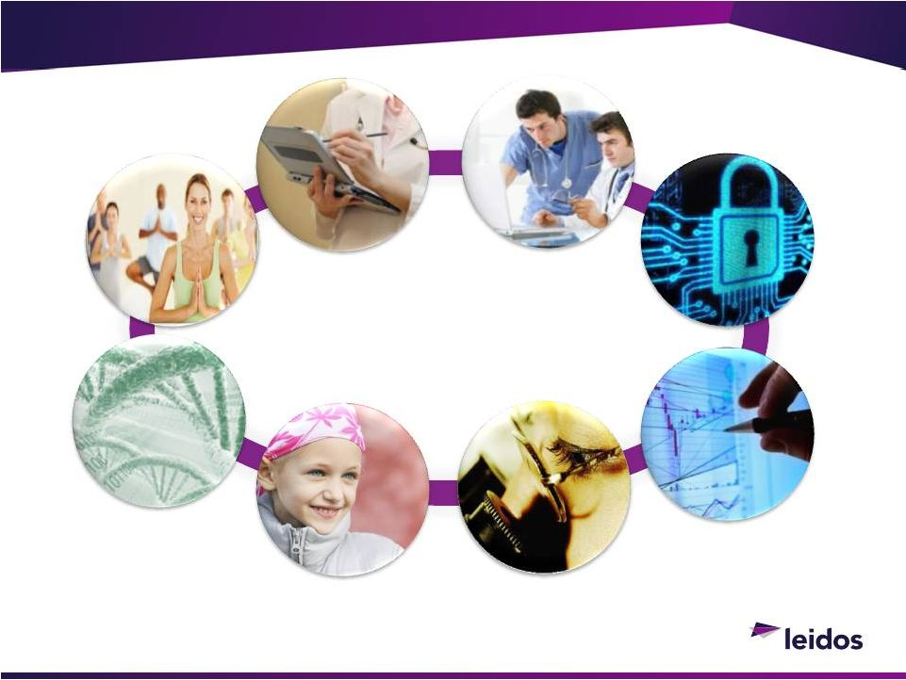
Health Solutions
Electronic Health Record
System Implementation
& Optimization
Health
Information
Security
Behavioral Health
Research &
Outreach
Biomedical
Data
Integration &
Warehousing
Health IT Framework
& Information
Exchange
Advanced
Data
Analytics &
Visualization
Biomedical
Research &
Development
Public Health
Surveillance
& Outreach
59
From the Research Bench to the Patient Bedside
©2013 LEIDOS. ALL RIGHTS RESERVED.

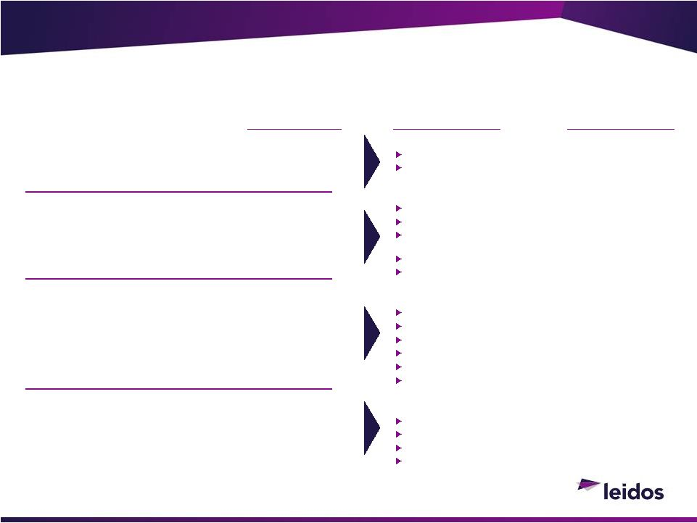
EHR implementation
Optimization
Information integration
IT services
Application development and
maintenance
Ongoing system support
Legacy system support
Strategic IT planning
Meaningful use
Clinical transformation
ICD-10
Revenue cycle management
Data analytics; cybersecurity
Behavioral health
Public health
Life sciences
Health research
What We Do
45%
15%
10%
Leidos Health
5-Year
Growth
Trajectory
510%
36%
10%+
Percent of
Leidos Health
Business
30%
36%
EHR Consulting
(Digitization)
Systems Integration
(Integration and Interoperability)
Strategic Services and Solutions
(Data Leverage)
Health Research and Life Sciences
(Precision Medicine and Personalization)
Capabilities
©2013 LEIDOS. ALL RIGHTS RESERVED.
60

61
©2013 LEIDOS. ALL RIGHTS RESERVED.
Leidos Health Clients
Helping Drive the Transformation Towards Value-Based Healthcare
Federal Health Clients
Commercial Clients

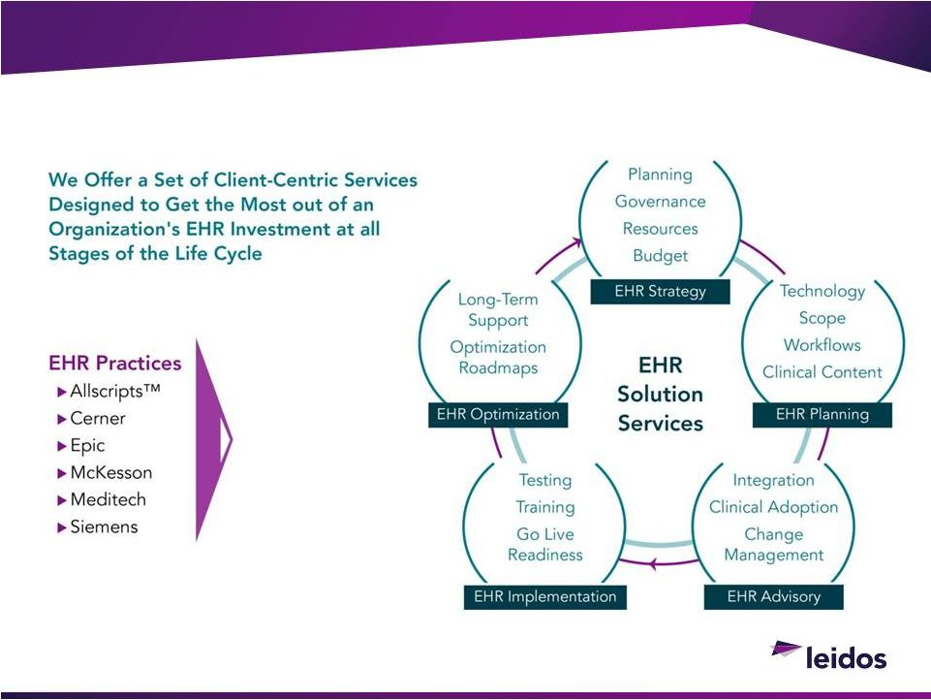
62
©2013 LEIDOS. ALL RIGHTS RESERVED.
EHR Consulting
Digitization

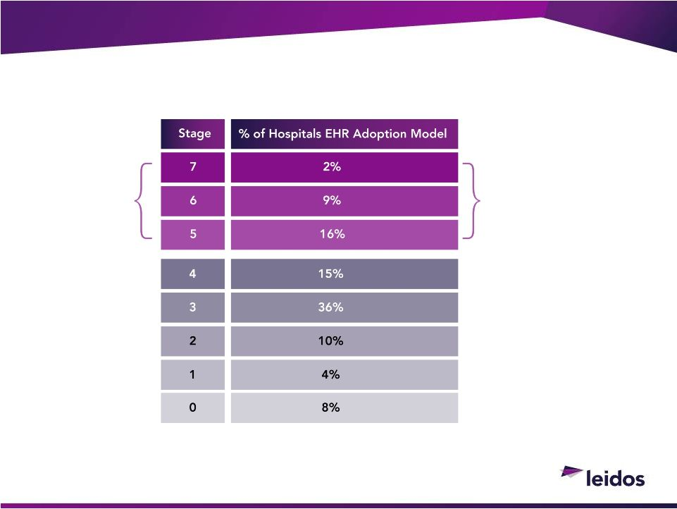
63
©2013 LEIDOS. ALL RIGHTS RESERVED.
EHR Consulting
Majority of Institutions Have Underdeveloped EHR Capabilities
Data from HIMSS Analytics Database Q1 2013
7
Digitization
Only
27%
of
hospitals have
reached Healthcare
Information and
Management Systems
Stage 5 or higher

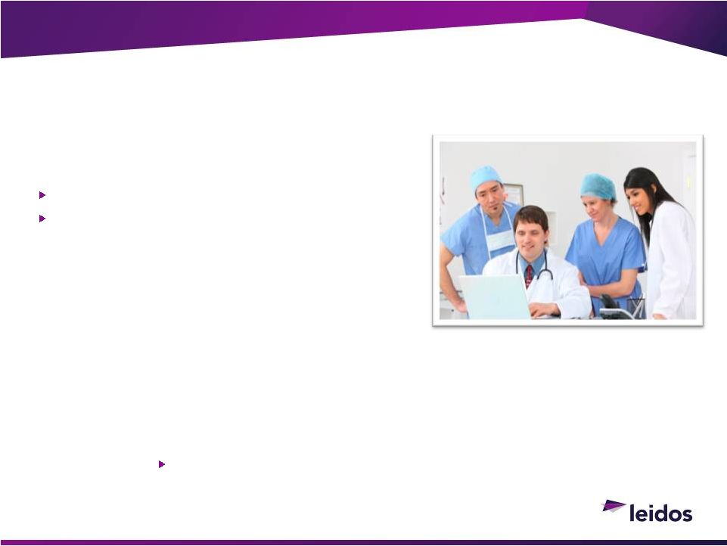
64
Developed & support the U.S. military AHLTA/CHCS
system, the largest EHR system ever implemented
©2013 LEIDOS. ALL RIGHTS RESERVED.
Systems Integration
Integration and Interoperability
Provided health IT & systems integration
support in connecting Inland Northwest
Health Services (INHS), one of the nations
first health information exchanges, to public
health entities and applications
Supported a major Canadian provincial health system in the
creation and development of a health information network to
link healthcare providers province wide
Links nearly 300 healthcare facilities in 126 communities &
380 pharmacies connecting approximately 19,000
healthcare professionals
Nearly 10 million beneficiaries
50 treatment facilities & 360 clinics


65
VA/DoD EHR Integration Opportunity
Servicing over 18 million patients in both VA / MHS
Total program cost: ~ $5 -
$20 billion
High Congressional visibility creating pressure for action
Possible Scenarios:
Expansion of existing sharing platforms
Adoption of existing systems by differing agency
Integration and deployment of new EHR systems (COTS)
©2013 LEIDOS. ALL RIGHTS RESERVED.
Systems Integration
Integration and Interoperability


66
Strategic Services and Solutions
True Value of Digitization is Unlocked Through Data Leverage
STRATEGIC
ADVISORY
SERVICES
VALUE-BASED
OUTCOMES
IT Strategy &
IT Strategy &
Program
Program
Management
Management
Cyber
Cyber
Security
Security
ICD-10
Transformation
Advanced Data
Advanced Data
Analytics
Analytics
Clinical
Clinical
Transformation
Transformation
Revenue Cycle
Revenue Cycle
Optimization
Optimization
Meaningful Use
(MU)
Data Leverage
©2013 LEIDOS. ALL RIGHTS RESERVED.



directed the full implementation of clinical
and revenue cycle applications at 27 hospitals
and clinics for one of the top academic
medical centers in the country
Revenue cycle transformation

for one of the largest public hospitals
(Grady Health System) in the United States
Advanced
Analytics
social network analytics solutions to
support product introduction
decisions internationally for one of
the largest pharmaceutical
companies in the country
67
©2013 LEIDOS. ALL RIGHTS RESERVED.
Strategic Services and Solutions
Data Leverage
deployed

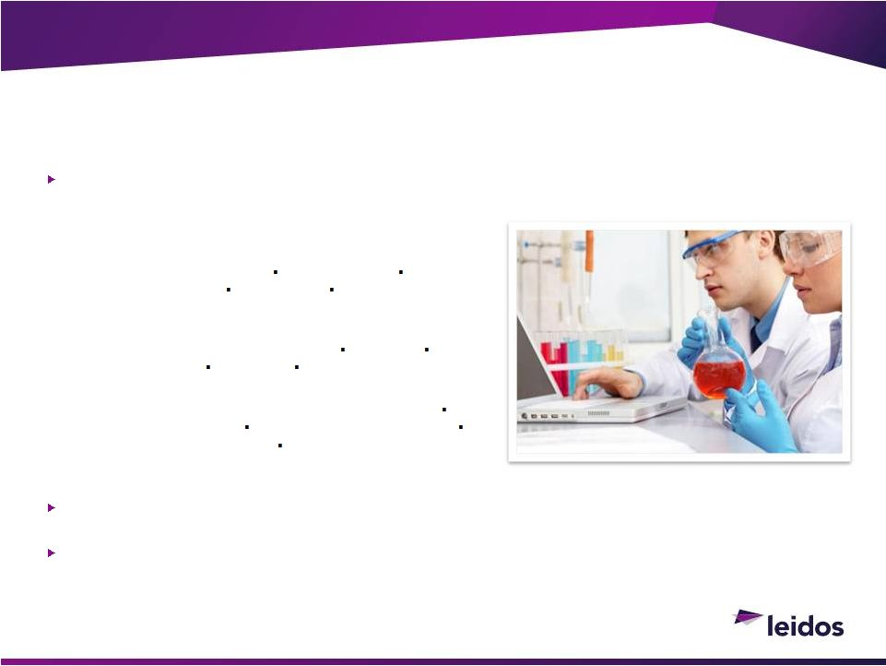
68
Leidos has over 25 years of combined programmatic experience providing solutions that enhance
health,
resilience,
readiness,
and
performance
through
research,
education,
training
and
counseling in areas such as:
Performance Enhancement:
Prediction of Unplanned Loss
Team Resilience
Traumatic Brain Injury
Rehabilitation
Career-Span Health
& Wellness
Operational Stress:
Post Traumatic Stress Disorder (PTSD)
Insomnia
Suicide Prevention
Depression
Re-Integration
Behavioral Sciences:
Adolescent Substance Abuse Counseling & Prevention
Substance Use & Abuse
Sexual Assault & Harassment
Family & Workplace Violence
Prevention of Sexually
Transmitted Disease (STDs)
Leidos
researchers
conduct
over
70
individual
research
studies
annually
and
have
supported
over
500 research projects in the last 5 years in the areas of health, resilience, and readiness
Human subject studies range from 100-2,000 and large database driven research studies are in
excess of 5 million records
©2013 LEIDOS. ALL RIGHTS RESERVED.
Health Research & Life Sciences
Precision Medicine
and Personalization

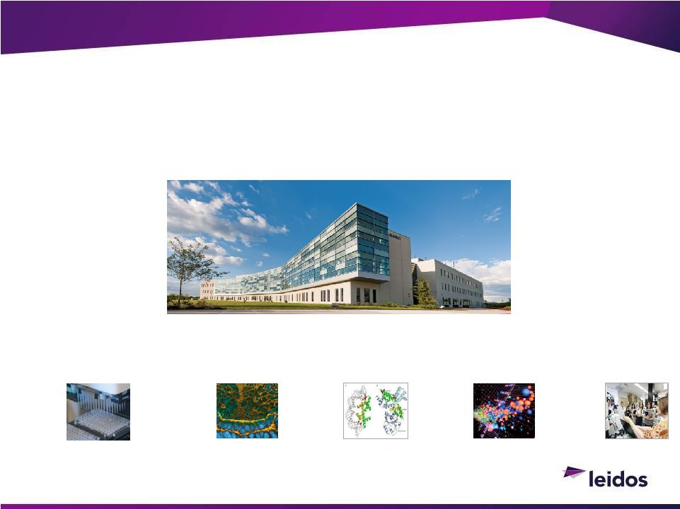
69
©2013 LEIDOS. ALL RIGHTS RESERVED.
Research and Life Sciences:
Leidos Biomedical Research
Frederick National Laboratory for Cancer Research
Advanced Technology Research Facility
Opened June 2012
Genetics
and
genomics
Proteins and
proteomics
Imaging and
nanotechnology
Advanced
biomedical
computing
Translational
Research
Precision Medicine
and Personalization

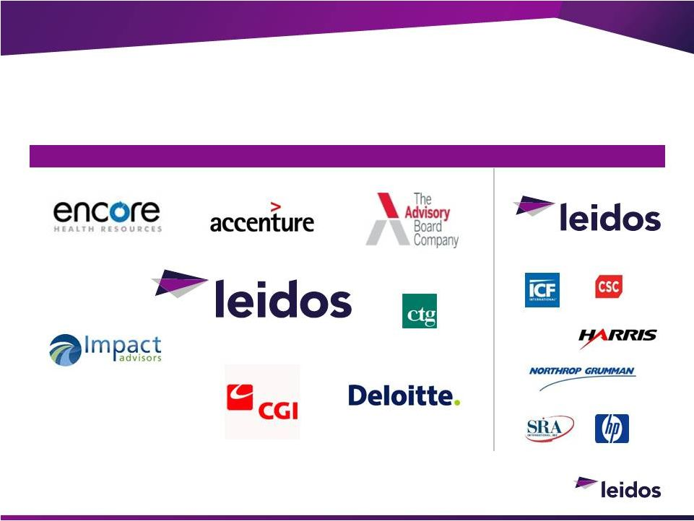
70
Competitive Landscape
©2013 LEIDOS. ALL RIGHTS RESERVED.
Commercial Health
Federal Health

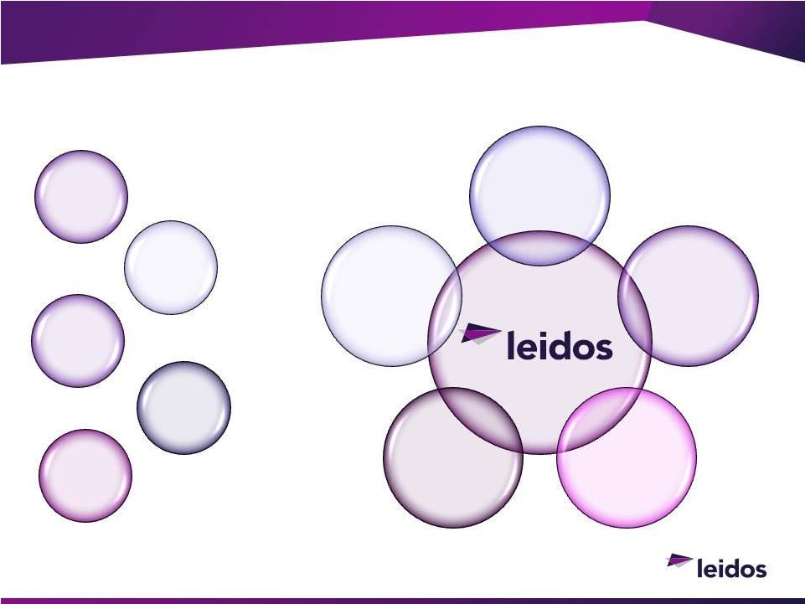
71
©2013 LEIDOS. ALL RIGHTS RESERVED.
Leidos Health Competitive Advantage
Life
Sciences
Clinical
SME
Health IT
Advanced
Data
Analytics
Behavioral
Health &
Wellness
Health IT
Clinical
SME
Life
Sciences
ADVANCED
DATA
ANALYTICS
BEHAVIORAL
HEALTH &
WELLNESS

Leidos Engineering

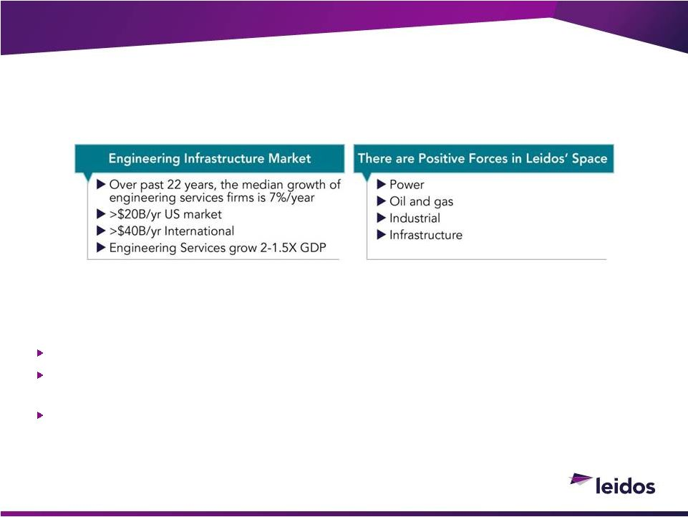
73
Consistently meets deadlines, budget and delivers on commitments
Uses systems approach to integrate engineering, technology, IT and consulting to
address emerging challenges
Has capabilities to bring clarity and insight to large data
©2013 LEIDOS. ALL RIGHTS RESERVED.
Leidos Engineering

a
Customer
Survey
of
over
800
Industry
Decision
Makers
Revealed
the
Following Top 3 Priorities

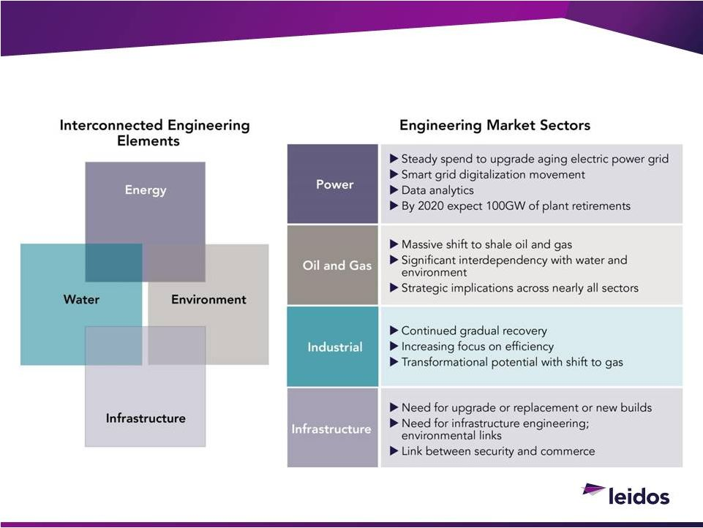
74
Market Drivers
©2013 LEIDOS. ALL RIGHTS RESERVED.

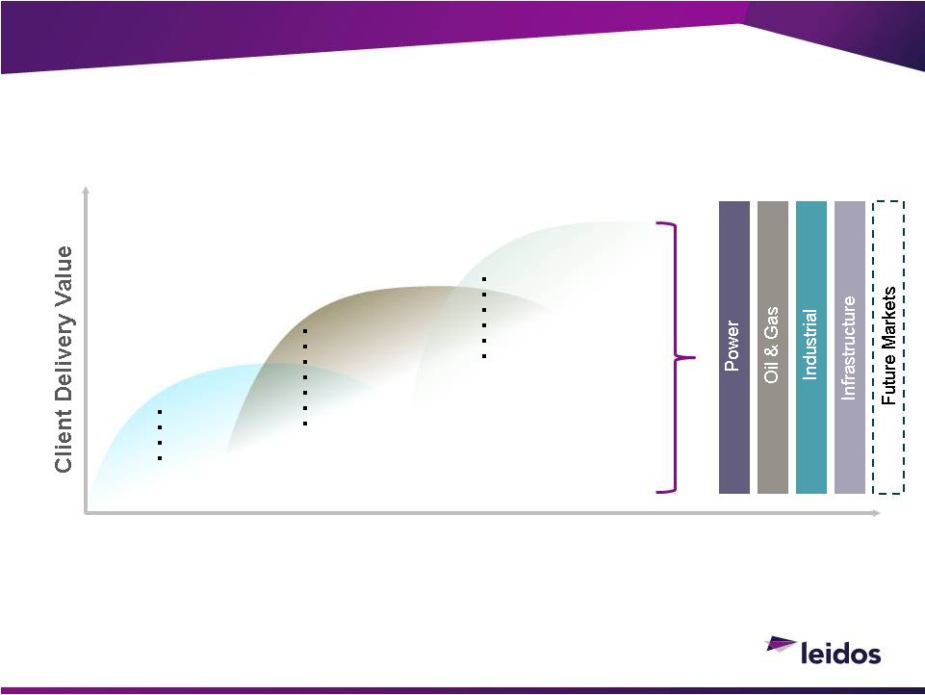
75
©2013 LEIDOS. ALL RIGHTS RESERVED.
Leidos Engineering Approach is Our Advantage
Combining Horizontal Capability & Applying to Industry Sectors
Addressing Market Interdependence Through Horizontal Leverage
Tomorrow
Today
Foundational
Differentiating
Disruptive
Architecture
Engineering
Environmental
DesignBuild
Systems Engineering
Systems Integration
Program Management
Financial Advisory
Technology Assessment
Energy Modeling
Energy Management
Information Technologies
Sensor Integration
Physical Controls
System Automation
Business Modeling
Data Analytics


Engineering Solutions
Secure
Commerce
Business and
Financial Advisory
Water and
Waste
Energy
Management
& Efficiency
Environmental
Services
Oil, Gas and
Chemicals
Renewable
Energy
Power
Delivery
and Smart
Grid
76
Bringing Engineering and Technology Together in Critical Markets
©2013 LEIDOS. ALL RIGHTS RESERVED.

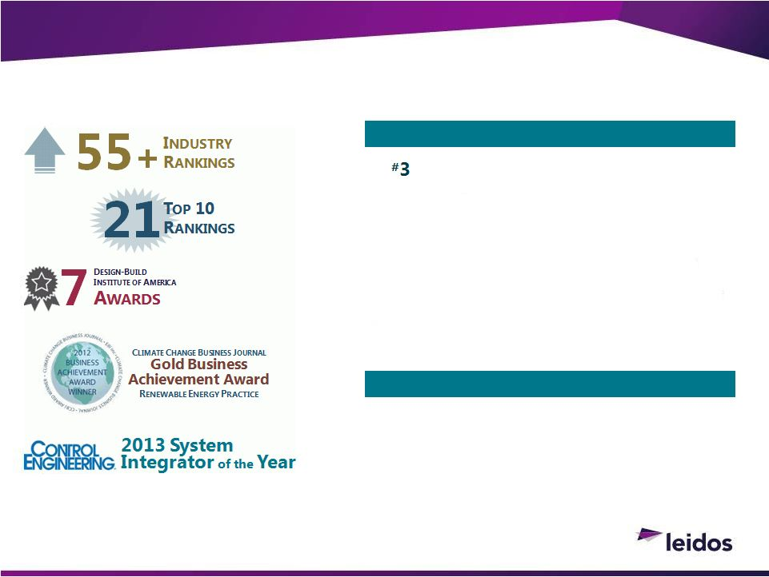
Industry Rankings and Awards
TOP NATIONAL RANKINGS
Business
Information
Modeling
(BIM)
Engineering
Firms
Building
Design+
Constr.,
July
2013
#
6
Transmission
&
Distribution
ENR,
July
2013
#7
Environmental
Management
ENR,
2013
#
8
Top
50
in
Program
Management
ENR,
June
2013
#
8
Top
Engineering/Architecture
Firms
BD+C,
July
2013
#
23
Top
25
in
Power
ENR,
July
2013
#
34
Top
500
in
Design
ENR,
April
2013
OTHER SELECT RANKINGS
#
4
Wind
Power
ENR,
July
2013
#
6
Auto
Plants
Engineering
Firms
ENR,
July
2013
#
9
Top
Data
Center
Engineering
Firms
ENR,
July
2013
#
46
Top
100
in
Design-Build
ENR,
June
2013
©2013 LEIDOS. ALL RIGHTS RESERVED.
77


What We Do
Percentage of Leidos
Engineering Business
Leidos Engineering 5 Year
Growth Trajectory
Capabilities
Power
Oil and Gas
Commercial and Industrial
Infrastructure
25%
10%
25%
40%
Consulting
Enterprise IT
Energy efficiency
T&D and smart grid
Renewable integration
Shale gas
Asset management
Remediation
Design and engineering
DesignBuild
Architect and engineering
Energy efficiency
Advanced communications
systems
Environmental support
Water resource management
Civil engineering
Financial transactions
Secure commerce products
5-8%
8-10%
3-6%
3-6%
©2013 LEIDOS. ALL RIGHTS RESERVED.
78

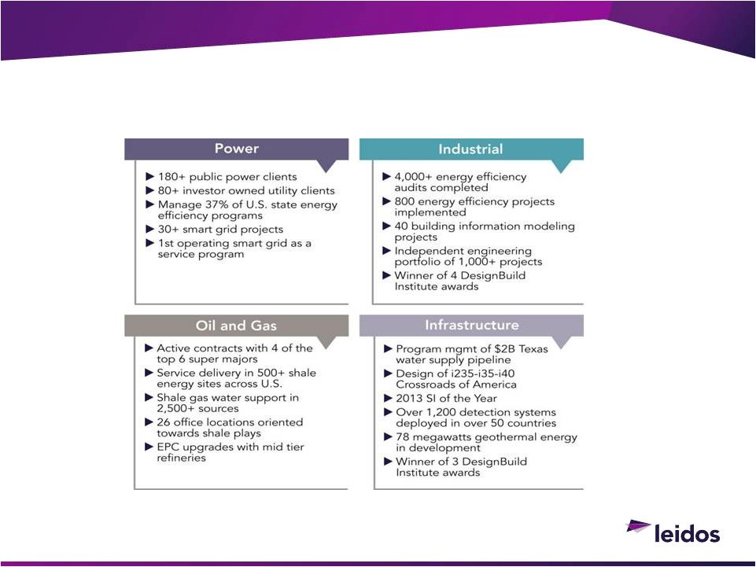
79
©2013 LEIDOS. ALL RIGHTS RESERVED.
Leidos Engineering Capabilities Delivered to Markets
Scale and Experience in Markets that Matter

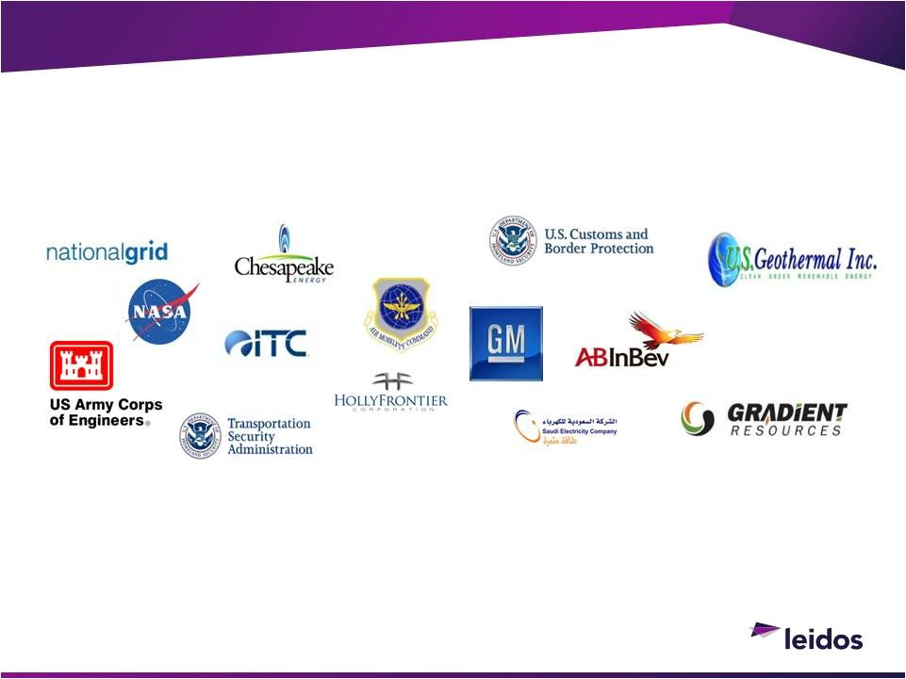
80
©2013 LEIDOS. ALL RIGHTS RESERVED.
Leidos Engineering Clients

and Other Fortune 100 Companies

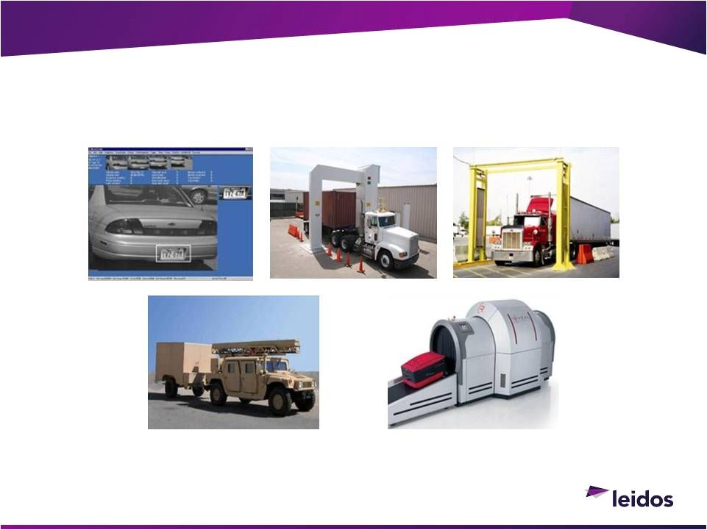
81
©2013 LEIDOS. ALL RIGHTS RESERVED.
Secure Commerce
Clients Include: CBP, TSA, DoD, DOS, Mexico, Middle East


82
Prepared
reports
on
nearly
1,000
power,
infrastructure
and
industrial
projects in 75 countries and territories
Independent
engineering
on
more
than
1,000
energy
projects,
nearing $200 billion in completed transactions
Active in independent engineering and owners advisory since 1978
Reviewed nearly 500
renewable energy and 150 biofuel projects
across 6 continents, with energy capacity in excess of 33,000
megawatts
over the last 2 years alone
Evaluated over 300 major technologies
©2013 LEIDOS. ALL RIGHTS RESERVED.
Leidos Engineering
Lenders
&
Developers

Consulting
Engineering
7 RECENT DEAL OF
THE
YEAR AWARDS
Project Finance
Magazine

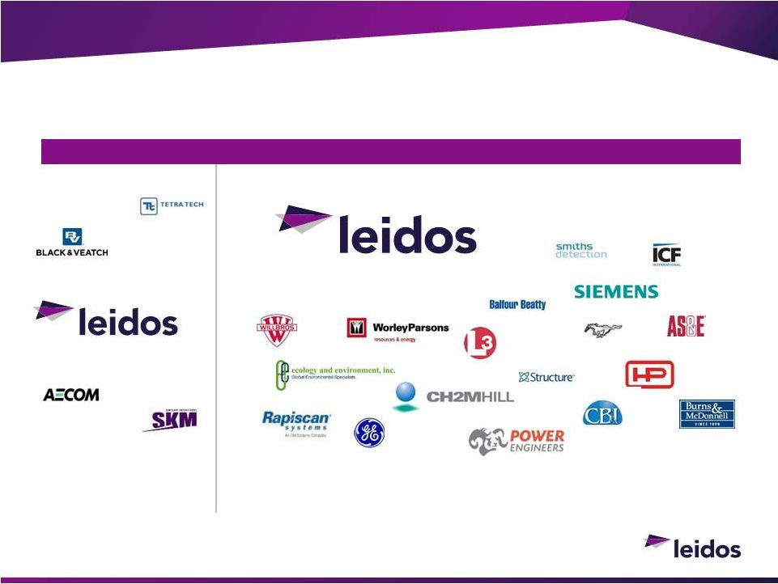
83
©2013 LEIDOS. ALL RIGHTS RESERVED.
Competitive Landscape
Large Engineering
Specialized Engineering

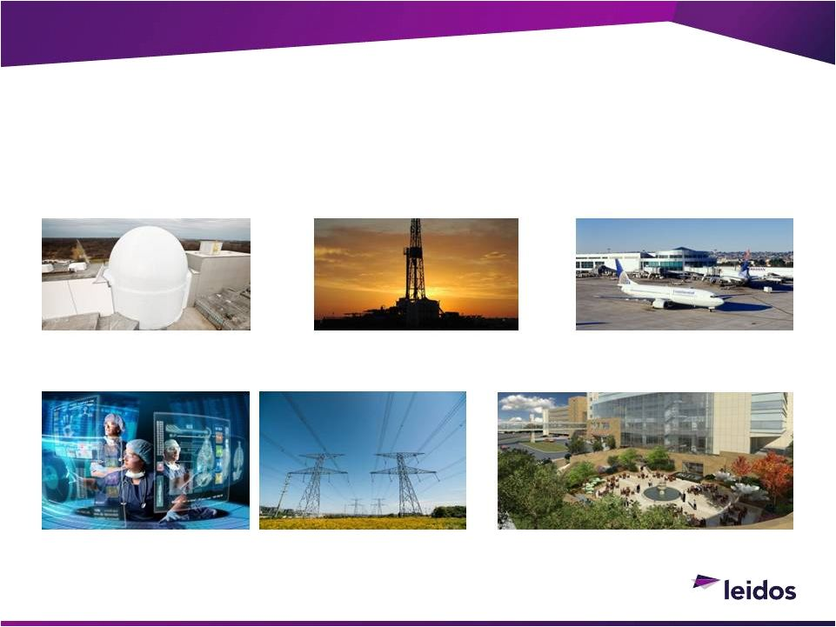
84
©2013 LEIDOS. ALL RIGHTS RESERVED.
Impact of Leidos Health & Engineering
NASA One-of-a-Kind Vibro-
Acoustic Research Facility
DesignBuild
Responsible Shale
Exploration Support
San Diego County Airport
Design, Engineering, Installation,
Testing, and Commissioning
Data Analytics
Oklahoma Cancer Research Center

Financial Overview
Mark Sopp
CHIEF FINANCIAL OFFICER


86
©2013 LEIDOS. ALL RIGHTS RESERVED.
Leidos Value Creation Roadmap
Proven Business Model 
On a New Path to Drive Shareholder Value
Profit-Focused Revenues
Year-over-year Operating Income Growth
Strong Cash Generation
Capital Allocation Effectiveness

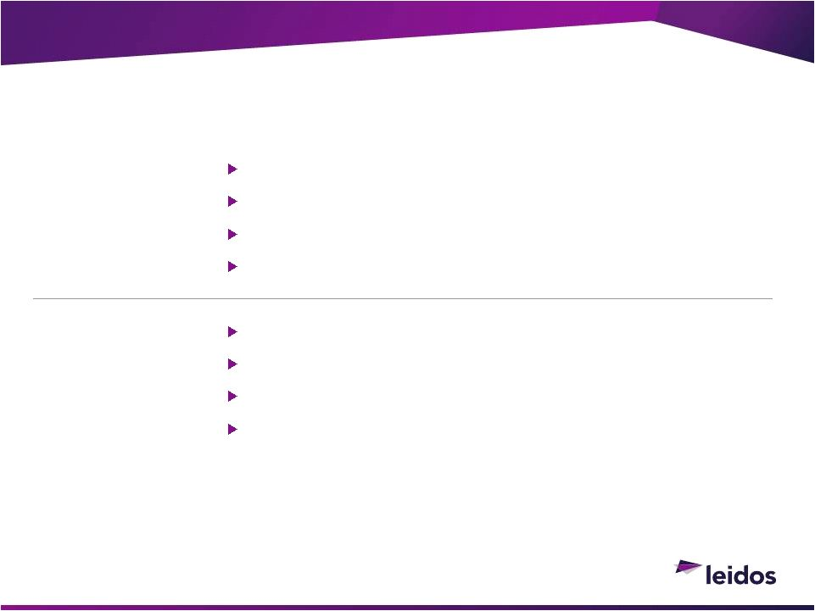
87
Quality revenues; profit focus
Stay within our wheelhouse; shape portfolio
Capitalize on OCI and commercial opportunities
Greater Leidos content, integrated technology
Complete transition year costs/charges
Full-year benefit of FY14 cost reductions; ongoing
Underperforming business areas removed
Reduce cost of delivery (procurement,
subcontracting)
©2013 LEIDOS. ALL RIGHTS RESERVED.
Profitability Actions
Geared for More Predictable and Low Capital-Intensive Profit Streams
Focus on
Profitable
Growth
Deliver
Expanded
Margins

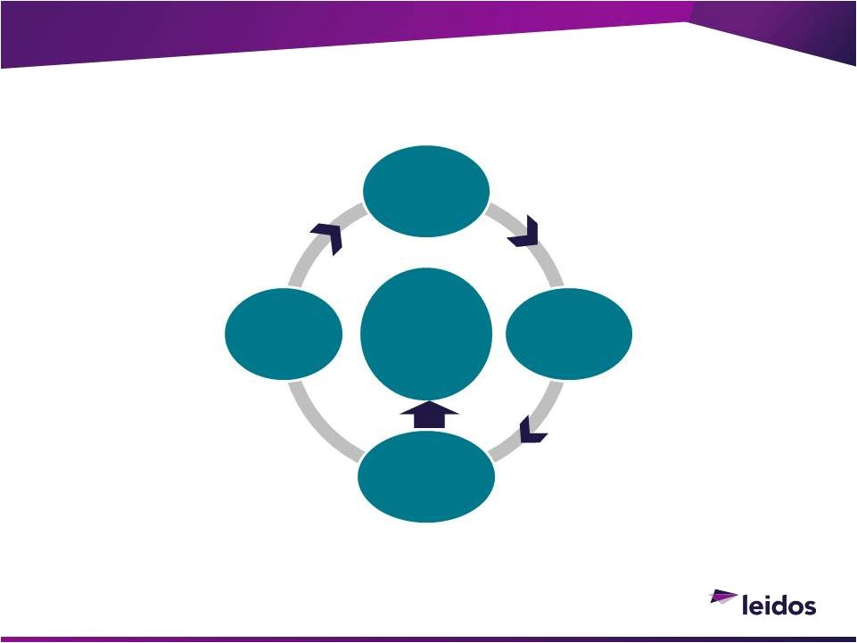
88
©2013 LEIDOS. ALL RIGHTS RESERVED.
Strong Cash Flow
Strong and Improving Capital Efficiency
Strong
Cash
Flow
No Factories
Insignificant
Pension
Variable Cost
Structure
Human
Capital
Based

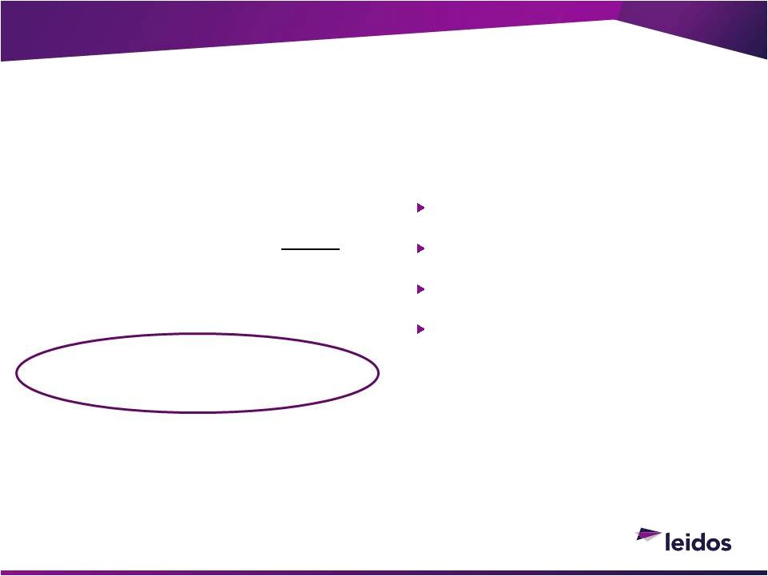
89
©2013 LEIDOS. ALL RIGHTS RESERVED.
Cash & Credit Statistics
Meaningful Near-Term Cash Deployment Opportunity
No debt maturities till 12/2020
Total Debt = $1,293M
Avg. Debt Rate 5.6%
Anticipate maintaining
investment grade rating
Cash at Spin
~$450M
Dividend from NSAIC
$295M
Estd Beg. Cash
~$745M
Estd End FY14
~$950M
CASH
DEBT

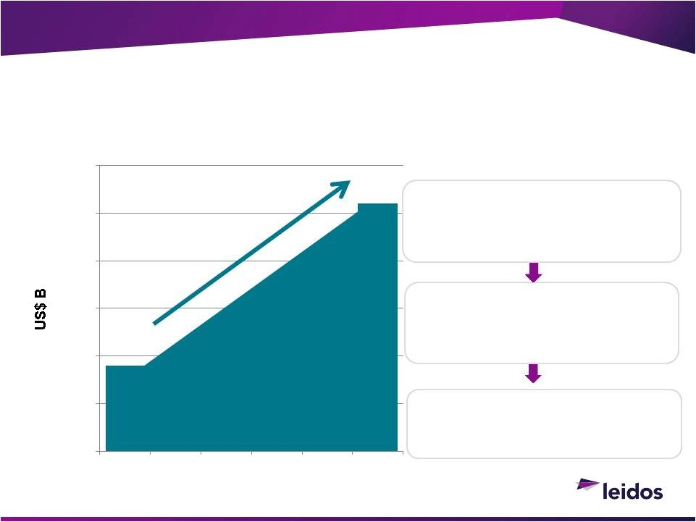
90
©2013 LEIDOS. ALL RIGHTS RESERVED.
Capital Deployment
$350M Projected FCF
*
/Year; >$2.5B deployable next 5 years
~1/3
-
Maintain/Increase
Regular Dividends
>1/3
-
Buybacks
&
Special Dividends
Selective M&A
1
*FCF = Free Cash Flow; Derived from projected Operating Cash Flow minus projected Capital Expenditures
$0.95B
$2.6B
$-
$0.5
$1.0
$1.5
$2.0
$2.5
$3.0
YE FY14
FY15
FY16
FY17
FY18
YE FY19
rd
rd

Established Businesses

Strengthens our 3 Markets

Recent Results & Outlook

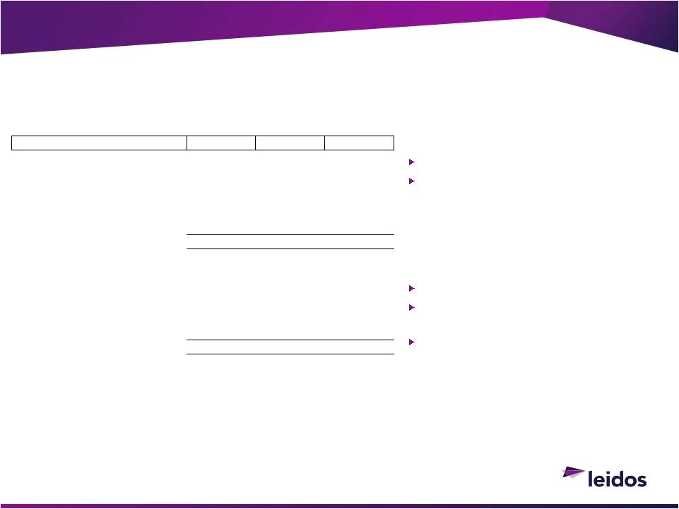
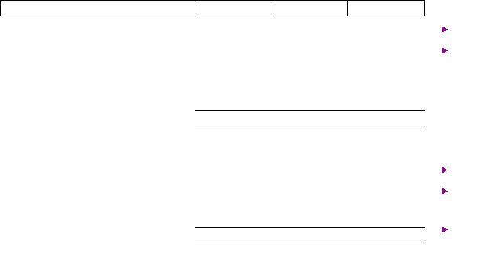
92
Pro Forma (PF) Financials
Consolidated + segments; Oct 13
Leidos PF includes:

CityTime settlement

>100bps stranded costs

Significant special charges FY12-14
Adjusted Non-GAAP Op Income
Discrete items adjusted
Provides additional insight into core
operating performance
Reflects stranded corporate costs
and does not reflect cost savings
program
©2013 LEIDOS. ALL RIGHTS RESERVED.
Leidos Historical Performance
$'s in millions
FY12
FY13
H1 FY14
Leidos Pro Forma Revenue
5,860
$
6,471
$
3,065
$
SAIC as Reported Operating Income
300
$
741
$
219
$
New SAIC
(343)

(288)

(105)

Stranded Corporate Costs
(66)

(70)

(41)

Separation Costs
-

10

55

Leidos Pro Forma Operating Income
(109)

393

128

Pro Forma Operating Income %
-1.9%
6.1%
4.2%
Non-GAAP Adjustments:
CityTime
540

-

-

Significant EAC Adjustments
-

10

37

Intangible Impairments
19

13

34

Regulatory and Legal Settlements
22

9

15

Adj. Non-GAAP Operating Income
472
$
425
$
214
$
Adj. Non-GAAP Operating Income %*
7.5%
6.6%
6.9%
* Operating Income % appropriately adjusted for CityTime and EAC revenue impacts
See Appendix for description of pro forma non-GAAP adjustments

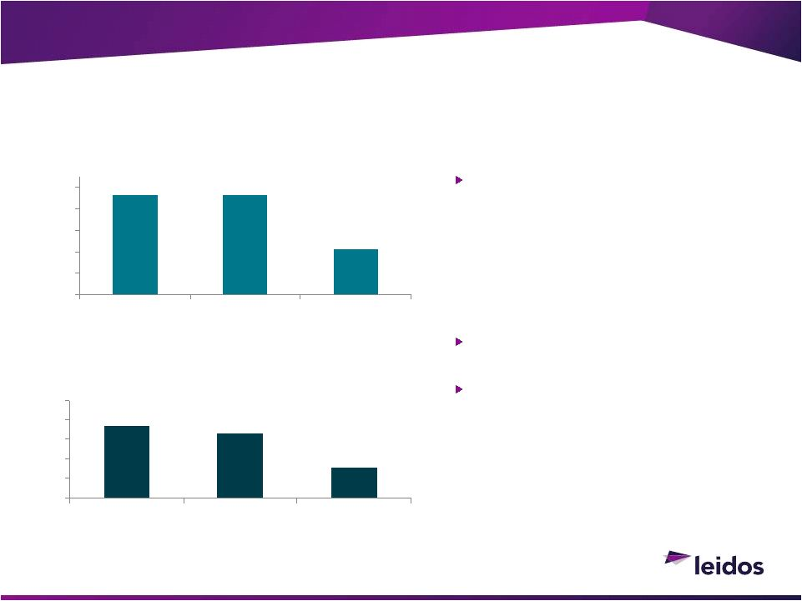
$368
$334
$153
$0
$100
$200
$300
$400
$500
FY12
FY13
FY14 1H
Adjusted Non-GAAP Operating Income
($M)
7.2%
7.2%
$4,631
$4,646
$2,116
$0
$1,000
$2,000
$3,000
$4,000
$5,000
FY12
FY13
FY14 1H
Adjusted Non-GAAP Revenue ($M)
93
Revenue
1HFY14 down due to JLI and Federal
spending cuts
Adjusted Non-GAAP Operating Income
Reflects stranded corporate costs;
does not reflect cost savings program
Adds back Impairments and EAC
adjustments for one program
©2013 LEIDOS. ALL RIGHTS RESERVED.
National Security Segment Financials
7.9%
See Non-GAAP reconciliation in the Appendix

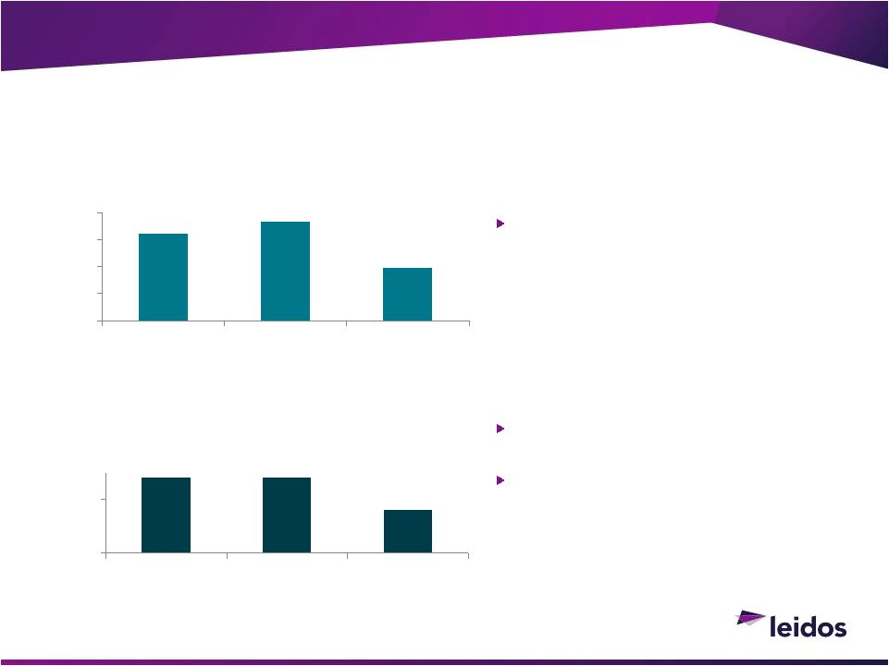
94
Revenue
Revenue; growth from acquisitions;
1HFY14 internal revenues flat
Adjusted Non-GAAP Operating Income
Reflects stranded corporate costs; does
not reflect cost savings
Adds back impairments and EAC
adjustments for one program
©2013 LEIDOS. ALL RIGHTS RESERVED.
Health & Engineering Segment Financials
8.6%
See Non-GAAP reconciliation in the Appendix
$1,622
$1,831
$972
$0
$500
$1,000
$1,500
$2,000
FY12
FY13
FY14 1H
Adjusted Non-GAAP Revenue ($M)
$139
$140
$79
$0
$100
FY12
FY13
FY14 1H
Adjusted Non-GAAP Operating
Income ($M)
7.6%
8.1%


95
Consistent with SAIC Inc. guidance issued Sept 4, 2013, except:

Separation now assumed; triggers Stranded Corporate Costs ~$60M
($.12 EPS)

Legal expenses previously reported as part of TSIT~$10M ($.02)

EPS, provided on a pre-split and post-split basis
©2013 LEIDOS. ALL RIGHTS RESERVED.
Leidos FY 14 Guidance
Revenues (billions)
5.85
$
to
6.10
$
EPS Continuing Operations, pre-stock split
0.45
$
to
0.51
$
EPS Continuing Operations, split adjusted 1:4
1.80
$
to
2.04
$
Operating Cash Flows (millions)
$325 +


96
©2013 LEIDOS. ALL RIGHTS RESERVED.
FY15 Margin Improvement Outlook
Major Levers:
Full year benefit of $200M+
cost reductions
Ongoing streamlining; lower
wrap rates
NSS removal of non-core
under-performing business
areas
Restoring normative
commercial health margins
HES focus on higher fee
consulting engineering projects
Profit-focused incentives and
accountability
Focused on Bottom Line in Difficult Top-Line Environment
FY14 1H Adjusted Non-GAAP Operating Income
6.9%
FY14/15 cost savings program
1.0% -
1.5%
HE Sector profit improvements
0.7% -
1.25%
Anticipated portfolio changes
0.1% -
0.2%
Targeted FY15 Operating Margin
8.0%
+


97
©2013 LEIDOS. ALL RIGHTS RESERVED.
Playing to our Strengths:
Leidos FY15 to FY17 Targets
Targeted EPS* Growth/Yr. 10.0%+
Targeted Annual
Operating Margin
8.0%+
Targeted Organic Growth:
FY15
+/-
low single digit
FY16-17
+ low single digit
Targeted Operating
Cash Flow/Yr.
$400M+
* GAAP EPS from Continuing Operations
Profit-focused
Lower cost structure
Strong Cash Flow
Attractive Regular
Dividend (~1/3 FCF)
Targeting > 1/3 FCF
buybacks/special
dividends


98
1.
Attractive, large, enduring, increasingly integrated markets
2.
Streamlining, separation, and portfolio moves prep for clean FY15+
3.
Profit growth and capital effectiveness focus
4.
Deployment opportunity > $2.5B over the next 5 years

>2/3 FCF targeted for dividends and buybacks

Select, established M&A to build our three markets

Systematically deploy excess cash
©2013 LEIDOS. ALL RIGHTS RESERVED.
Summary
Repositioned with Focus on Driving Profit Growth and Returning Cash to Shareholders

Appendix

100
The unaudited pro forma consolidated financial information included in this presentation was derived from the Companys
historical consolidated financial statements and is being presented to show the effect of the proposed spin-off of New SAIC.
The unaudited pro forma consolidated financial information should be read in conjunction with the historical financial
statements and accompanying notes. The unaudited pro forma consolidated financial information is presented for the six
months
ended
August
2,
2013
and
the
years
ended
January
31,
2013
and
2012
and
assumes
the
separation
occurred
on
February 1, 2011.
The pro forma adjustments are based on the best information available and assumptions that management believes are
reasonable, that reflect the impacts of events directly attributable to the proposed spin-off, and that are factually
supportable. The pro forma adjustments may differ from those that will be calculated to report New SAIC as discontinued
operations in Leidos
future filings. The unaudited pro forma consolidated financial information is provided for illustrative
and
informational
purposes
only
and
is
not
intended
to
represent
or
be
indicative
of
what
Leidos
results
of
operations
or
financial position would have been had the separation occurred on the dates indicated. The unaudited pro forma
consolidated
financial
information
also
should
not
be
considered
representative
of
Leidos
future
results
of
operations
or
financial position.
The pro forma adjustments represent the following:

Removal of the results of operations for the Technical Services and Information Technology segment that
comprises New SAIC.

Removal
of
non-recurring
transaction
and
infrastructure
setup
costs
incurred
by
the
Company
in
connection
with
the proposed spin-off of New SAIC.

Addition of certain general corporate overhead expenses (stranded costs) that were not specifically related to
New SAIC and do not meet the requirements to be presented as a component of discontinued operations.
©2013 LEIDOS. ALL RIGHTS RESERVED.
Unaudited Pro Forma Consolidated Financial
Information


101
This presentation includes the financial measures Adjusted Non-GAAP Revenue, Adjusted Non-GAAP
Operating Income, and Free Cash Flow, all of which are defined as non-GAAP financial measures by the
Securities and Exchange Commission (SEC). These measures may be different than similarly-titled non-
GAAP financial measures used by other companies. The presentation of this financial information is not
intended to be considered in isolation or as a substitute for the financial information prepared and
presented in accordance with generally accepted accounting principles (GAAP). Explanations of our non-
GAAP financial measures are as follows:
Adjusted
Non-GAAP
Revenue
is
a
non-GAAP
financial
measure
that
is
reconciled
to
the
most
directly
comparable GAAP financial measure, Revenue. Adjusted Non-GAAP Revenue adjusts Revenue for the
following discrete events:
CityTime

This
adjustment
represents
to
a
legal
settlement
related
to
a
timekeeping
contract
with the City of New York.
Significant
EAC
Adjustments

This
adjustment
represents
write-downs
for
two
discrete
contracts during the periods presented that were unusual in nature and in amount.
The Company uses non-GAAP financial measure to provide investors with visibility to how the company
performed without these discrete events.
©2013 LEIDOS. ALL RIGHTS RESERVED.
Non-GAAP Reconciliations

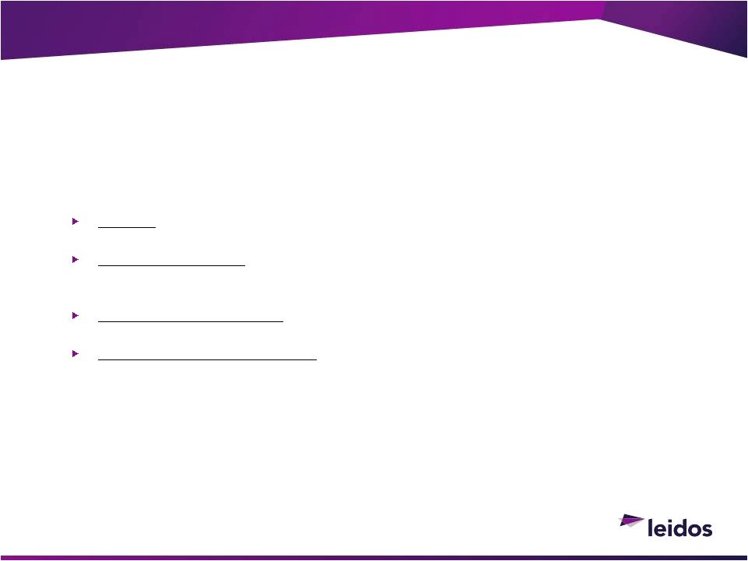
102
Adjusted
Non-GAAP
Operating
Income
is
a
non-GAAP
financial
measure
that
is
reconciled
to
the most
directly comparable GAAP financial measure, Operating Income. Adjusted Non-GAAP Operating Income
adjusts Operating Income for the following discrete events:
CityTime

This
adjustment
represents
to
a
legal
settlement
related
to
a
timekeeping
contract
with the City of New York.
Intangible
Impairments

This
adjustment
represents
impairments
of
long-lived
assets
due
to
changes
in
actual
performance
against
performance
projected
when
the
long
lived
assets were
acquired.
Significant
EAC
Adjustments

This
adjustment
represents
write-downs
for
two
discrete
contracts during the periods presented that were unusual in nature and in amount.
Regulatory
and
Legal
Settlements

This
adjustment
represents
settlements
for
discrete
regulatory and legal matters.
The Company uses non-GAAP financial measure to provide investors with visibility to how the company
performed without these discrete events.
©2013 LEIDOS. ALL RIGHTS RESERVED.
Non-GAAP Reconciliations
(Continued)

103
©2013 LEIDOS. ALL RIGHTS RESERVED.
Non-GAAP Reconciliations 
Adjusted Non-
GAAP Revenue and Operating Income
Note: The as reported
amounts above and throughout this presentation have been recasted to give effect to
reorganizations and discontinued operations
Non-GAAP Adjusted Operating Income Reconciliation by Sector
FY12
FY13
FY14
HE Seg
NSS Seg
TSIT
Corp Seg
Total
HE Seg
NSS Seg
TSIT
Corp Seg
Total
HE Seg
NSS Seg
TSIT
Corp Seg
Total
SAIC as Reported Revenue
1,622
$
4,631
$
4,238
$
(2)
$
10,489
$
1,831
$
4,646
$
4,693
$
(5)
$
11,165
$
972
$
2,101
$
2,116
$
(8)
$
5,181
$
SAIC Gemini, Inc.
(4,238)

-

(4,238)

(4,693)

(4,693)

(2,116)

(2,116)

CityTime to Leidos
(391)

(391)

(1)

(1)

-

Leidos Pro Forma Revenue
1,622

4,631

-

(393)

5,860

1,831

4,646

-

(6)

6,471

972

2,101

-

(8)

3,065

Non-GAAP Adjustments:
CityTime
-

-

-

410

410

-

-

-

-

-

-

-

-

-

-

Significant EAC Adjustments
-

-

-

-

-

10

-

-

-

10

16

15

-

-

31

Adj Non-GAAP Revenue
1,622
$
4,631
$
-
$
17
$
6,270
$
1,841
$
4,646
$
-
$
(6)
$
6,481
$
988
$
2,116
$
-
$
(8)
$
3,096
$
Sector as Reported Operating Income
156
$
398
$
(199)
$
(55)
$
300
$
160
$
371
$
314
$
(104)
$
741
$
45
$
157
$
139
$
(122)
$
219
$
SAIC Gemini, Inc.
-

-

199

-

199

-

-

(314)

28

(286)

-

-

(139)

34
$
(105)

Stranded Corporate Costs
(17)

(49)

-

-

(66)

(20)

(50)

-

-

(70)

(13)

(28)

-

-
$
(41)

CityTime
-

-

-

(542)

(542)

-

-

-

(2)

(2)

-

-

-

-
$
-

Pro Forma Separation Costs
-

-

-

-

-

-

-

-

10

10

-

-

-

55
$
55

Pro Forma Operating Income
139

349

-

(597)

(109)

140

321

-

(68)

393

32

129

-

(33)

128

Pro Forma Operating Income %
8.6%
7.5%
0.0%
151.9%
-1.9%
7.6%
6.9%
0.0%
1133.3%
6.1%
3.3%
6.1%
0.0%
412.5%
4.2%
Non-GAAP Adjustments:
CityTime
-

-

-

540

540

-

-

-

-

-

-

-

-

-

-

Significant EAC Adjustments
-

-

-

-

-

10

-

-

-

10

17

20

-

-

37

Intangible Impairments
-

19

-

19

-

13

-

13

30

4

-

34

Regulatory and Legal Settlements
-

-

-

22

22

-

-

-

9

9

-

-

-

15

15

Adj. Non-GAAP Operating Income
139
$
368
$
-
$
(35)
$
472
$
150
$
334
$
-
$
(59)
$
425
$
79
$
153
$
-
$
(18)
$
214
$
Adj. Non-GAAP Operating Income %
8.6%
7.9%
N/A
N/A
7.5%
8.1%
7.2%
N/A
N/A
6.6%
8.0%
7.2%
N/A
N/A
6.9%


104
Free
Cash
Flow
is
a
non-GAAP
financial
measure
that
is
reconciled
to
the
most
directly
comparable
GAAP
financial
measure,
cash
flows
used
in
operating
activities.
The
company
believes
that
reporting free cash flow provides investors with greater visibility into how effectively it generates
cash. The company calculates free cash flow by subtracting expenditures for property, plant and
equipment from total cash flows used in operating activities.
©2013 LEIDOS. ALL RIGHTS RESERVED.
Non-GAAP Reconciliations 
Free Cash Flow
($ in millions)
FY15-FY19
Projected average annual operating cash flow
400
$
Projected average annual expenditures for property, plant and equipment
(50)
Free cash flow
350
$

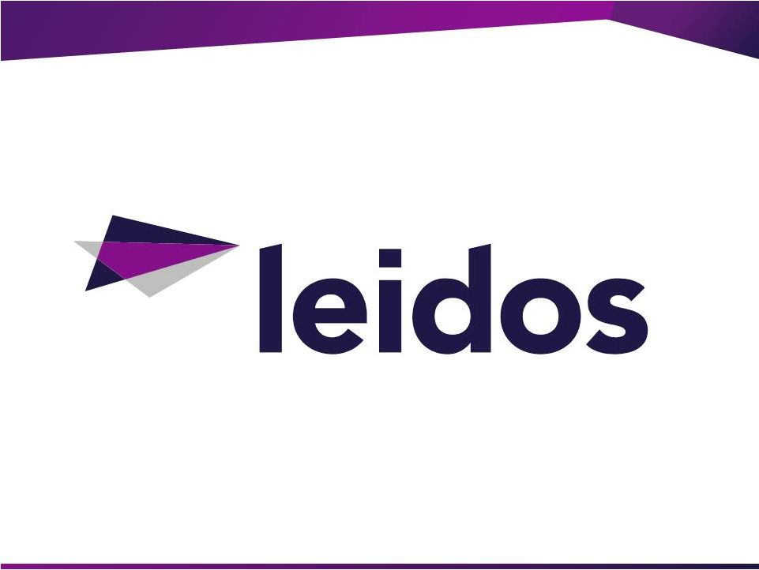


Investor Day Presentation
September 11, 2013


SAIC.com
©
SAIC. All rights reserved.
V127 12noon
Forward-Looking Statements
Certain statements in this presentation contain or are based on "forward-looking" information within the meaning of the Private Litigation Reform Act of 1995. In some
cases,
you
can
identify
forward-looking
statements
by
words
such
as
"expects,"
"intends,"
"plans,"
"anticipates,"
"believes,"
"estimates,
and
similar
words
or
phrases.
Forward-looking statements in this presentation include, among others: our intent to separate into two independent publicly traded companies as a result of the
proposed spin-off; revenue, growth and cost-efficiency expectations for the two independent companies following the spin-off; the expectation that the spin-off will be
tax-free;
statements
regarding
the
resources,
potential,
priorities,
competitive
positioning
and
opportunities
for
the
independent
companies
following
the
spin-off;
expectations about future dividends and the timing of the proposed transaction.
These statements reflect our belief and assumptions as to future
events that may not
prove to be accurate. Actual performance and results may differ materially from the forward-looking statements made in this presentation depending on a variety of
factors, including, but not limited to: failure to obtain necessary regulatory approvals or to satisfy any of the other conditions to the proposed spin-off; adverse effects on
the market price of our common stock and on our operating results because of a failure to complete the proposed spin-off; failure to realize the expected benefits of the
proposed spin-off; negative effects of announcement or consummation of the proposed spin-off on the market price of the companys common stock; significant
transaction costs and/or unknown liabilities; general economic and business conditions that affect the companies in connection with the proposed spin-off;
unanticipated expenses such as litigation or legal settlement expenses; changes in capital market conditions that may affect proposed debt financing; the impact of the
proposed spin-off on the Companys or the newly formed companys employees, customers and suppliers; disruption to business operations as a result of the proposed
transaction; the inability to retain key personnel; and the inability of the companies to operate independently following the spin-off. The proposed spin-off will be subject
to customary regulatory approvals, the receipt of a tax opinion from counsel, the execution of intercompany agreements, finalization of the capital structure of the two
corporations, final approval of the SAIC board and other customary matters.
These are only some of the factors that may affect the forward-looking statements contained in this presentation. For further information concerning risks and
uncertainties associated with our business, please refer to the filings we make from time to time on behalf of SAIC,Inc. and SAIC Gemini Inc. with the U.S. Securities
and Exchange Commission (SEC), including the "Risk Factors," "Management's Discussion and Analysis of Financial Condition and Results of Operations" and "Legal
Proceedings" sections of the Registration Statement on Form 10 of SAIC Gemini, Inc., and any amendment thereto, which may be viewed or obtained through the SECs
website, www.sec.gov.
All
information
in
this
presentation
is
as
of
September
4,
2013.
The
Company
expressly
disclaims
any
duty
to
update
the
forward-looking
statement
provided
in
this
presentation to reflect subsequent events, actual results or changes in the Company's expectations. The Company also disclaims any duty to comment upon or correct
information that may be contained in reports published by investment analysts or others.
2

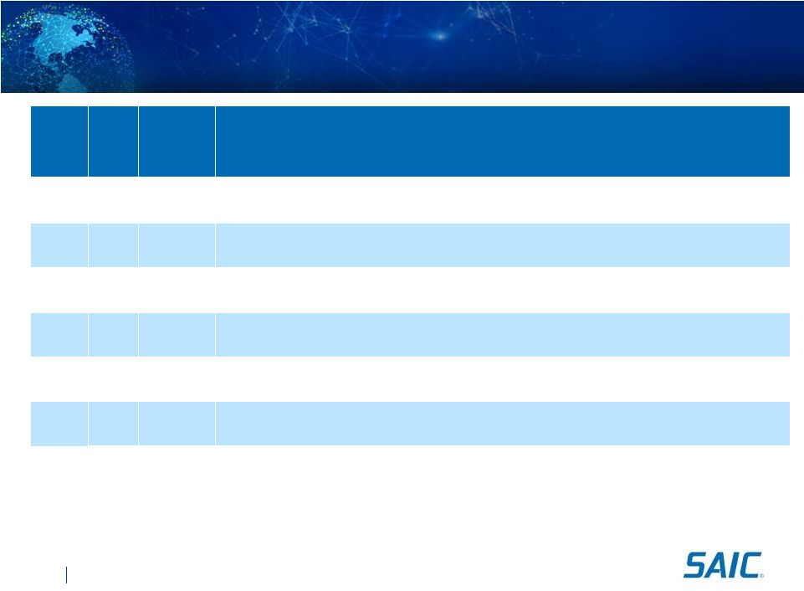
SAIC.com
©
SAIC. All rights reserved.
SAIC Investor Day 
Wednesday, September 11
Start
Stop
Duration
(mins)
Topic
1:30
1:35
5
Opening Remarks and Introductions: Paul Levi, Investor Relations & Treasurer
1:35
2:15
40
Introduction and Company Overview: Tony Moraco, Chief Executive
Officer (CEO)
2:15
2:45
30
Enterprise Information Technology & Technical and Engineering: Nazzic Keene, Sector President
2:45
3:00
15
Break
3:00
3:30
30
Financial Highlights: John Hartley, (CFO)
3:30
3:45
15
Closing Remarks: Tony Moraco, (CEO)
3:45
4:30
45
Questions and Answers: Tony Moraco, Nazzic Keene, and John Hartley
3

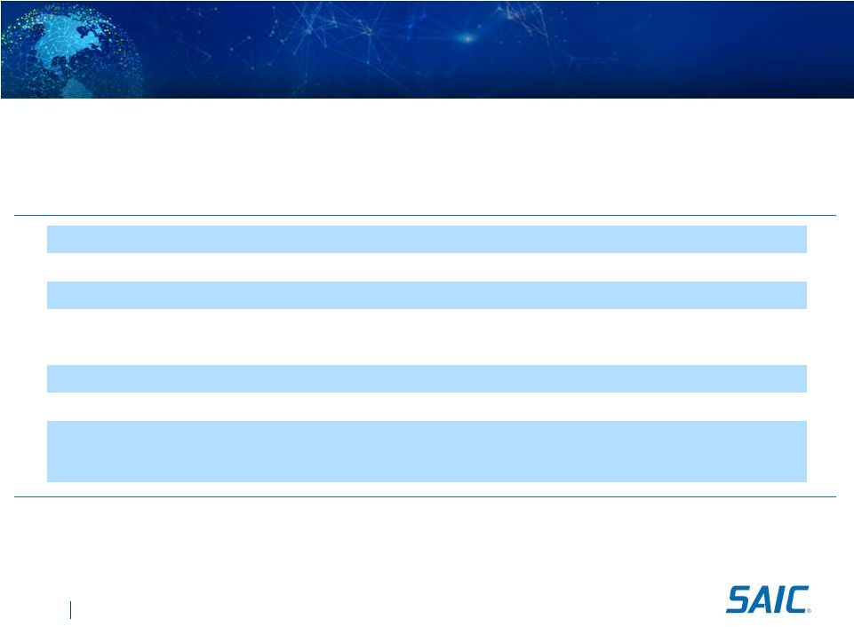
SAIC.com
©
SAIC. All rights reserved.
V127 12noon
Transaction Overview

On September 27, 2013, the Parent (to be renamed Leidos Holdings, Inc.) plans to spin-off the technical engineering and enterprise
information technology business

The IRS issued a favorable ruling as to the tax-free nature of the transaction
Distributing Company
SAIC,
Inc
(NYSE:
SAI)
changing
to
---
Leidos
Holdings,
Inc.
(NYSE:
LDOS)
Distributed Company
Science Applications International Corporation
Ticker
SAIC
Exchange
NYSE
Distribution Ratio
One share of SAIC for each 7 shares of SAI
Expected SAIC Shares Outstanding
~ 49 million
Dividend Policy
SAIC
currently
intends
to
pay
an
initial
dividend
of
$0.28
(1)
per
quarter
on
its
common stock
Capital Structure
$226 million Cash
$200 million Revolving Credit Facility
$500 million Term Loan

Expected Key Dates
-
When-Issued Trading Begins:
September 16, 2013
-
Distribution Date:
September 27, 2013 (11:59 PM/ET)
-
Distribution Record Date:
September 19, 2013
-
Regular Way Trading Begins:
September 30, 2013
4
(1)
Dividend adjusted for share distribution ratio


Company Overview
Chief Executive Officer 
Tony Moraco

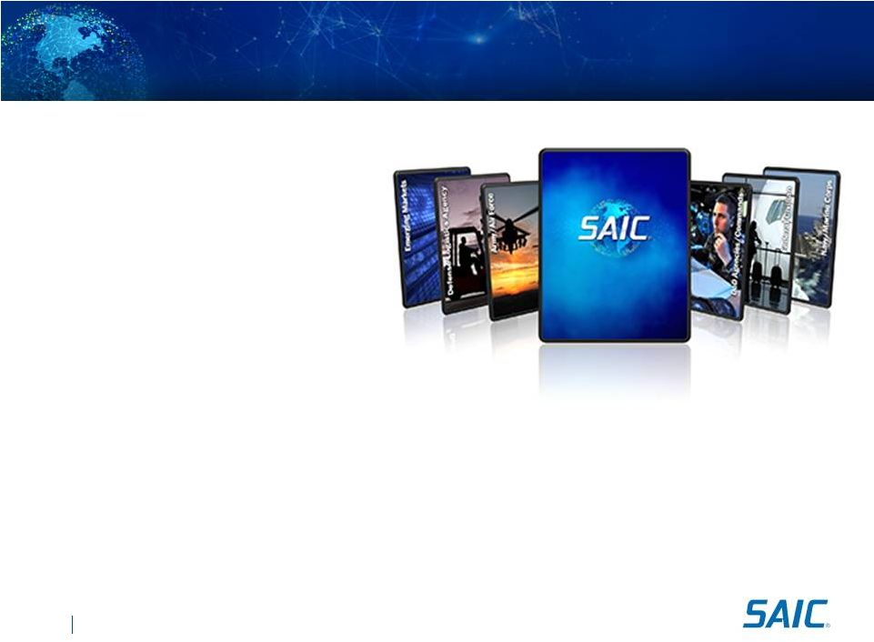
SAIC Overview

Leading technology integrator
specializing in technical engineering
and enterprise IT services to the
U.S. Government

Long term mission service delivery
and customer relationships

40+ year history of successful performance

Significant scale and diversified contract base, over $4.0 billion in annual revenues

Highly skilled workforce of about 14,000 employees

Strong and predictable cash flow

Experienced management team of proven industry leaders
6
SAIC.com
©
SAIC. All rights reserved.
V127 12noon

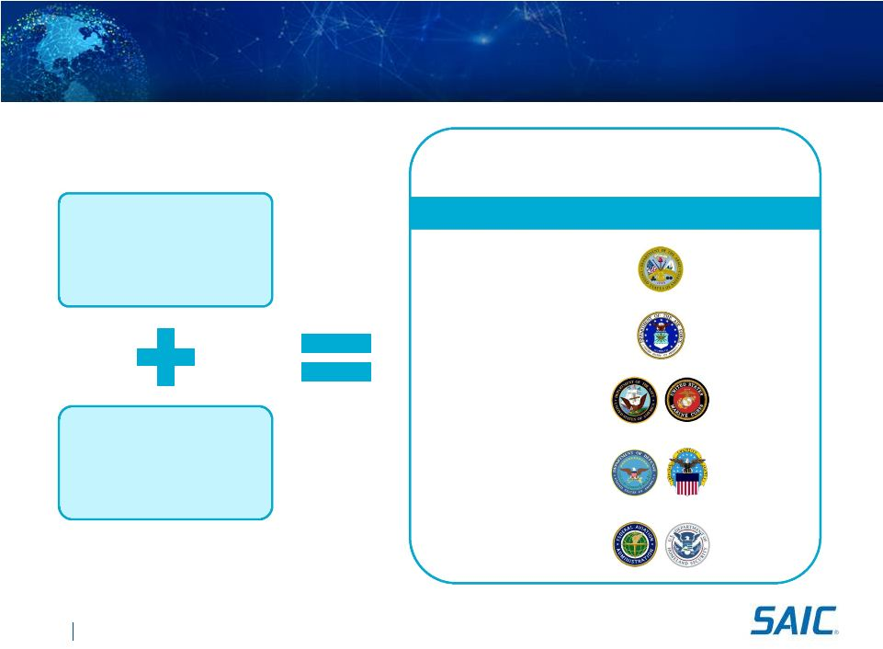
SAIC.com
©
SAIC. All rights reserved.
V127 12noon
$37B
Army
Federal Civilian
Total US Government
SAIC Addressable
Prior to Split
~$160B
New Unconstrained
Addressable
~$25B
Customer
Addressable Spend
Navy/Marine Corps
$30B
DoD Agencies /
Defense Logistics
$35B
$60B
Spin Enables Access to a Larger Federal Market
SAIC Addressable After Split
~$185B
7
$23B
Air Force

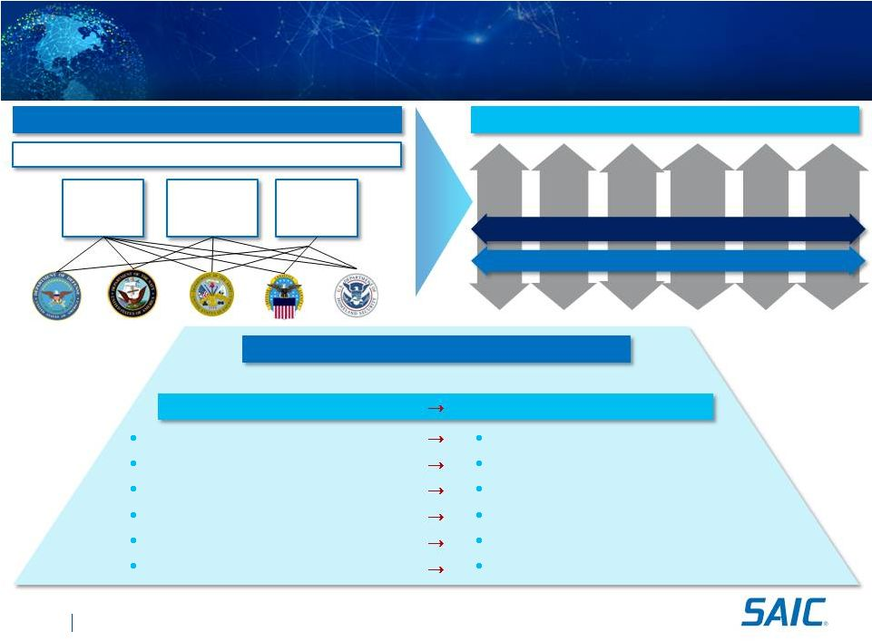
SAIC.com
©
SAIC. All rights reserved.
V127 12noon
Enterprise Transformation to Create a Highly
Aligned Organization
Historical SAIC, Inc. Structure
New SAIC Structure
Corporate
Defense
Solutions
Group
Intelligence
Surveillance
Reconnaissance
Group
Health, Energy &
Civil Solutions
Group
Continuing Themes
World-class Delivery
Ethical Culture
Enterprise entrepreneurship
Customer / portfolio management
Organizational alignment
Market segment focused
Enhanced utilization and resource deployment
Selling enterprise capabilities
Individual entrepreneurship
Independent contract management
Silo organization structure
Diverse industries
Ad Hoc resource deployment
Business Unit focused selling
Present Themes
New Themes
Army /
Air
Force
State &,
Local,
Commercial
Navy /
Marine
Corps
Defense
Logistics
Agency
DoD
Agencies
Commands
Federal
Civilian
Enterprise IT Services
Technical & Engineering Services
Customer Affinity
8

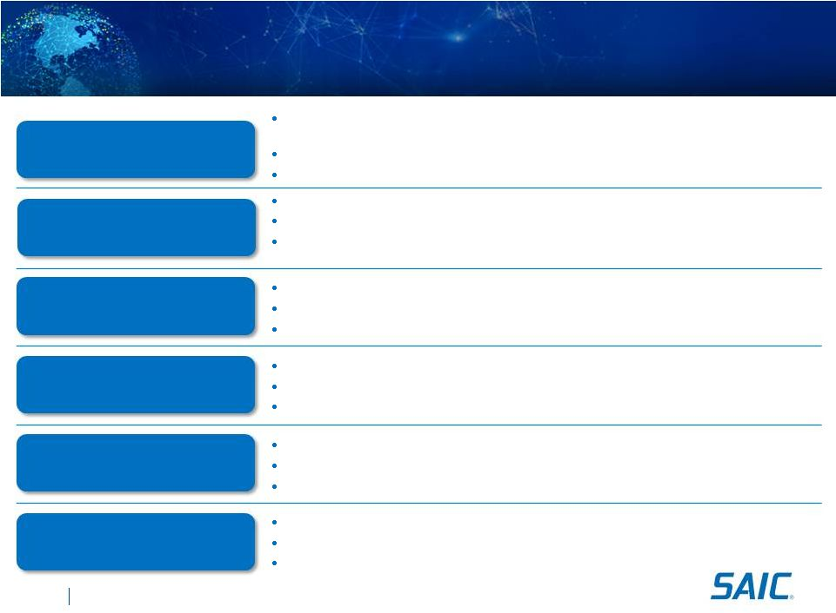
SAIC.com
©
SAIC. All rights reserved.
V127 12noon
Investment Highlights
Focused on serving our customers leveraging both deep mission domain knowledge and the
breadth of enabling IT solutions
Strategic alignment with the enduring mission needs of our customers
Long term relationships with all key customers, with several individual contracts over 20 years
Enduring Customer Relationships
And Mission-Orientation
Technical Experts Led by
Experienced Management
Tailored Operational Model and
Competitive Structure
66% of our employees deployed at customer sites
Over 65% of workforce hold a security clearance; 32% of workforce have a technical degree
Executive team members average over 25 years of industry experience
Effective account management and service lines for critical mission delivery
Optimized corporate center leveraging shared services for efficient pricing structures
Execute enterprise best practices to include CMMI certification
Solid Financial Position
Recurring revenue base with margin expansion potential
Strong cash flow generation and balance sheet strength
Flexibility of pursuing capital deployment alternatives
Full Lifecycle Offerings
End-to-end offerings support entire mission and enterprise lifecycles
Services
include
design,
development,
integration,
training,
and
sustainment
Leadership position built upon differentiated offerings such as Supply Chain Management,
Hardware Integration, and Global Network Integration
Significant Scale and Diversified
Contract Base
One
of
the
largest
pure
play
technical
services
providers
to
the
U.S.
Government
Over 1,500 active contracts and task orders
Prime contractor on 91% of select premier contract vehicles across the federal government
9

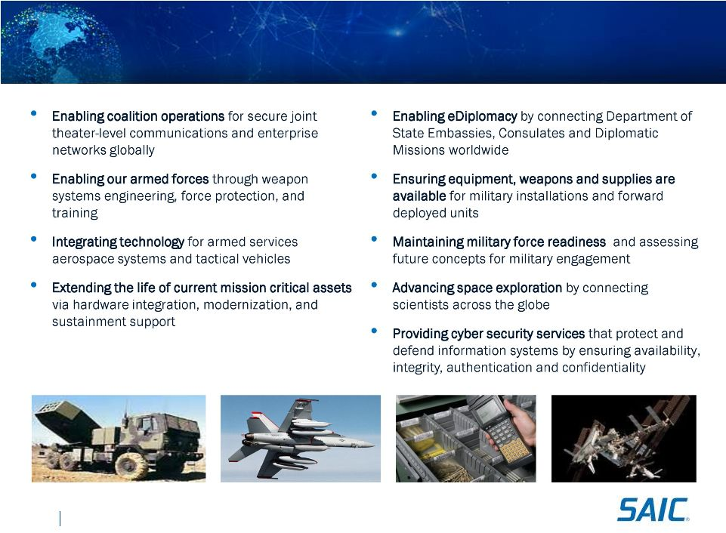
SAIC.com
©
SAIC. All rights reserved.
V127 12noon
Mission-Oriented Services Promote Enduring Revenue
10

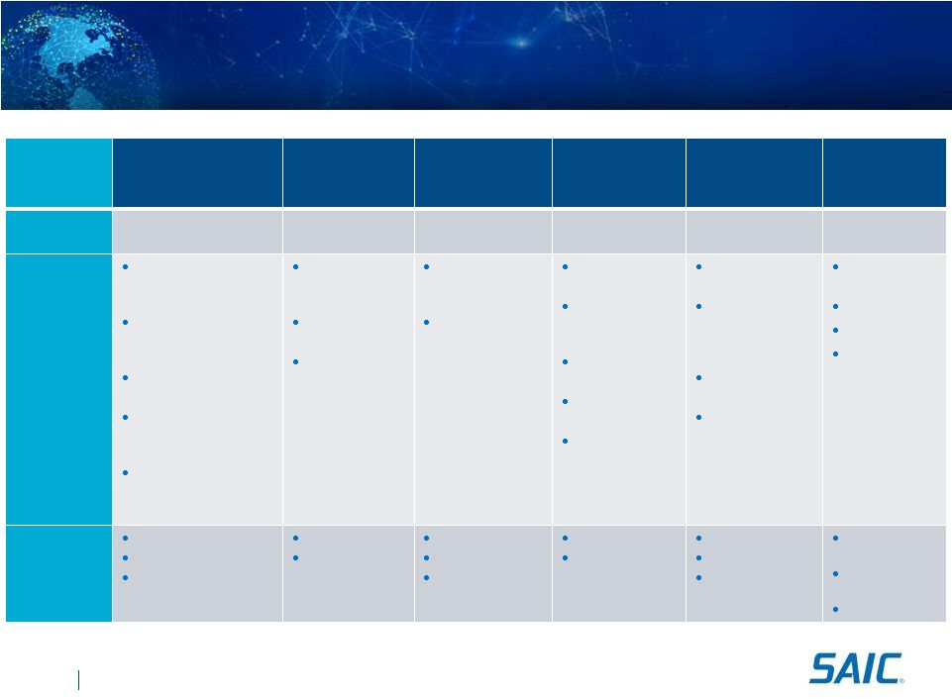
Enduring Customer Relationships
11
Customer
Army/Air Force
Navy/
Marine Corps
Defense Logistics
Agency
DoD Agencies &
Commands
Federal
Civilian
State, Local
and
Commercial
Relationship
Strength
30+ years
30+ years
30+ years
30+ years
20+ years
20+ years
Top
Customers
and
Commands
Aviation & Missile Life
Cycle Management
Command
Program Exec. Office for
Simulation, Training, &
Instrumentation
Mission & Installation
Contract Command
Air Force 754th
Electronics Systems
Group
Research, Development
& Engineering Command
Space & Naval
Warfare Systems
Command
U.S. Fleet Forces
Command
Naval Surface
Warfare Center
Crane Division
Defense Logistics
Agency Troop
Support
Defense Logistics
Agency Land and
Maritime
U.S. Central
Command
Defense
Information
Systems Agency
Missile Defense
Agency
Defense Threat
Reduction Agency
Washington
Headquarters
Services
Department of
Homeland Security
National
Aeronautics and
Space
Administration
Department of
State
Department of
Agriculture
State of
California
Toyota
Hawaii
City of San
Diego
Sample
Contract
Values /
Lengths
$820M / 3 years
$670M / 5 years
$433M / 5 years
$667M / 3 years
$245M / 5 years
$2.3B / 10 years
$1.4B / 10 years
$1.1B / 7 years
$345M / 4 years
$255M / 5 years
$4.0B / 10 years
$3.0B / 5 years
$2.6B / 10 years
$150M /
5 years
$100M /
5 years
$43M / 5 years
SAIC.com
©
SAIC. All rights reserved.
V127 12noon

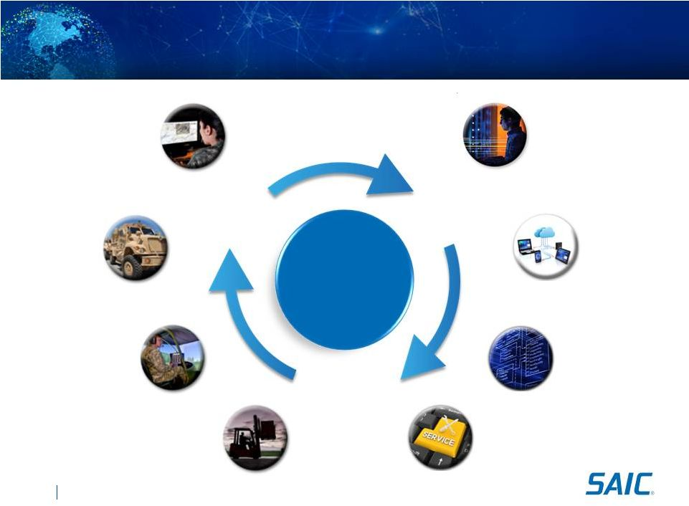
SAIC.com
©
SAIC. All rights reserved.
V127 12noon
Full Lifecycle Services & Solutions
12
Mission
& SETA
Hardware
Integration
Training &
Simulation
Logistics &
Supply Chain
Network
Integration
Software
Integration
Emerging IT
Solutions
IT Managed
Services
SAIC
Services &
Solutions
DESIGN
Engineering
& Analysis
BUILD
Develop &
Integrate
SUPPORT
Operations &
Maintenance

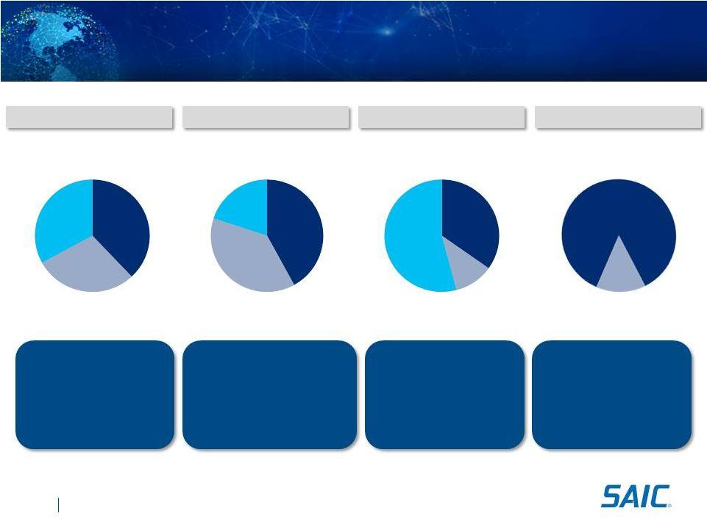
SAIC.com
©
SAIC. All rights reserved.
V127 12noon
Significant Scale and Diversified Contract Base
Contract Type
Contract Concentration
Revenue Mix
Balanced Distribution of
Revenue Sources
Scalable Prime Contracts
91% SAIC Prime Contracts
Over 1,500 Active
Contracts and Task Orders
Over $7B in Backlog
Time & Materials
29%
(1)
(1)
Includes fixed-price-level-of-effort.
ID/IQ vs. Non-ID/IQ
Strong ID/IQ Contract
Win Rate
Generally a Top 5 Task
Order Awardee on
Multi-Award ID/IQs
Cost Reimbursable
38%
Fixed Price
33%
Materials
20%
Subcontractors
38%
Top 5
Contracts
35%
Top 6 
10
Contracts
11%
Other
Contracts
54%
ID/IQ
86%
Non-ID/IQ
14%
Value Add Labor
42%
13

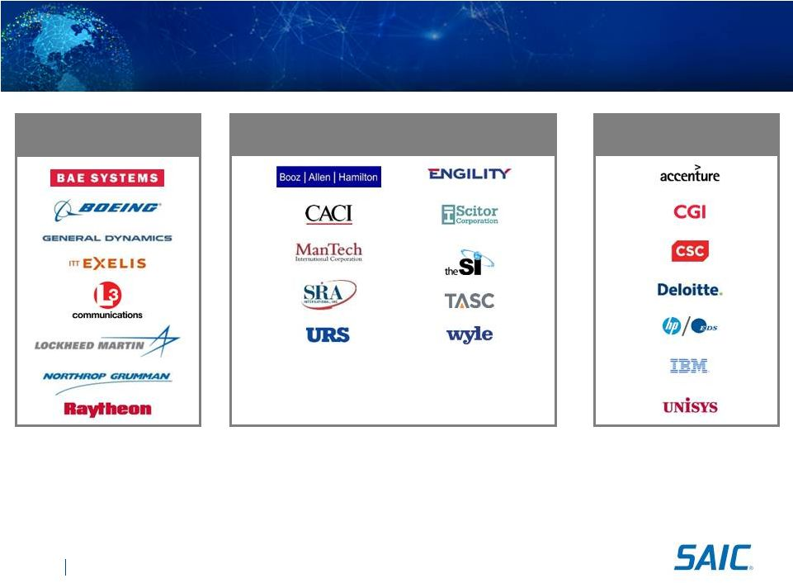
SAIC.com
©
SAIC. All rights reserved.
SAIC Competitive Landscape
14
OEM Defense
Contractors
Pure Play
SETA & Government Services
Diversified IT
Services
SAIC competes effectively across this landscape

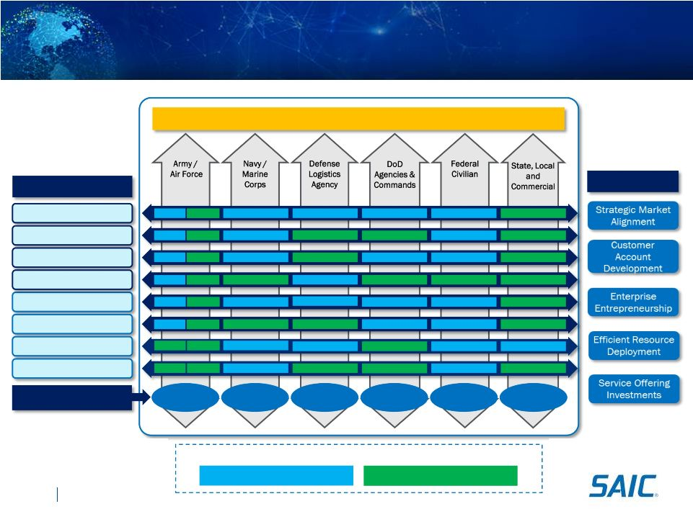
SAIC.com
©
SAIC. All rights reserved.
V127 12noon
Customers
SAIC Market Position
Offerings
Network Integration
Software Integration
IT Managed Services
Emerging IT
Mission & SETA
Hardware Integration
Training & Simulation
Logistics & Supply Chain
Grow
Protect/Expand
Benefits
Addressable Market
$24B
$60B
$32B
$3B
$30B
$60B
Operating Model to Drive Growth
15

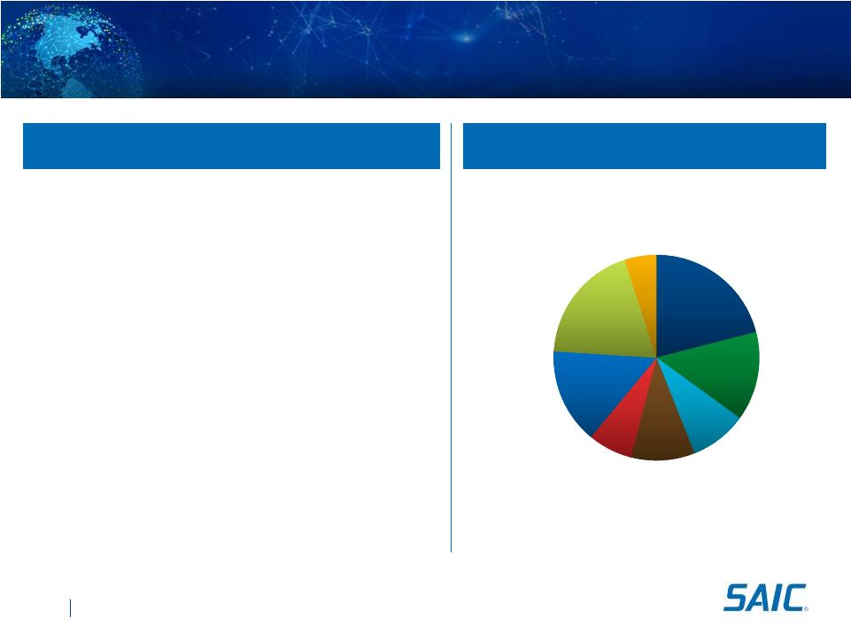
SAIC.com
©
SAIC. All rights reserved.
V127 12noon
Workforce with Technical Expertise

About 14,000 employees

66% of employees deployed at
customer sites

Over 65% of employees hold a security
clearance

Large percentage of workforce with
higher education

Veterans account for approximately
25% of our workforce

Key certifications in critical technologies
across Microsoft, Cisco and VMware
Mission &
SETA
21%
Hardware
Integration
14%
Training &
Simulation
9%
Logistics &
Supply
Chain
10%
Network
Integration
7%
Software
Integration
15%
IT Managed
Services
19%
Emerging IT
Solutions
5%
Employee Demographics
Distributed Employee Base
16

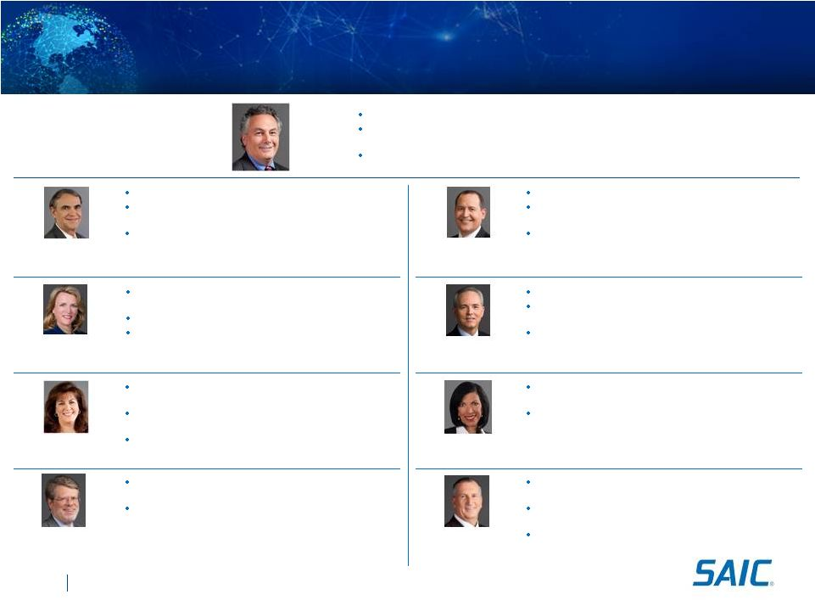
SAIC.com
©
SAIC. All rights reserved.
Experienced Leadership Team
Deborah
L.
James
President, Technical
and Engineering Sector
Brian F. Keenan
Executive Vice President
Human Capital Officer
Executive Vice President, SAIC Communications & Govt
Affairs
Senior Vice President, SAIC Business Unit General Manager
Former Assistant Secretary of Defense for Reserve Affairs,
Department of Defense
Senior Vice President, SAIC Corp Strategy
and Planning
Prior to SAIC, Senior Vice President and General Manager,
CGI, U.S. Enterprise Markets
Communications and IT industry experience after
graduating from the University of Arizona
Executive Vice President of SAIC Human Resources
Prior to SAIC, spent more than 15 years
at Mobil and ExxonMobil in HR leadership roles
Served seven years in the U.S. Army
Nazzic S. Keene
President,
Enterprise IT Sector
Former Acting President of SAICs Defense Solutions Group
Led U.S. Navy and Marine Corps marketing efforts for SAICs
Systems Engineering Group
21 years various assignments with U.S. Army Corps of
Engineers
Thomas G. Baybrook
Chief of Administration
and Operations
Senior Vice President and SAIC Corporate Controller
Joined SAIC in 2001 as Vice President and Director of
Accounting Operations
Before joining SAIC, spent 12 years with
Deloitte LLP
John R. Hartley
Chief Financial Officer
Laura K. Kennedy
Senior Vice President
and Chief Ethics Officer
Prior to SAIC, served as Vice President for Global
Compliance at Honeywell International
Prior to Honeywell, spent 21 years in legal private
practice, specializing in the areas
of government contracts and international
trade compliance
Prior to SAIC, served as General Counsel for MWH Global,
SRA International and Raytheon Missile Systems
Prior business law experience with Sidley Austin and
Perkins Coie in telecommunications and aerospace
industries
Mark D. Schultz
Executive Vice President
General Counsel
17
Thomas E. Wofford
Senior Vice President,
Internal Audit
Prior to SAIC, served as Director of Global Audit for
General Electrics Energy Division
Prior internal audit experience with Dresser, Inc., Trinity
Industries, and E-Systems, Inc.
Also served as Manager of Finance, Controller, and CFO
with E-Systems subsidiaries
Anthony J.
Moraco
Chief
Executive
Officer
President, SAIC Government Solutions Group
President, SAIC Intelligence, Surveillance, and
Reconnaissance Group
Executive Vice President, SAIC Corporate Operations
(1) Nominated to become Secretary of the U.S. Air Force
(1)

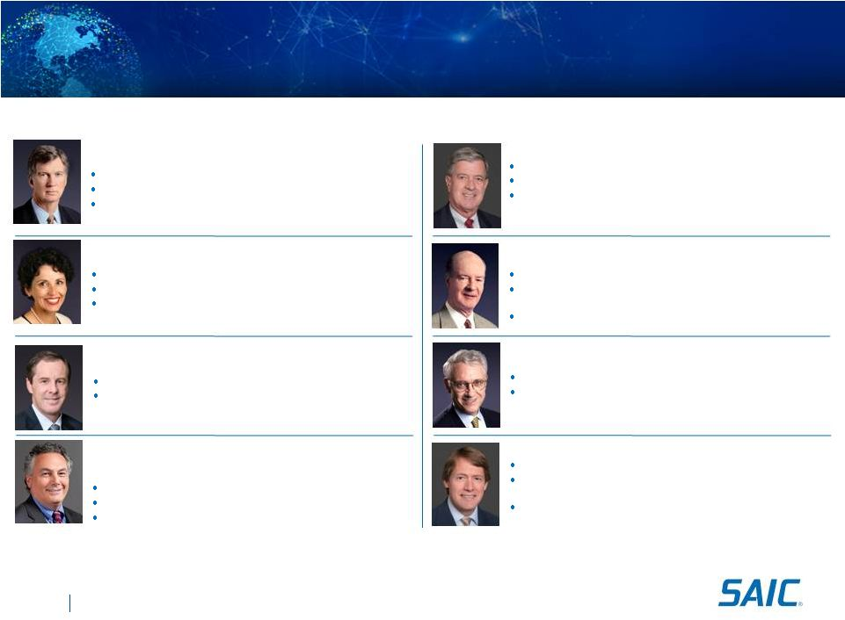
SAIC.com
©
SAIC. All rights reserved.
SAIC Board of Directors
18
Thomas F. Frist, III *
Director since
September 2009
Edward J. Sanderson, Jr. (Chairman) *
Director since
October 2002
Jere A. Drummond *
Director since
July 2003
Steven R. Shane
John J. Hamre *
Director since
June 2005
Anthony J. Moraco
Chief Executive Officer of Science Applications
International Corporation
Robert A. Bedingfield
*
Historical SAIC, Inc. board member
(1) Nominated to become Director of the National Science Foundation
Executive Vice President of Oracle (Retired)
President of Unisys Worldwide Services
Partner at both McKinsey & Company and Accenture
(formerly Andersen Consulting)
President of Purdue University (Retired)
Chancellor at the University of California, Riverside
Chief Scientist of the National Aeronautics and Space Administration
Principal of Frist Capital, LLC
Co-Managed FS Partners, L.L.C.
President, SAIC Government Solutions Group
President, SAIC Intelligence, Surveillance, and Reconnaissance Group
Executive Vice President, SAIC Corporate Operations
Global Coordinating Partner at Ernst & Young LLP (Retired)
Aerospace & Defense Practice Leader at Ernst & Young
Trustee of the University of Maryland at College Park Board of
Trustees since 2000
Vice Chairman of BellSouth Corporation (Retired)
President and Chief Executive Officer of BellSouth Communications
Group
President and Chief Executive Officer of BellSouth
Telecommunications, Inc
President and CEO of the Center for Strategic & International Studies
Served as Deputy Secretary of Defense
Partner at Accenture plc (Retired)
Managed Accentures US Federal, State and Local, Canada
Federal and Canadian Provincial businesses
Provided advisory services to the executive level at Fannie Mae
and other clients
*
(1)
France A. Córdova
Director since
February 2008

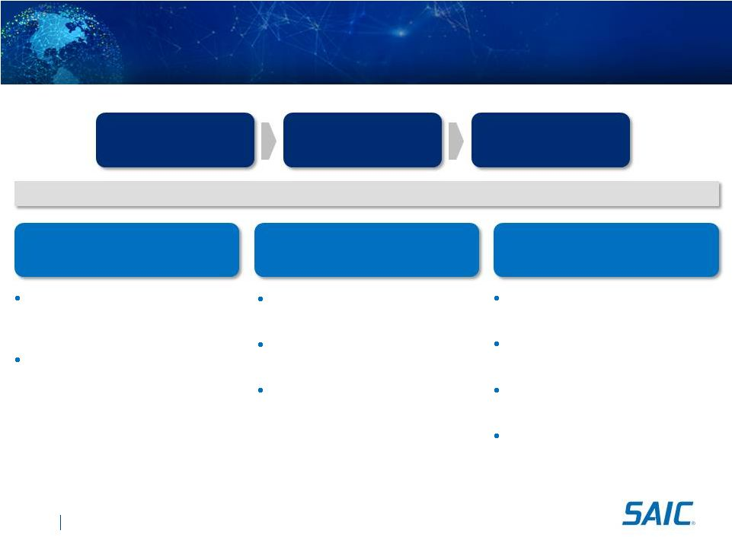
SAIC.com
©
SAIC. All rights reserved.
V127 12noon
Internal Transformation
Enterprise
Investments
Tailored Offerings
Key Investment Areas
Business Development
Capabilities
Efficient corporate center structure
designed to the new companys
business model
Operating model implementation

Focuses customer account
management

Optimizes resource deployments
Pipeline expansion from OCI
elimination
Prioritized investment for Bid and
Proposal in each Customer Group
Leverage broad prime contract
vehicle base
Investments in workforce subject
matter expertise
Investments in differentiated
offerings in each service line
Technology re-use of proven offerings
for tailored solutions
Develop strategic partnerships to
enhance capabilities
Expanded Market
Share
Reinvesting in our enterprise drives shareholder value
19
Key Investments

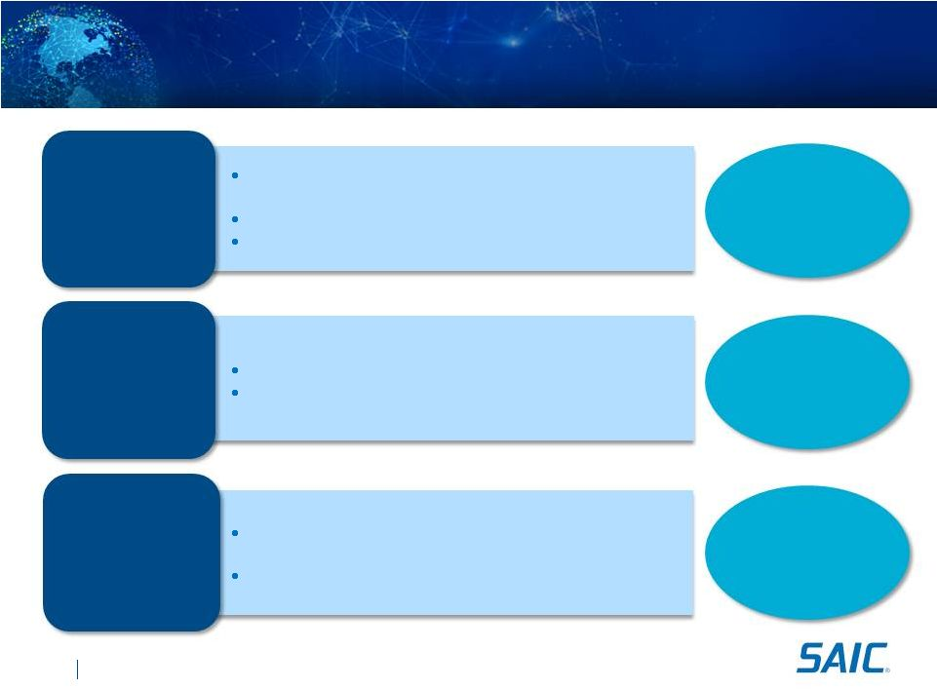
SAIC.com
©
SAIC. All rights reserved.
V127 12noon
Strong
Revenue Base
With Margin
Expansion
Predictable
Cash
Generator
Capital
Deployment
Consistency
Strong Financial Position
Large, recurring revenue base; $4B+ renewed
company
with significant scale and market position
Revenue base provides significant investment capacity
Margin opportunities in leaner, focused organization
CASH FLOW
REVENUE &
MARGIN
CAPITAL
DEPLOYMENT
Predictable free cash flow to support capital deployment
Balance sheet strength with firepower for future growth
Disciplined philosophy in deploying capital for
shareholder value
Direct return to shareholders of excess cash
20

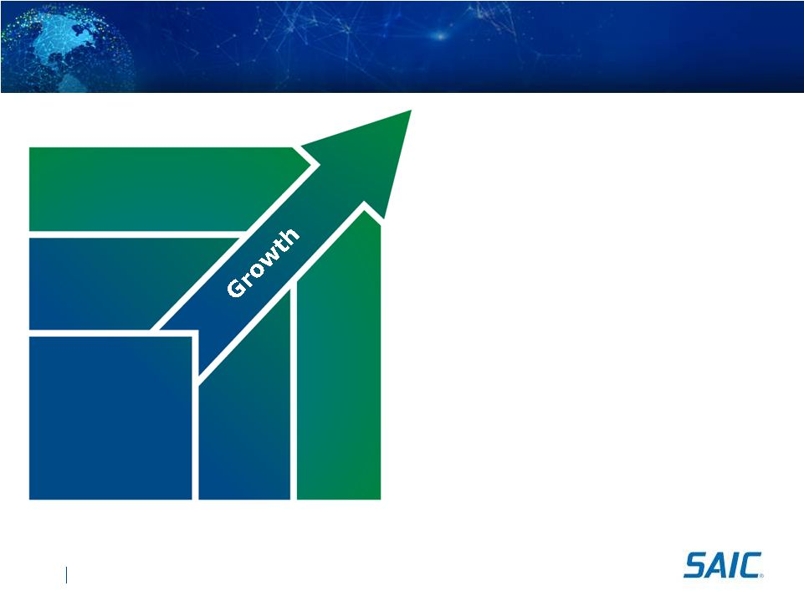
Performance Strategy Summary

Protect
-
Excellent contract execution
-
Retain incumbent positions

Expand
customers
-
Leverage existing service line portfolio to
existing customers

Grow
-
Strategic targeting of new customers for
our mature capabilities
-
Utilize differentiated offerings
Strategically aligned enterprise investments
to expand offerings
Grow into
Market Adjacencies
Expand with
Current
Customers
Protect
Our Base
SAIC.com
©
SAIC. All rights reserved.
V127 12noon
our
revenue
base
current
offerings
to
current
into
white
space
21


Sector Overviews
Sector President 
Nazzic Keene

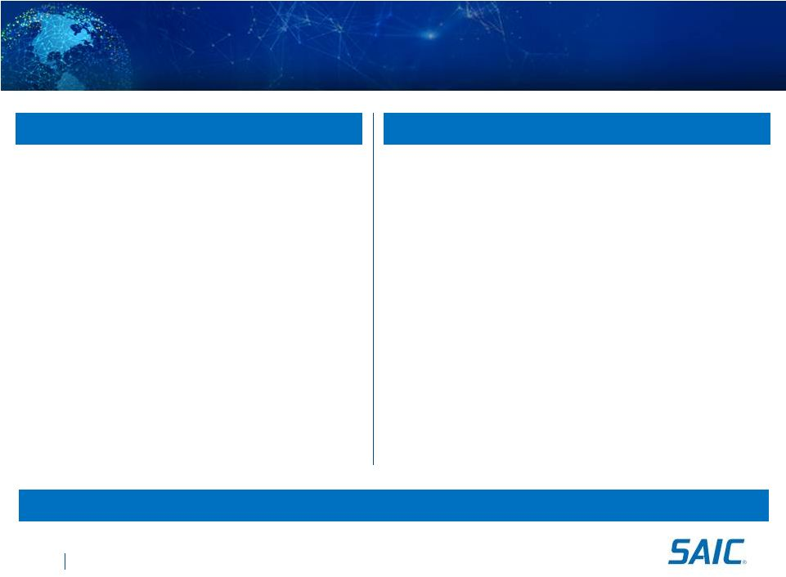
Sector Overviews

Deliver proven full systems lifecycle
Information technology solutions and
services

Design, development, deployment,
management, operations, and security

Deliver mission critical technology
solutions solving most complex
customer IT challenges

Leverage technology to significantly
reduce our customers operating costs
while improving their mission support

Provide mission focused full life-cycle
technical, engineering, and
professional services

Customer affinity coupled with technical
expertise

Cost-effective solutions through enabling
technologies, tailored toolsets, and
innovative methodologies

Specialize in weapons system
engineering, logistics and supply chain
management, ground vehicle
integration, system upgrade and
maintenance, training and simulation,
and program support services
Intersection of mission and technology for dependable and reliable service delivery
23
Enterprise Information Technology
Technical and Engineering
SAIC.com
©
SAIC. All rights reserved.

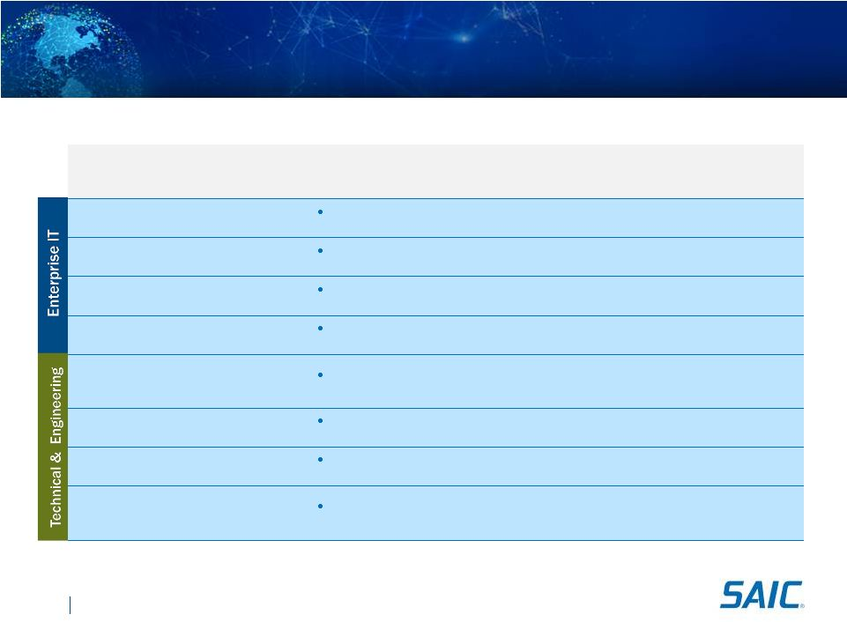
SAIC.com
©
SAIC. All rights reserved.
Top Contracts & Programs
24
Customer / Program
Scope
Period of
Performance
(POP)
Total
Contract
Value
U.S. Army/ITES-2S
Supports IT services including data centers and
software development
2006 
2016
$1.5B
State Dept / Vanguard
Provides enterprise-wide IT network
infrastructure services
2011 
2021
$2.6B
NASA / NICS
Manages communication services for all 80,000
network users
2011 
2021
$1.3B
DHS / EAGLE
Provides infrastructure engineering, O&M, and
software development services
2006 
2013
$1.2B
U.S. Army Aviation and Missile Command
Expedited Professional & Engineering
Support Services
Engineering and software support for aerospace
systems
2005 -
2013
$3B
Defense Logistics Agency Tires
Successor Initiative
Supply chain management services for military
tires
2005 -
2013
$3B
U.S. Navy Network Integration
Engineering Facility
C4I services for Navy's premier C4ISR System
Center lab
2011 2018
$1.2B
National Aeronautics and Space
Administration JSC Safety and Mission
Assurance Engineering Contract
Safety and mission assurance engineering
support services
2013 -
2018
$200M


Service Offerings

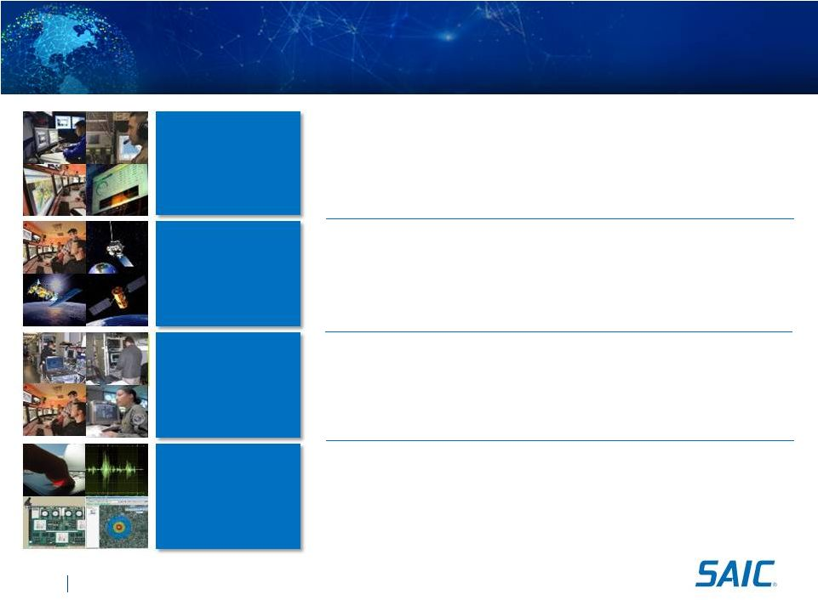
Network
Integration
Software
Integration
IT Managed
Services
Emerging IT
Solutions

Design and integration for Wide
Area Networks and Local Area
Networks

IP telephony integration

Network security

Resiliency and redundancy

Certification and accreditation

Software application development
and maintenance

Rapid legacy system modernization

Service-oriented architecture design

Mobile application development
and management, application
stores

ERP integration

Mobility

Data center management

Operation and cloud migration

Network engineering

Disaster recovery

Managed mobile and tactical
infrastructure solutions

Cloud and virtualized computing
infrastructure

Big data and data analytics

Software defined networks

Business transformation

Cyber security
Enterprise Information Technology Offerings
26
SAIC.com
©
SAIC. All rights reserved.

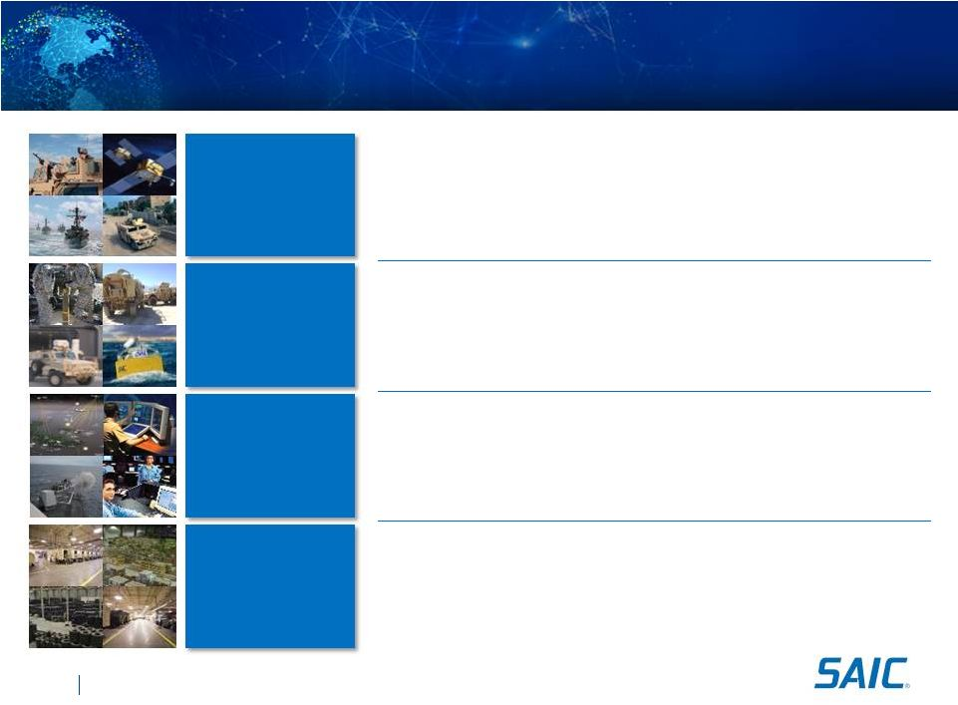
SAIC.com
©
SAIC. All rights reserved.
Technical and Engineering Offerings
Mission &
SETA
Hardware
Integration
Training &
Simulation
Logistics &
Supply Chain

Mission support including base security and mission engineering

SETA support including high-end engineering support, assistance
& advisory services, C4 systems, R&D support

Program Support: Program management

In-service engineering support

C5ISR system integration
services

Force protection systems

Training and mission rehearsal
planning and management

Scenario development

Live, virtual, and constructive
training

Simulation training aids
and products

Process improvement

Supply chain management

Stock management support

Material acquisition

Demand forecasting

Distribution

Sustaining engineering

Marine engineering

R&D support
27

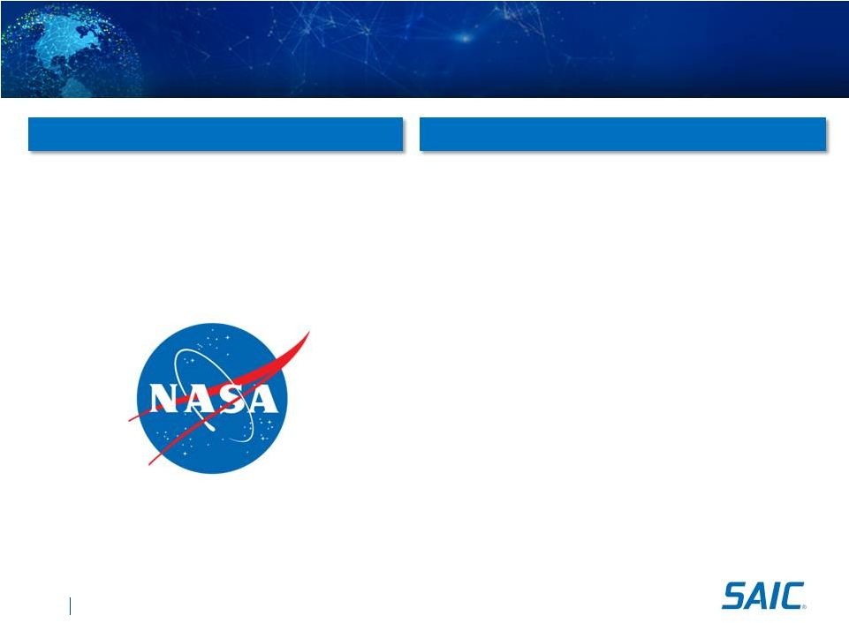
SAIC.com
©
SAIC. All rights reserved.

Contract Name: Integrated Communications
Services

Customer: National Aeronautics and Space
Administration

POP: 6/2011 -
5/2021

Contract Value: $1.3 Billion
Network Integration
NASA Integrated Communications Services
Providing two thirds of the agencys IT
infrastructure, we enhance the user
experience for more than 60,000 NASA
professionals at locations worldwide
Contract Details
SAIC
Offerings
28

Consolidates and manages Wide Area Networks and
Local Area Networks and provides a single, global
point of contact for every NASA center

Manage NASAs Global Network connecting
numerous countries, including Russia, Australia,
Germany, Canada, Spain, Argentina, France, and
Chile

500+ point to point dedicated circuits

35,000+ switch voice circuits

Satellite services for each center

3 Wide Area Networks: Mission, Corporate, and
Research

50+ LANs (including international connectivity)

80,000 network users

156,000 devices connected

200 connections to universities and partners

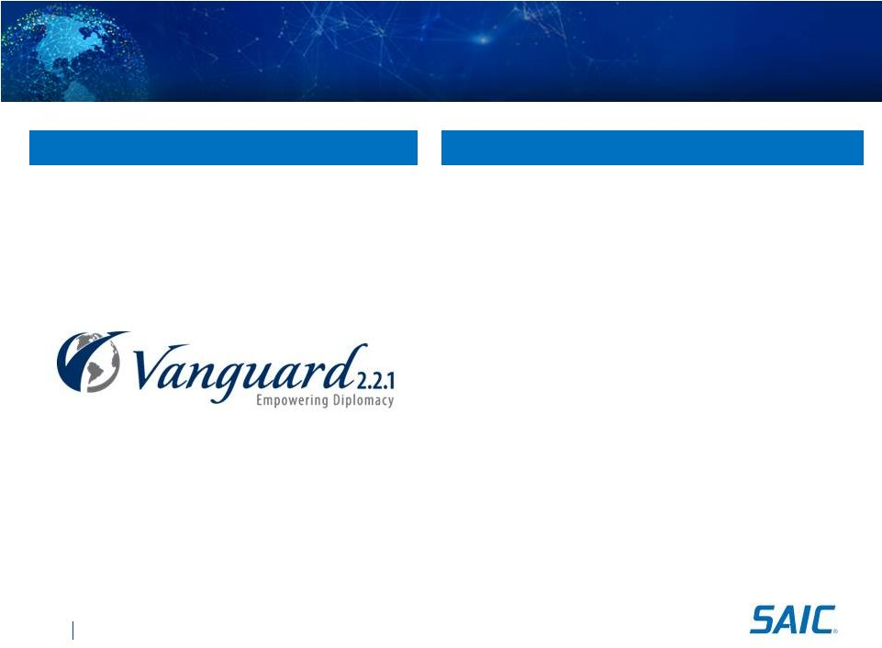
SAIC.com
©
SAIC. All rights reserved.

Contract Name: Vanguard 2.2.1

Customer: Department of State

POP: 2/2011 
2/2021

Contract Value: $2.6 Billion
Maintain and enhance enterprise-wide IT network and
services infrastructure for Department of State Bureau of
Information Resource Management
IT Managed Services

Support 105,000 users at 385 DoS sites worldwide including
classified environments

24/7/365 technical Tier II and Tier III support

2,000+ servers

5,000 Blackberries / 5,000 network devices
Network Integration

40,000+ phone lines, including POTS and secure

500+ point to point direct circuits; 250+ VPNs

50+ satellite and microwave circuits

10+ connections to other government agencies
Software Integration

~40 active Development, Modernization, and Enhancement
(DME) projects to expand system capabilities and services

IT transformation projects to extend the Foreign Affairs
Network in support of other agencies
Department of State Vanguard 2.2.1
Developing a new partnership by
providing a broad spectrum of IT,
network, and software services in support
of U.S. diplomats around the globe
Contract Details
SAIC Offerings
29

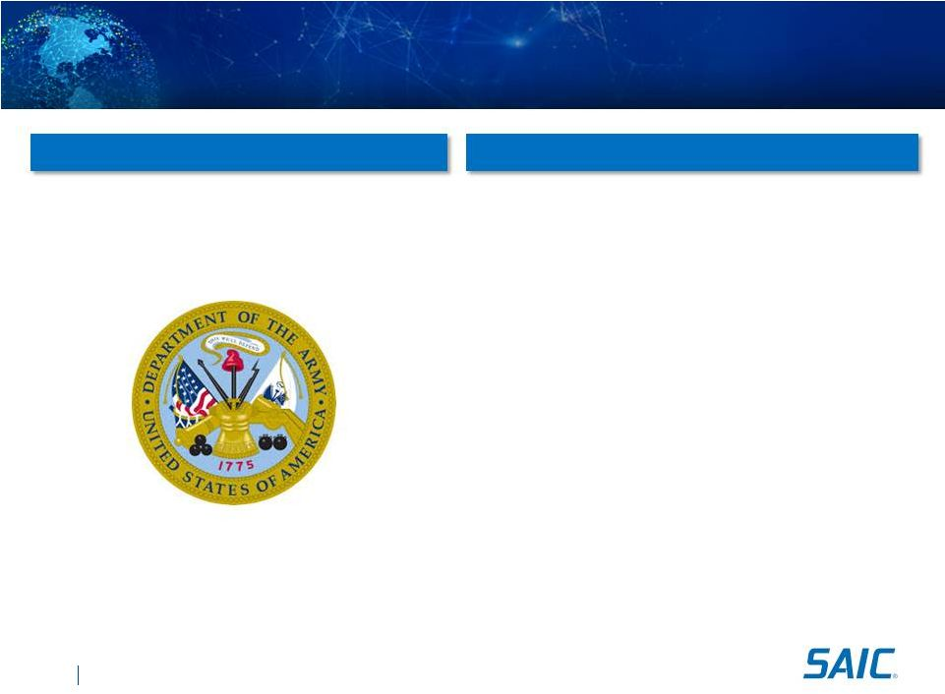
SAIC.com
©
SAIC. All rights reserved.
V118_15AUG_3PM
AMCOM Express BPA

Contract Name: AMCOM Express BPA

Customer: U.S. Army

POP: 2/2005 
2/2015

Contract Value: $3.0 Billion
Partner with customers to apply
broad-based mission, platform,
and technical knowledge to
serve unique needs
Contract Details
SAIC Offerings
30
Mission & SETA
Training & Simulation
Software Integration

C4ISR/Cyber analysis and test

Air worthiness analysis for all special operations
helicopters, Army airplanes and unmanned aircraft
systems (UAS/Drones)

Corrosion prevention and control for aviation and missile
weapons systems

Develop and integrate advanced technologies during
entire life cycle of supported systems

Trained over 20,000 students in basic skills and digital
master gunner courses

Serious gaming solutions

Maintain and operate UAS simulations in support of live,
virtual and constructive simulation events

Lifecycle SW support for over 200 projects in the

aviation, UAS, missiles, mission command,
and force protection domains

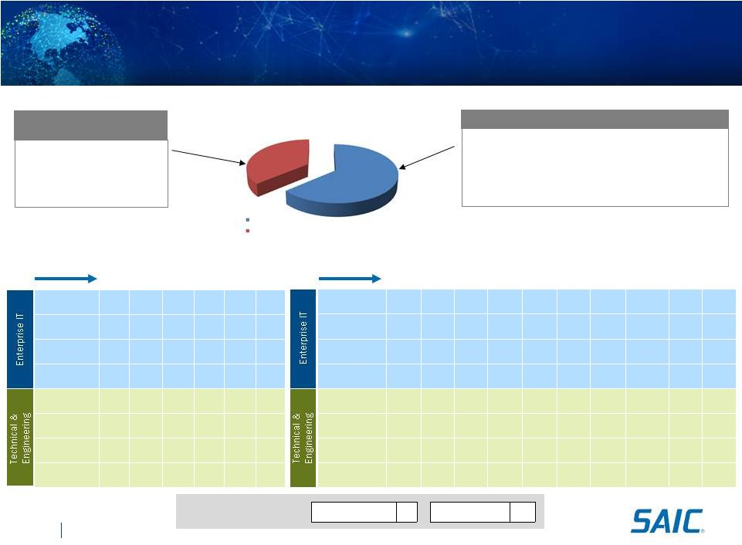
SAIC.com
©
SAIC. All rights reserved.
Department of Transportation
Expanding in the Federal Aviation Administration
Network
Integration
X
Software
Integration
X
IT Managed
Services
Emerging IIT
Solutions
X
Mission
& SETA
Hardware
Integration
X
X
X
Logistics &
Supply Chain
X
X
Training and
Simulation
X
X
X
X
X
31
Protect/Expand
X
Network
Integration
X
X
X
X
X
X
Software
Integration
X
X
X
X
IT Managed
Services
X
X
X
X
X
X
X
X
X
Emerging IIT
Solutions
X
X
X
X
X
X
X
Mission
& SETA
X
X
X
X
X
X
Hardware
Integration
Logistics &
Supply Chain
X
X
X
X
X
X
Training and
Simulation
X
X
X
X
X
X
X
Full Portfolio Pipeline
ITSS-SD
$150M
2013
FCS
$110M
2013
AIMM S2
$30M
2013
CSMC
$60M
2014
IT Infr
$100M
2014
NG Inits
$110M
2014
Flight Svcs
$400M
2014
SE2020 SB
$35M
2014
ATCOTS
$200M
2014
NAVTAC
$200M
2015
NextGen
Inititives
$107M
ATO-T
Eng
$70M
ATO-T
C&F
$32M
Volpe
TMIS
$150M
ETASS-
SB
$60M
ITSS
$156M
Current Contracts ($575M)

Systems Acquisition Support

Concept Development

Requirements Definition

Prototype Development

Safety Engineering

Testing

Air Traffic Control

Telecom, Wireless services

Flight and Aviation Information to Airlines or General Aviation

Infrastructure Support

Outsourced Service: Training, Helpdesk, Cloud

Management, Cloud solutions, IT application to support
non-NAS functions
Current Contracts
Opportunities
FY2012 FAA Addressable Market
$3B
Grow
X
New focus area for SAIC
Traditional market
space for SAIC
SAIC Market Position
Enterprise IT
Technical Services

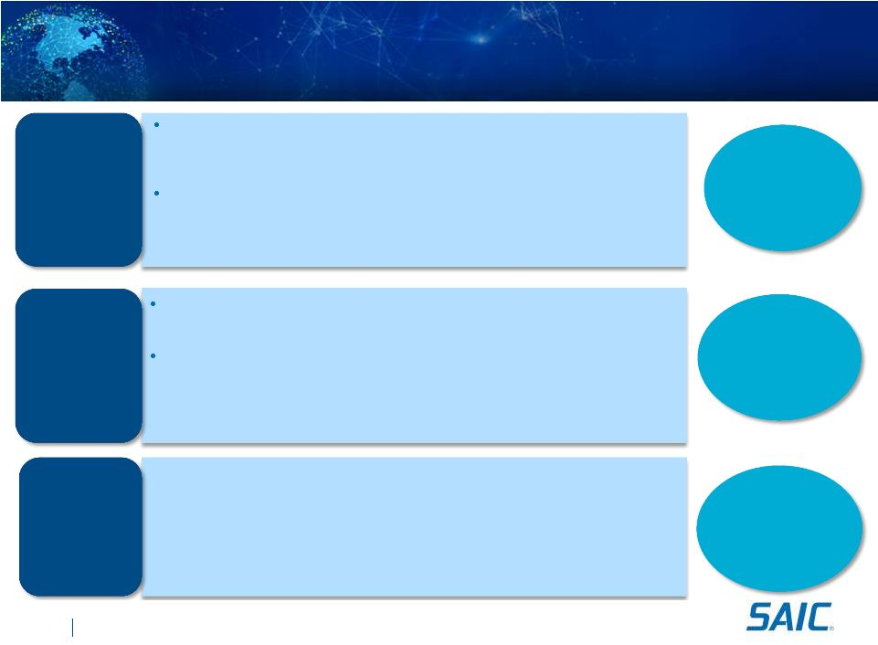
SAIC.com
©
SAIC. All rights reserved.
Stable and
Predictable
Revenue
Incremental
Revenue &
Profit
Accelerated
Profitable
Growth
Integrated Growth Strategy
Recognized and valued by our customers as trusted and
highly capable partner dedicated to their mission success

Dedicated client management team

Flawless execution of proven services and solutions
Maximize position in mission critical areas

Global network integration

Combat & weapon systems engineering, integration, and modernization

Supply chain management including prime vendor maintenance & repair operations
32
EXPAND
PROTECT
GROW
Leveraging our strong 40+ year SAIC heritage while thoughtfully investing
in the future to retain our competitive advantage

Expand market position in existing clients by selling the full enterprise
Growth Opportunities in

Cloud 
migration and brokerage Solutions

Mobility systems integration

Government
side
engineering
and
technical
support

Hardware integration, integrated training, and logistics services
Well positioned for future growth selling proven, market leading solutions
into adjacent markets


Next generation enterprise networks & unified communications

ITaaS Platform 
all IT as a service

Managed services, outsourced solutions

Enterprise IT and technical and engineering services (e.g. Air Force)

Technical services expansion/OCI uplift (e.g NAVAIR/NAVSEA)

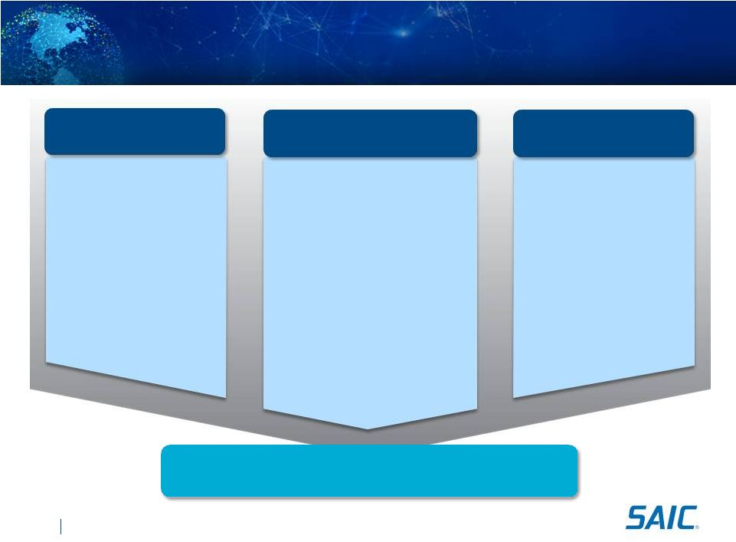
Our Model Will Drive Operational Excellence & Growth

Building on our 40+ year
history of serving our
customers

Dedicated account
management teams of
experienced senior executives

Improved customer
relationships through focused
account management

More effectively sell and deliver
the entire range of SAICs
services and solutions to all
customers, both current and
new
33
Services and Solutions
Functional Alignment

Enhanced, innovative
capabilities and solutions
through service group
alignment and focus on
best-in-class

Through enterprise-wide
resource planning, easier,
quicker access to the right
resources at the right time,
wherever in SAIC they reside

Leverage enterprise-wide
skills and expertise for
program needs and issue
resolution

A highly competitive cost
structure to bid and win
more profitable work

Optimized services
across the company to
maintain competitive
rates that help stretch
customer budgets
Customer Centric
SAIC.com
©
SAIC. All rights reserved.
One connected
team focused on enterprise goals and
aligned on company success

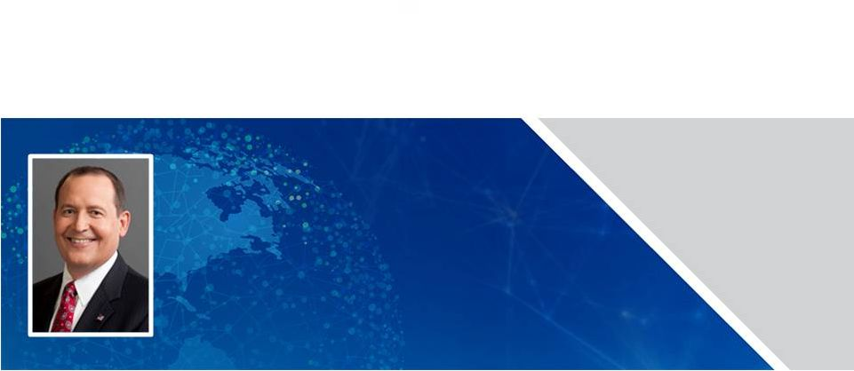
Financial Overview
Chief Financial Officer 
John R. Hartley

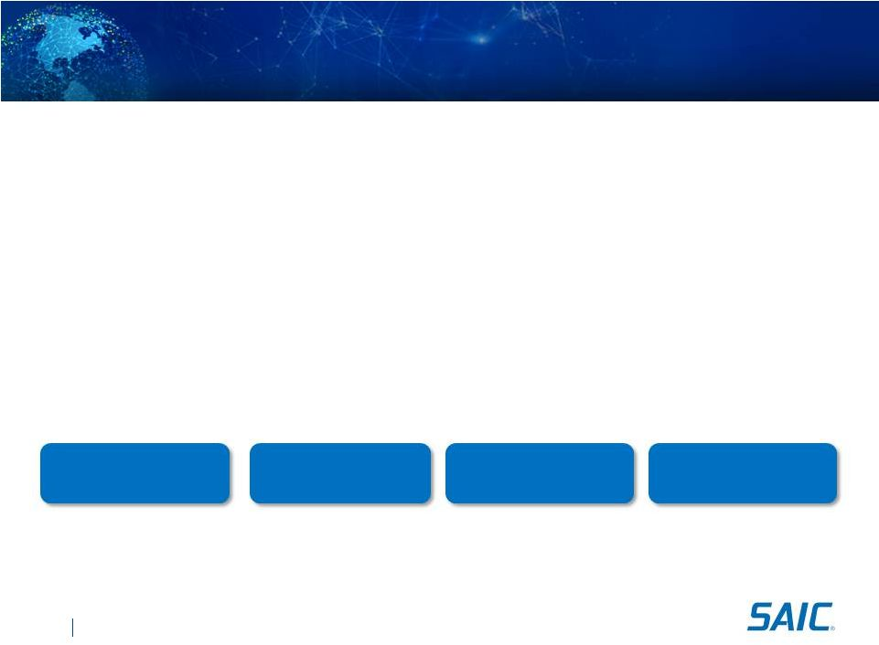
SAIC.com
©
SAIC. All rights reserved.
V127 12noon
Financial Objectives Post Spin

Low single digit revenue growth in challenging market

Considering revenue base of approximately $4 Billion

Incremental operating margin improvement

Indirect cost structure efficiency, increased value added content, and solid
program execution

Efficient free cash flow in excess of net income

Effective and disciplined capital deployment

Deploying cash in excess of minimum operating needs
Strong Cash Flows
Disciplined Capital
Deployment
Margin Performance
Solid Financial Position
35
SAICs financial objectives designed to grow
shareholder value

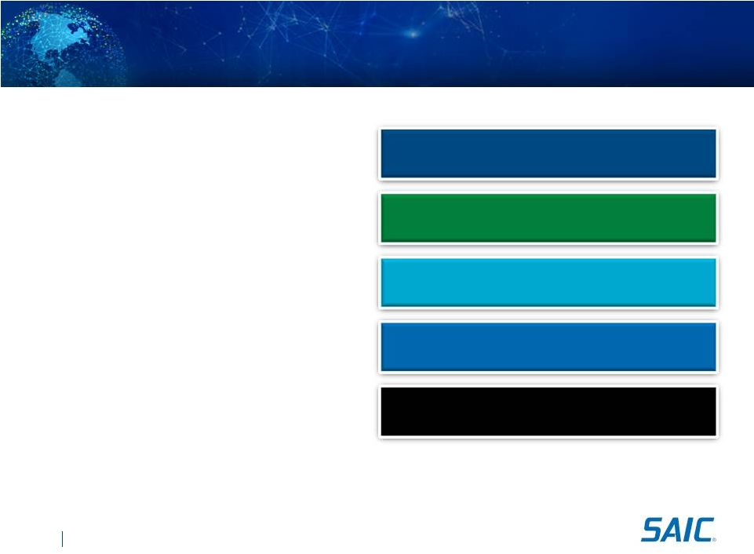
SAIC.com
©
SAIC. All rights reserved.
V127 12noon
SAIC 
Creating Shareholder Value
Organizational alignment
Value Proposition Principles:
Say what we do
Do what we say
Transparency of mission
Make our value proposition clear
36
Grow shareholder value through delivery of return on investment

Understood and executed at every level
of the enterprise

Explicit and disciplined in how we
deliver value

Tangible metrics that measure our
progress

Well aligned incentives that drive
behavior throughout the enterprise

Transparency with investors to provide
visibility into business

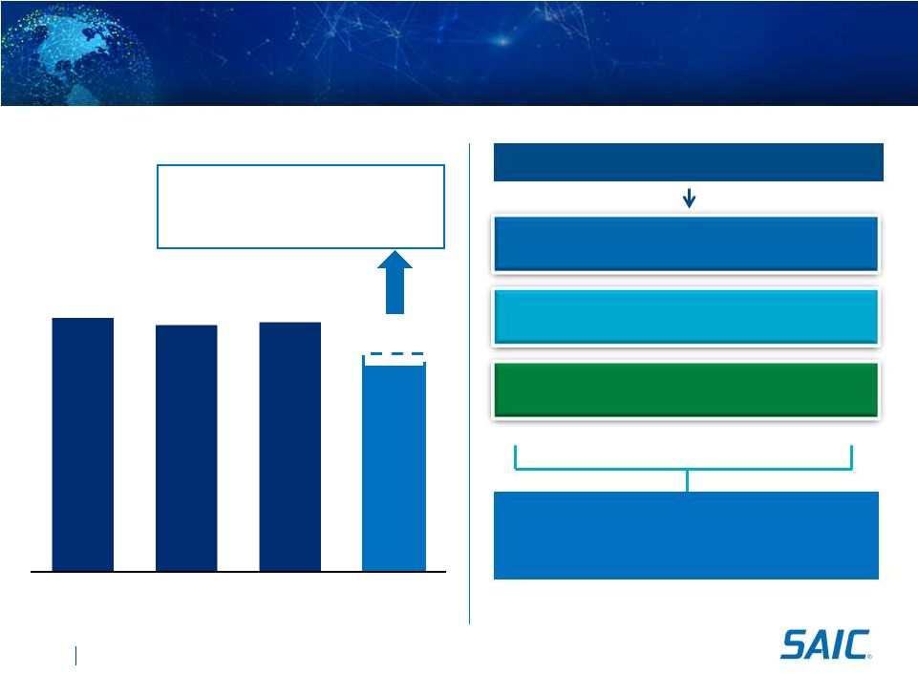
SAIC.com
©
SAIC. All rights reserved.
V127 12noon
Financial Performance
Revenues
(1)
($ in millions)
$3,850
$4,767
$4,637
$4,690
$4,100
FY 2011
FY 2012
FY 2013
FY 2014E

~$400M loss of DGS contract

~$100M OCO drawdown

~$125M Sequestration/budget pressures
(1) Excludes revenues performed by parent.
37
Revenue Drivers
Stable and Diversified Base
Expand Existing Customer
Grow Underserved Agencies
Revenue Performance
Solid Book-to-Bill and Backlog

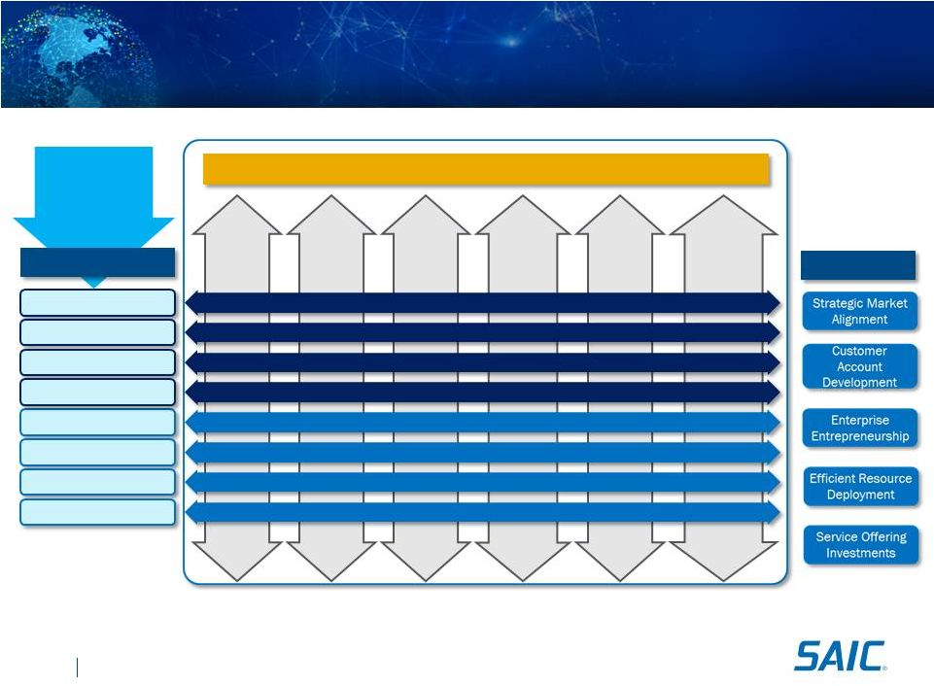
SAIC.com
©
SAIC. All rights reserved.
V127 12noon
Aligned with Performance Measures
Army /
Air Force
State, Local
and
Commercial
Navy /
Marine
Corps
Defense
Logistics
Agency
DoD
Agencies &
Commands
Federal
Civilian
Customer Organization Revenue
Offerings
Network Integration
Software Integration
IT Managed Services
Emerging IT Solutions
Mission & SETA
Hardware Integration
Training & Simulation
Logistics & Supply Chain
Benefits
Service
Organization
Revenue
38
Incentive Structure Aligned
with Operational Priorities

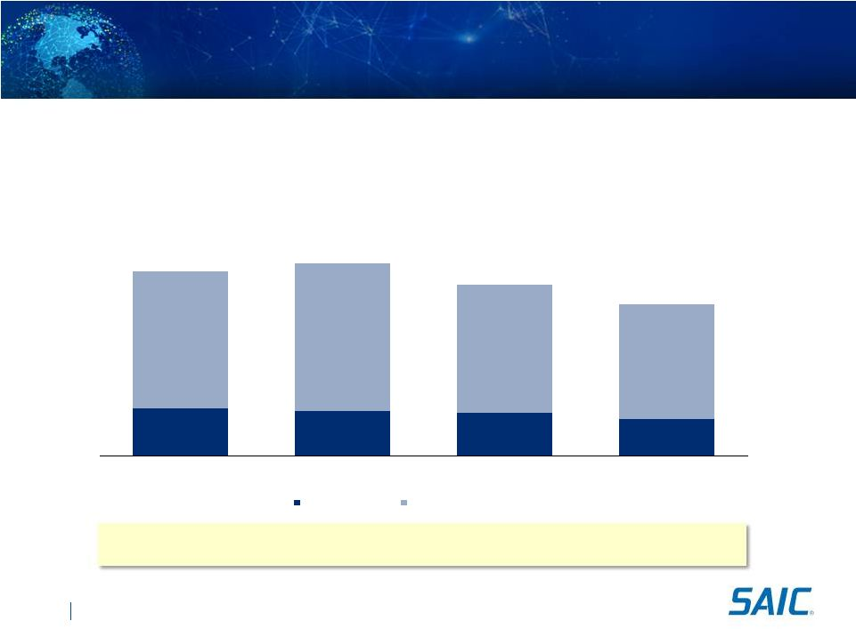
SAIC.com
©
SAIC. All rights reserved.
V127 12noon
Backlog
Historical Backlog
($ in millions)
39

Continued increase in ID/IQ contracts

Award delays continuing

Growth in pending awards
Book to Bill Ratio
(1)
H1 FY 2014 book to bill ratio.
(1)
2,144
2,056
1,953
1,664
6,204
6,655
5,811
5,209
$8,348
$8,711
$7,764
$6,873
FY 2011
FY 2012
FY 2013
Q2 FY 2014
Funded Backlog
Negotiated Unfunded Backlog
--
1.1x
0.8x
0.6x

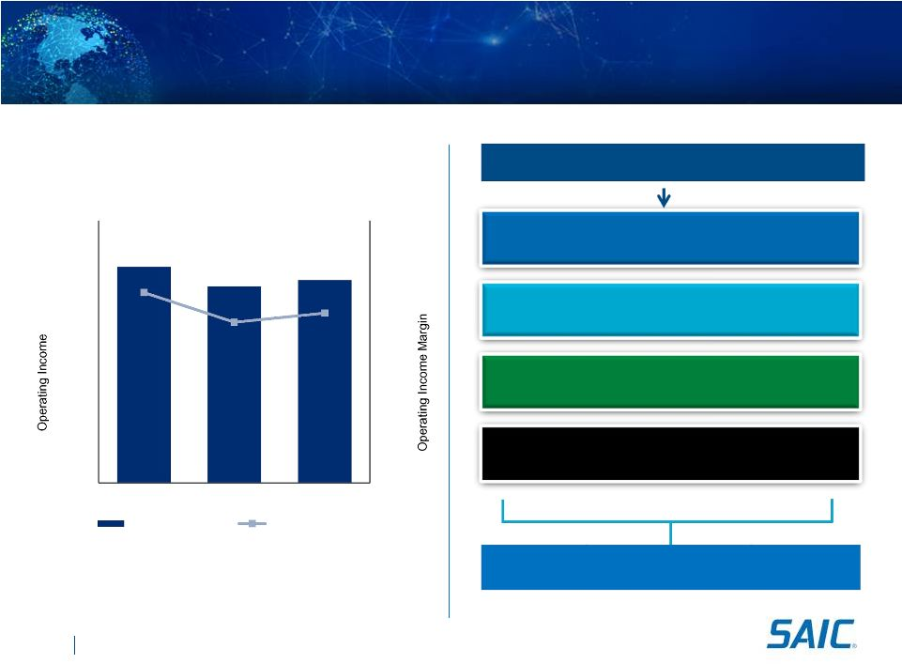
SAIC.com
©
SAIC. All rights reserved.
V127 12noon
Financial Performance
(1)
Excludes $28 million of separation transaction expenses in FY 2013. FY14 will
also reflect separation transaction expenses.
Operating Income Drivers
40
Operating Income Improvement
$0
$100
$200
$300
$400
FY 2011
FY 2012
FY 2013
4%
5%
6%
7%
8%
$329
$299
$309
6.9%
6.4%
6.6%
Operating Income
Operating Income %
Reduce indirect cost
Increase value add base
Leverage scale
Strong Program Execution
(1)
Operating Income (Excluding Separation Expenses)
($ in millions)

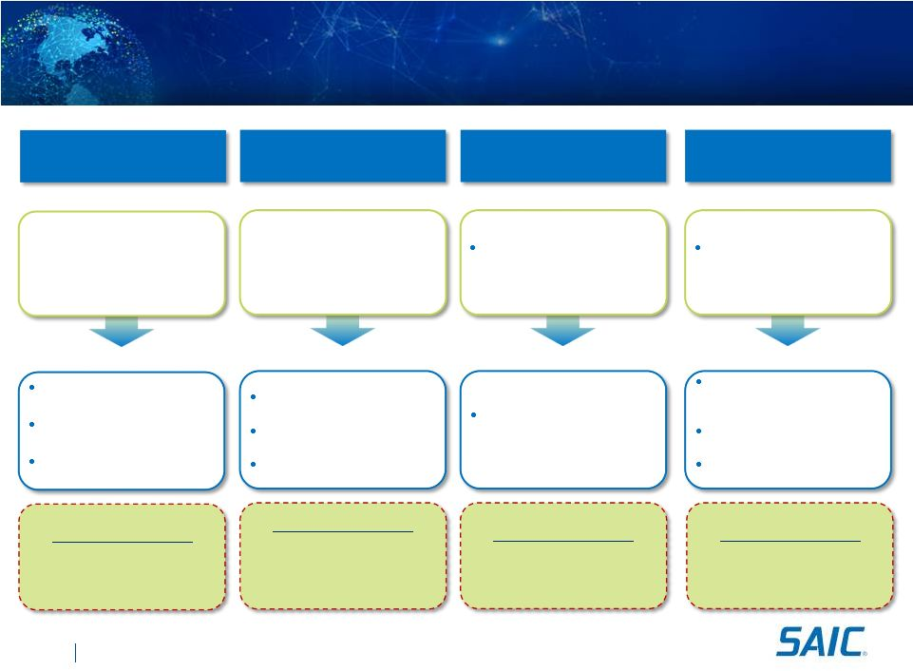
SAIC.com
©
SAIC. All rights reserved.
V127 12noon
Operating Income Drivers
Current
Current
Current
Current
Future
Future
Future
Future
41

Corporate organization
designed for entire
organization

Significant Group indirect
infrastructure

Incentives motivate
subcontract activities

Value added base
decreasing (currently only
42% of revenue)
Costs structure motivates
lowering contract fees to be
competitive
Decentralized business
models with reactive program
management approach
Indirect cost structure
efficiency
Vigilance about removing
unnecessary costs
Manage unallowable and
unbillable costs
Incentives aligned to motivate
SAIC content and collaboration
Explicit about capabilities we
provide and what we partner for
Value added base increasing
Bid more contract fee with
competitive cost structure
and differentiated solutions
Capability alignment promotes
proactive program management
approach
Improve fee performance on all
programs
Continue to make our customers
successful
Cost Optimization
Increase Value
Added Base
Leverage Scale
Program Execution
Success Indicator
Bid fee versus actual
fee performance
Success Indicator
Fee performance by
service offering
Success Indicator
Percentage of value
add versus subcontract
labor by capability
Success Indicator
Best in class indirect
rates versus peers

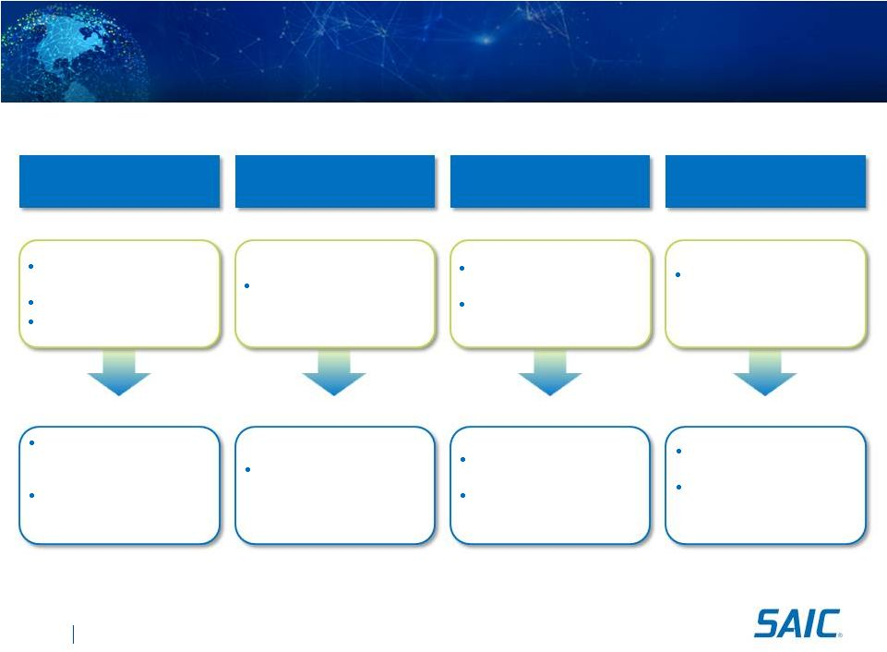
SAIC.com
©
SAIC. All rights reserved.
V127 12noon
Near-Term Cost Optimization Opportunities
Organizational
Simplification
Facility Rationalization
Benefit Alignment
Strategic Sourcing
Current
Current
Current
Current
Separate support functions
across the organization
Complicated structure
Redundant internal processes
118 locations occupying ~3.2
million square feet
Common across entire
enterprise
Limited use of competitive
benefit packages
Separate vendor
relationships among
segments
Future
Future
Future
Future
Centralize shared services
infrastructure with efficient
support model
Discontinue certain internal
processes for more efficient
client service
Close about 50 sites and
reduce about 20 sites (~1.1
million square feet)
Benefits better aligned to
market
Disciplined utilization of
competitive benefit packages
Centralize strategic sourcing
function
Negotiate more effectively
with vendors by leveraging
buying power
42

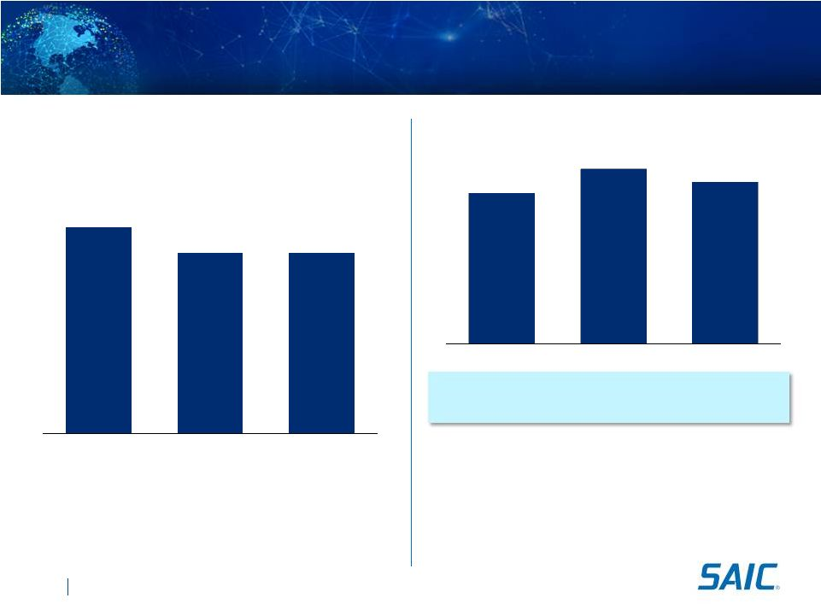
Multiple of Net Income
1.3x
1.7x
1.5x
Historical Operating Cash Flow
($ in millions)
$261
$303
$280
FY 2011
FY 2012
FY 2013

Operating cash flow generation of greater than 1.0x of net
income on long term basis

Capital expenditures are expected to be less than 1% of total
revenues

FY14 cash flow negatively impacted by cancellation of
governments accelerated payment program (~$30M)

Ample flexibility to pursue capital deployment alternatives
$208
$182
$182
FY 2011
FY 2012
FY 2013
Historical Net Income
($ in millions)
Historical Net Income and Cash Flow Generation
FY13 includes separation transaction expenses net of tax
SAIC.com
©
SAIC. All rights reserved.
V127 12noon
43

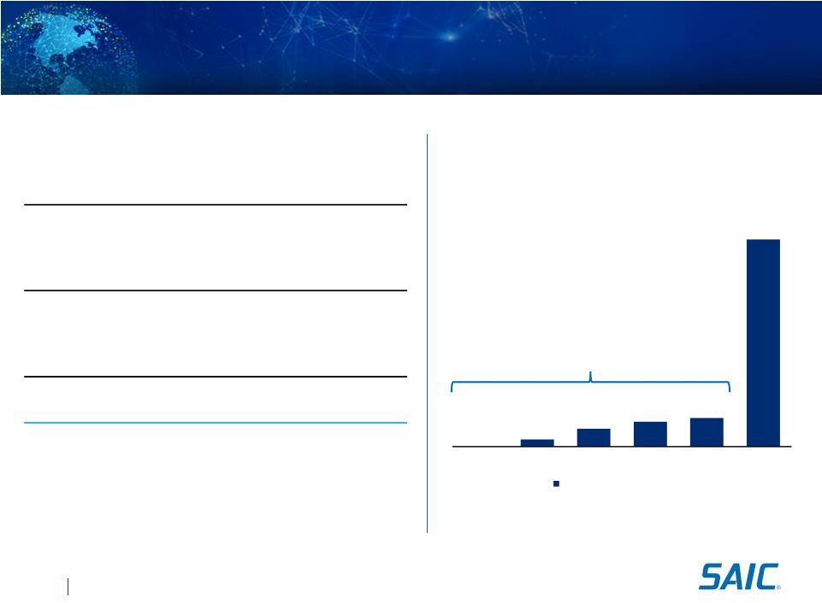
SAIC.com
©
SAIC. All rights reserved.
V127 12noon
Capital Structure Overview
Capitalization
($ in millions)
Debt Maturity Profile
($ in millions)
$138M
44
(1)
Undrawn, 5-year $200 million Senior Unsecured Revolving Credit Facility.
(2)
EBITDA excludes Gemini transaction/separation expenses.
--
$13
$31
$44
$50
$362
FY 2014
FY 2015
FY 2016
FY 2017
FY 2018
FY 2019
$500M Term Loan at Spin
5/3/2013
Pro Forma
Cash
$226
New Revolving Credit Facility
--
New Term Loan Facility (Fixed Rate with Interest Rate Swap)
$500
Capital Lease Obligations & Notes Payable
3
Total Debt
$503
Total Book Equity
384
Total Capitalization
$887
Credit Statistics
Total Debt / FY 2014 EBITDA
Less than 2.0x
(1)

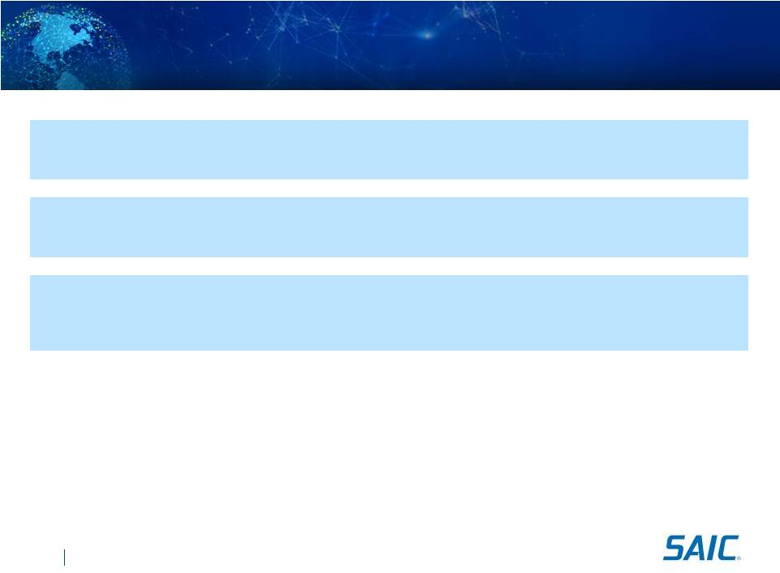
SAIC.com
©
SAIC. All rights reserved.
V127 12noon
SAIC FY14 Guidance

Revenue
$3.85 Billion to $4.10 Billion

Diluted Earnings Per Share
(1) (2)
$0.34 to $0.38

Operating Cash Flow
Equal to or Greater Than
$125 Million
(1)
Based upon SAIC, Inc. average effective share count of 343 Million at September 4, 2013,
includes estimated transaction expenses of $35M net of taxes.
(2)
After adjustment for the distribution in the spin transaction ratio of one (1) SAIC share for
every seven (7) SAI owned, Diluted Earnings Per Share guidance will be $2.38 to $2.66, as
adjusted.
45

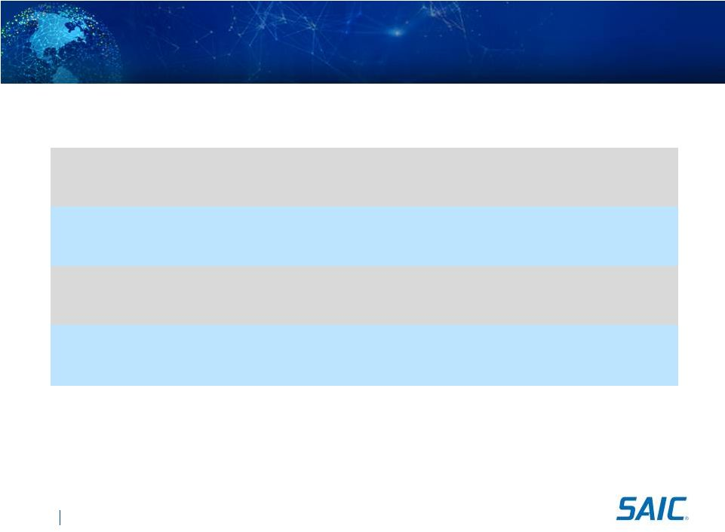
SAIC.com
©
SAIC. All rights reserved.
V127 12noon
Long Term Financial Targets FY14 to FY16
Annual Organic Revenue Growth
Low single-digit growth
Target Operating Margin (for 3 to 5 years)
Year-over-Year Increase
Tax Rate
35% to 40% range
Maximize cash flow generation, free cash flow to
exceed net income
Deploy excess cash for shareholder
value creation
46

SAIC.com
©
SAIC. All rights reserved.
V127 12noon
Capital Allocation Priorities

Dividend

Maintain relative portion of historical SAIC, Inc.

Debt
Reduction

Not
intended
in
excess
of
required
amortization

Capital
Deployment
For
shareholder
value
creation
47
Capital deployment in excess of minimum operating cash level
current dividend


Closing Remarks
Chief Executive Officer 
Tony Moraco

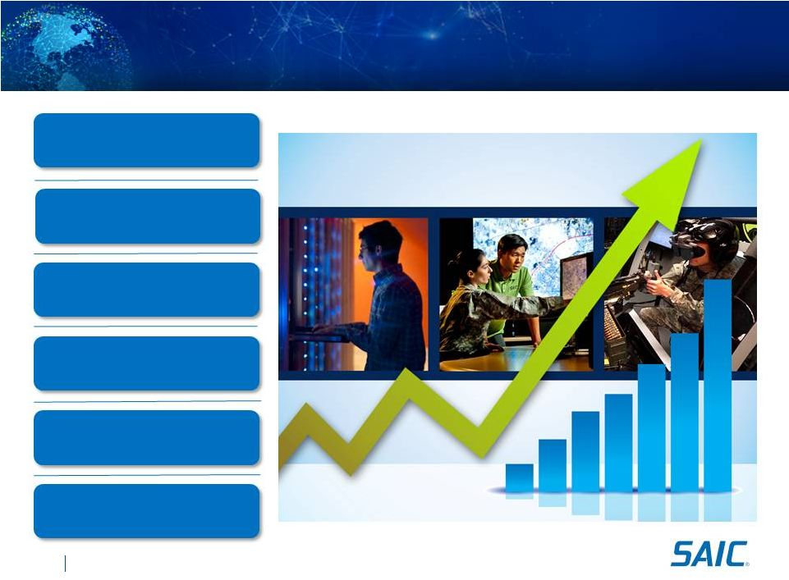
SAIC.com
©
SAIC. All rights reserved.
V127 12noon
Investment Highlights
Enduring Customer Relationships
and Mission-Orientation
Technical Experts Led by
Experienced Management
Tailored Operational Model and
Competitive Structure
Solid Financial Position
Full Lifecycle Offerings
Significant Scale and Diversified
Contract Base
49



